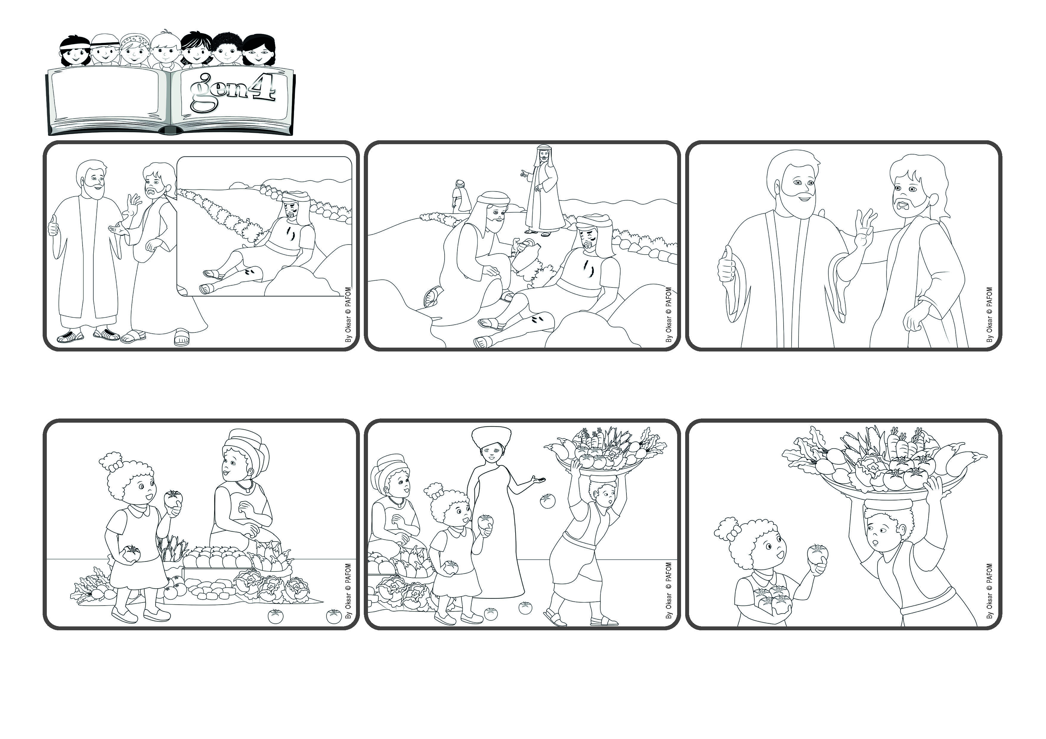

“You shall love the Lord your God (...) and your neighbor as yourself.” (Lk 10:27)
(January 2024, Theme for the 2024 Week of Prayer for Christian Unity)
Word
of Life
Let’s love God and everyone around us
“Who do you think did the most important thing?” Jesus asked the man. He answered: “The third one who took care of him because he was wounded.” “That’s right!” Jesus said, “Now you go and do the same for every neighbor you meet.”
A priest passed by that way and also a leader of the synagogue. They looked at him but did not help him. It was only a foreigner, a Samaritan, who stopped, put bandages on his wounds and then took him to a nearby hotel. He paid the man there to take care of him.
A person who had studied a lot asked Jesus: “What is the most important thing to do in life?” Jesus answered with a story: There was a man on a journey and he was attacked by robbers, who stole evereything he had and left him half dead by the side of the road.
Maya said: One day I was going home and I passed by the market where there are always many people selling fruit and vegetables. When I said hello to one lady, I saw on the ground in front of me a tomato, and then another and then still another....
The man looked very tired and worried. And so I stopped and picked up all the tomatoes. He thanked me with a big smile and I was happy too because I had been able to help him. Maya from Uganda
I looked around and saw that they came from a big basket that a man was struggling to carry because it was so heavy! No one had noticed that he was losing all those beautiful tomatoes that would soon be crushed under people’s feet!
© PAFOM, Drawings and text provided by the Gen4 Center.
The Gen4 are the young children of the Focolare Movement, which was founded by Chiara Lubich.

