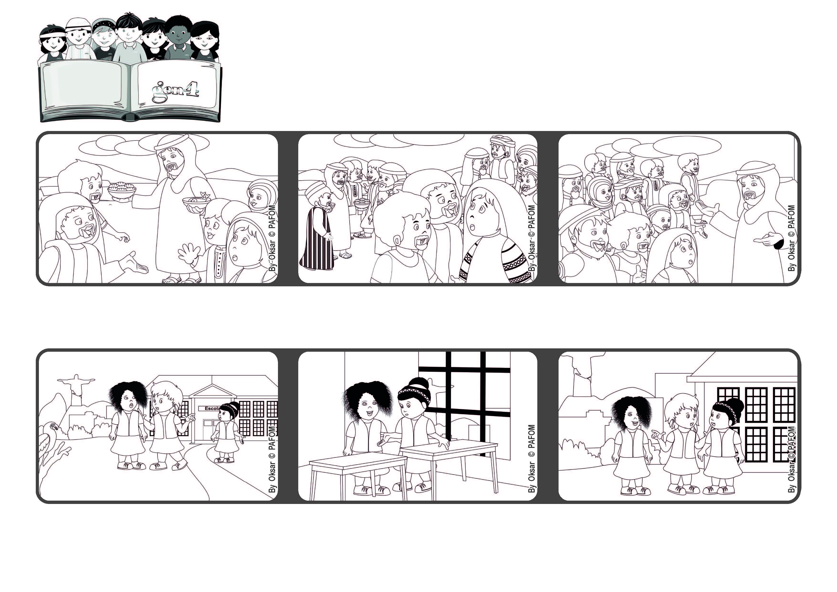
February 2022
Word of Life
“Anyone who comes to me I will never drive away” (Jn 6:37)
Jesus is always waiting for us
First, I asked her if what I heard was true. She was very sad and told me it was not.
Jesus reminded them that God had sent him to help everyone, to forgive everyone and not to lose anyone.
However, some people didn’t understand who Jesus was. They didn’t believe in him and started saying bad things about him.
Jesus had just performed the miracle of multiplying the bread and fish. The people were so enthusiastic that they kept looking for him.
I decided that we shouldn’t break our friendship over that and so I asked them to apologize to one another. They did and now we are all very good friends.
Experience of Benta from Brazil: One of my friends said something bad about another girl. When we went back into the classroom, I went up to that girl.
© PAFOM, Drawings and text provided by the Gen4 Center.
The Gen4 are the young children of the Focolare Movement, which was founded by Chiara Lubich.

