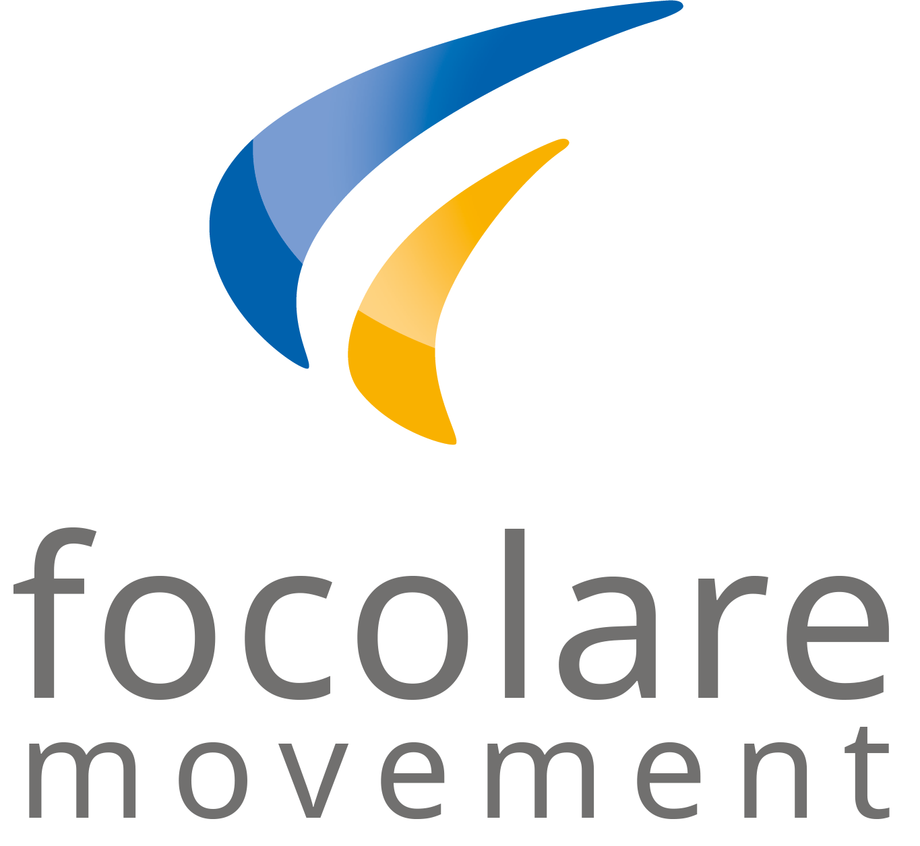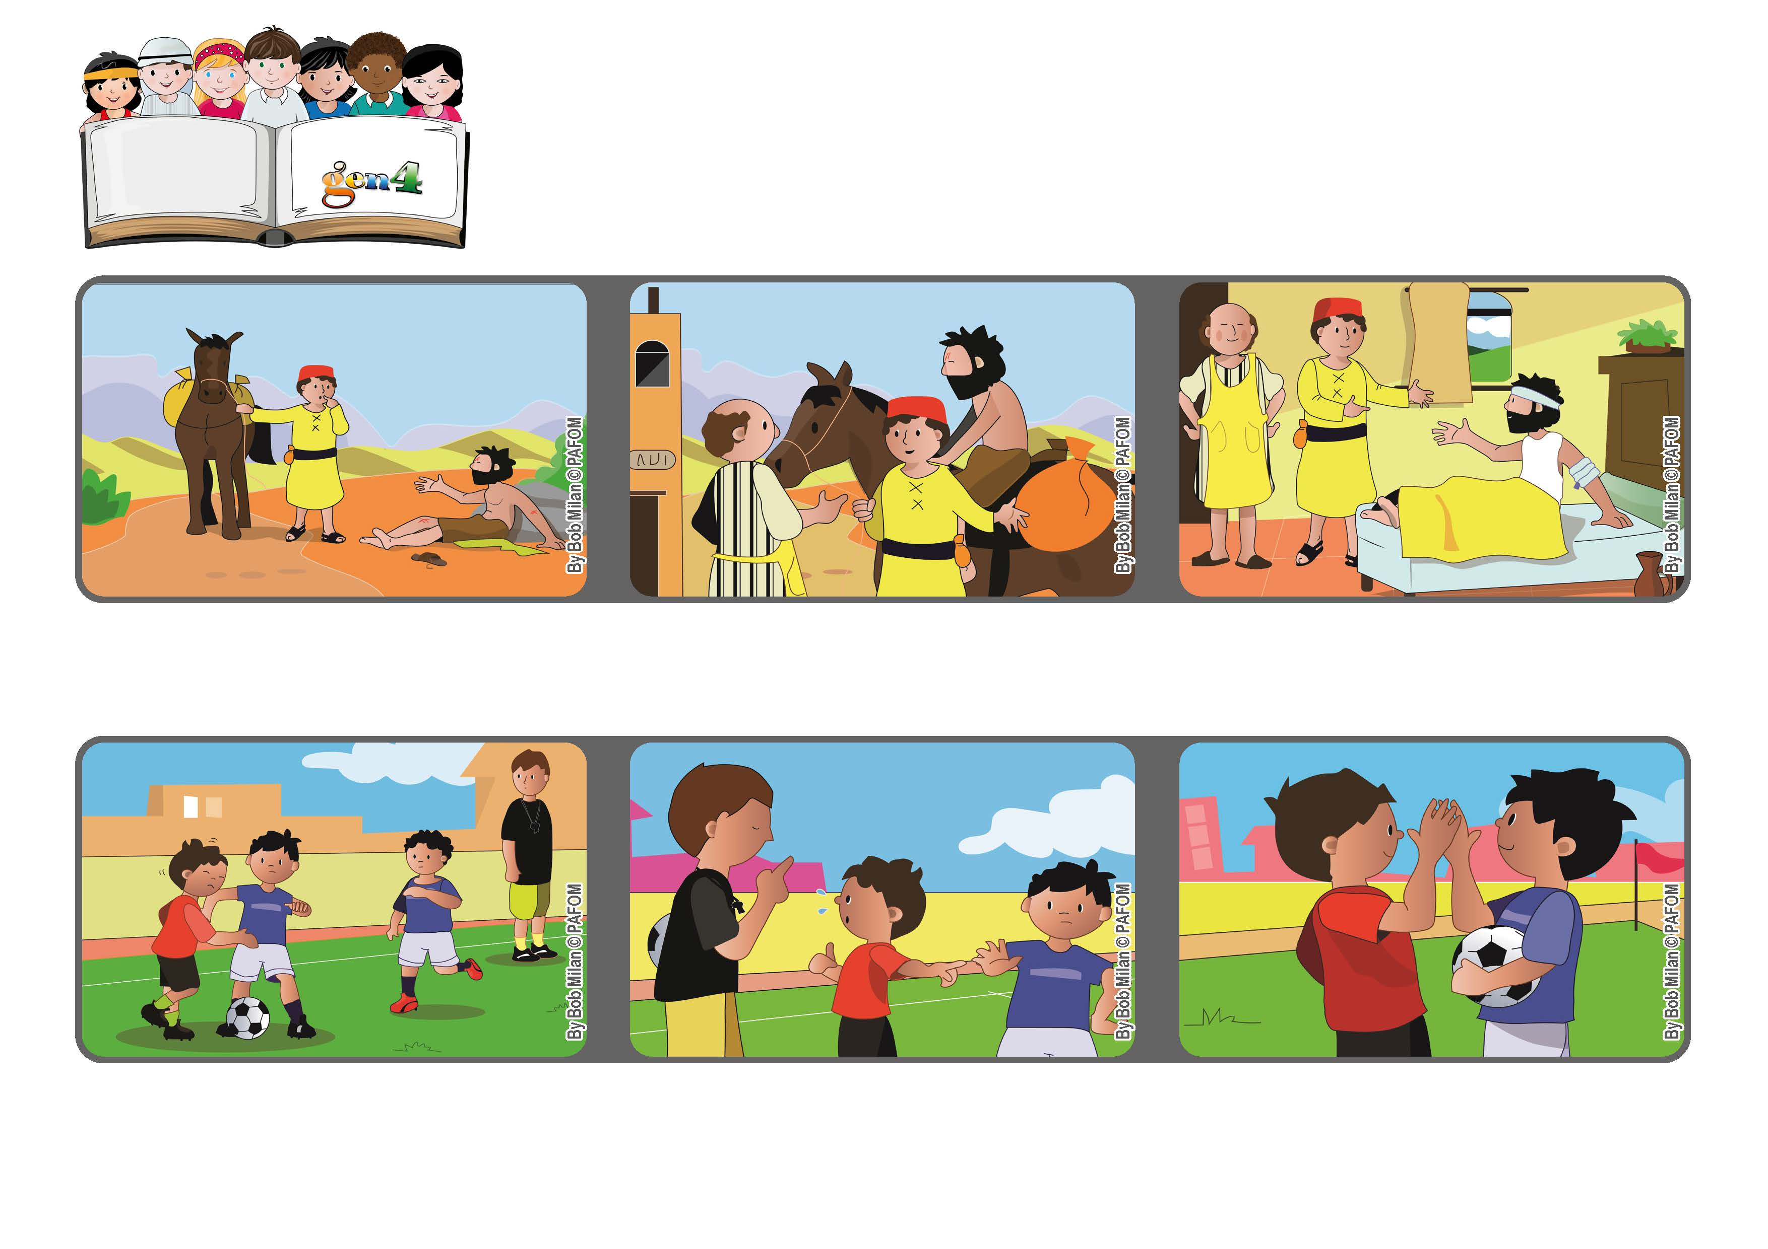
Word of Life
March 2021
“Make me know your ways, O Lord, teach me your paths.” (Ps 25:4)
Point your compass on love
Pope Francis wrote a very beautiful letter to remind us that we are all brothers and sisters and so it’s possible for us to love one another as Jesus taught us.
Robert from France: One day during a soccer game, my team was winning. The other team started to elbow me until I fell down and bruised my chest.
Helping someone in trouble or doing something for others, like the Good Samaritan, is always the best choice.
Sometimes we are undecided and don’t know what is the right thing to do.
I was crying and called for a foul, but it wasn’t accepted. I got very angry and decided that I would start to elbow the boy who made me fall down.
But then I thought about Jesus in him and I made a different decision. I forgave him. At the end of the game, we were still friends.
© PAFOM, Drawings and text provided by the Gen4 Center.
The Gen4 are the young children of the Focolare Movement, which was founded by Chiara Lubich.

