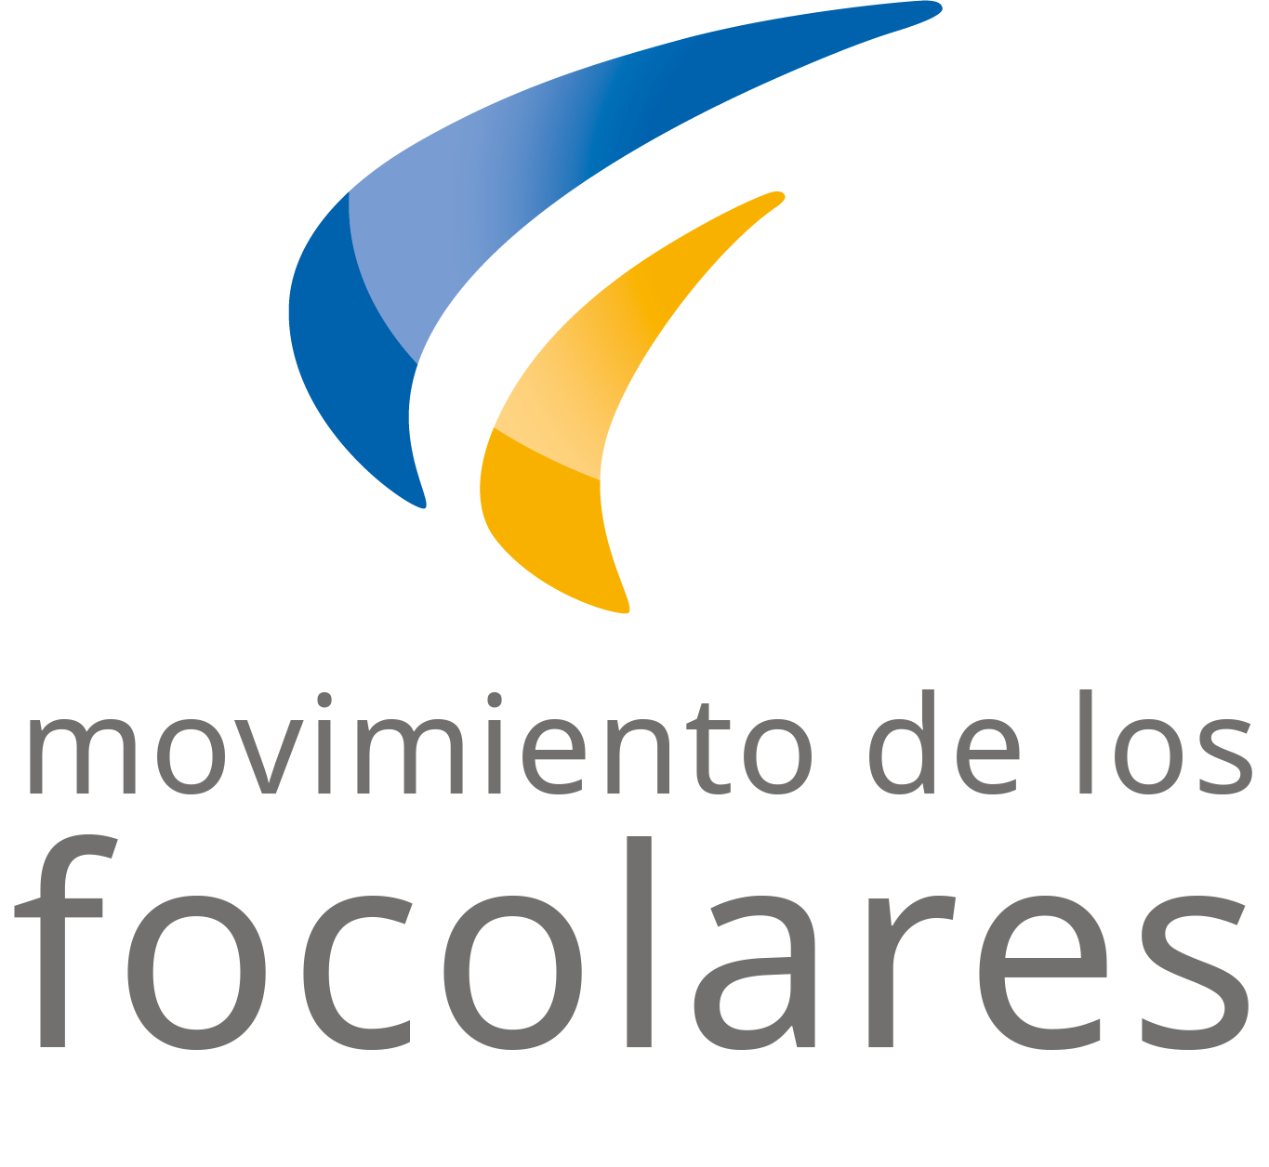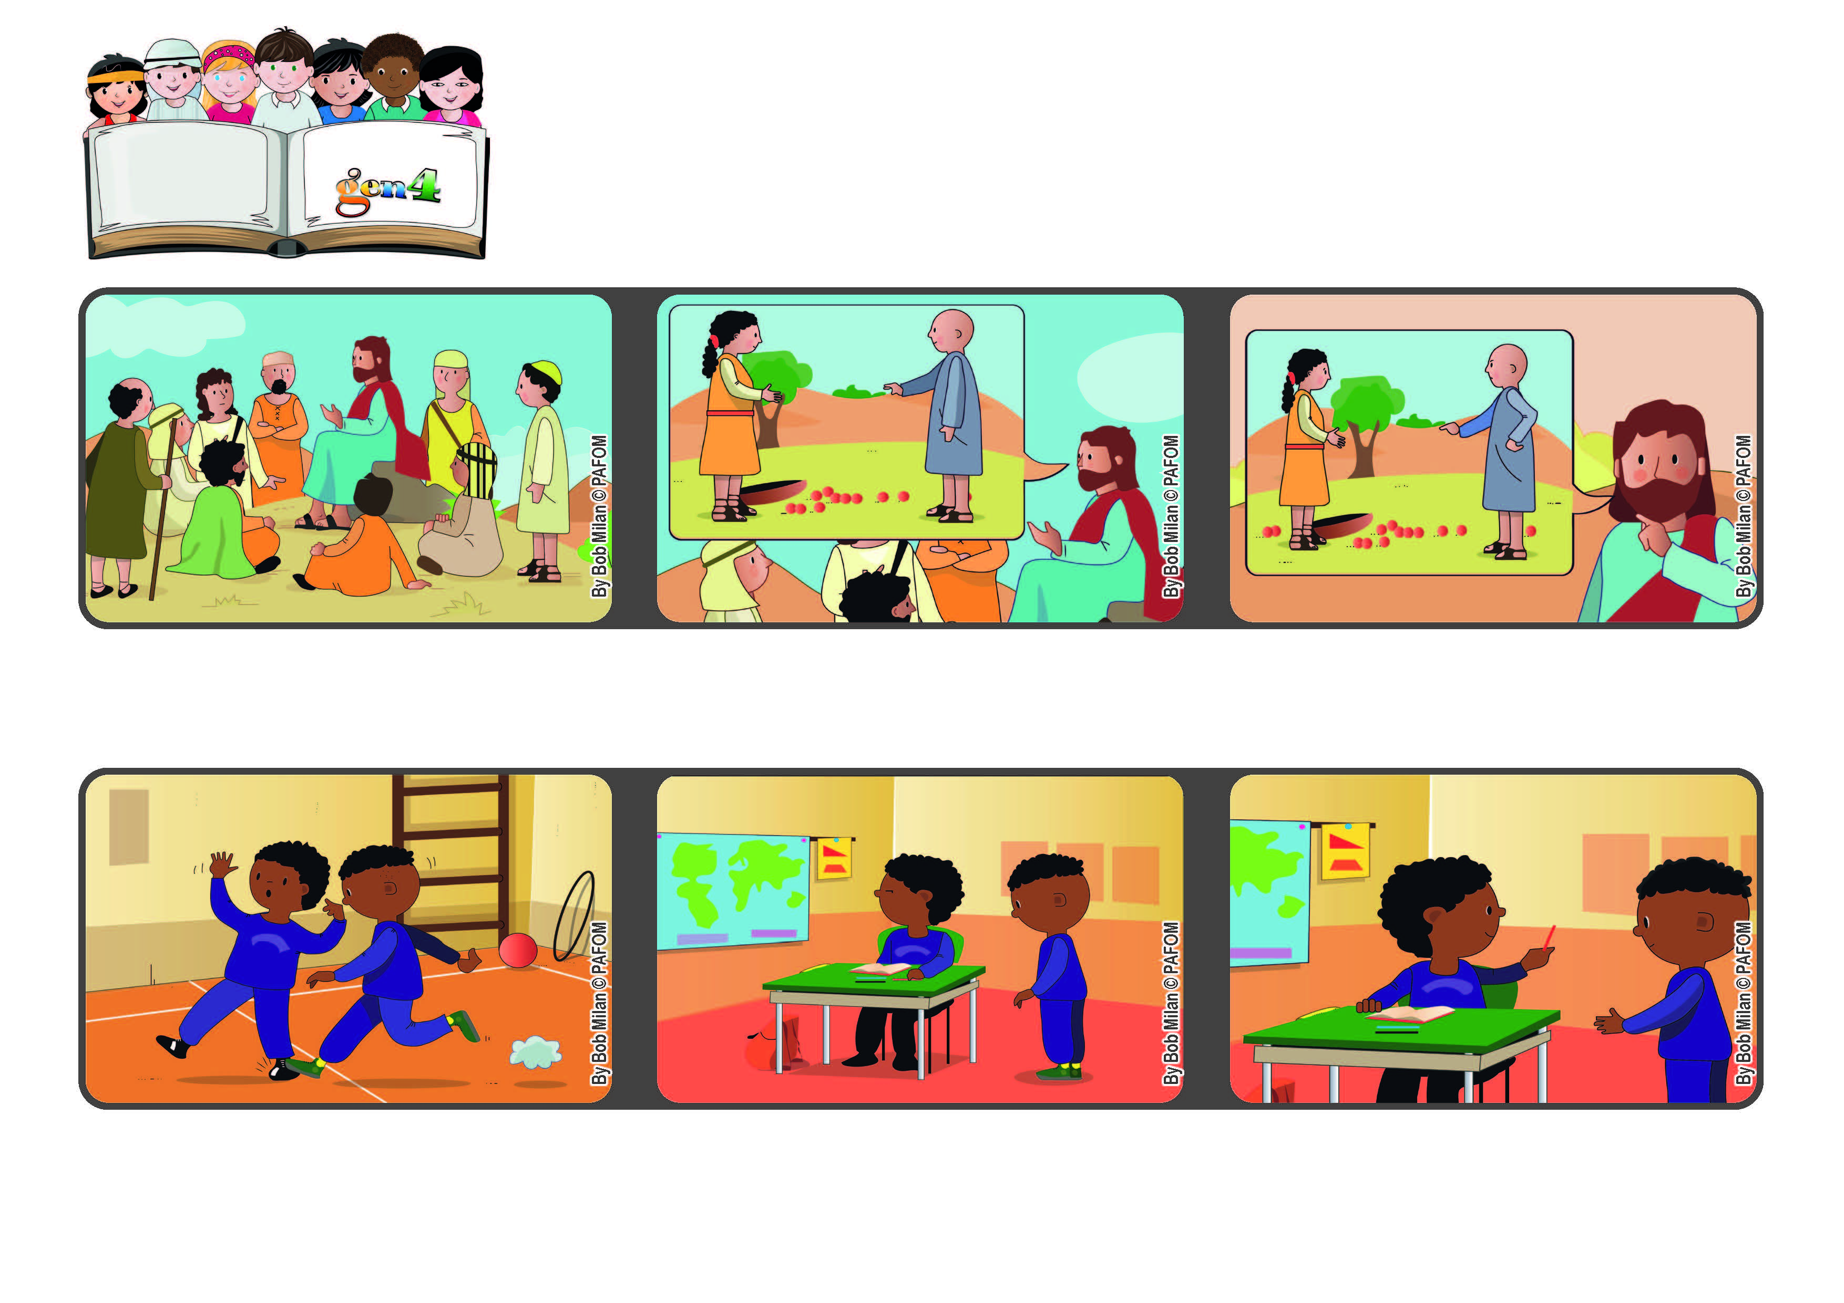
March 2022
Word of Life
“Forgive us our debts, as we also have forgiven our debtors” (Mt 6:12).
Let’s forgive others!
When we went back into the classroom, he asked me for a pencil, but I was still mad at him.
God always forgives everyone and so we should do the same.
In that prayer we ask God to forgive us for all the bad things we did and we promise to forgive anyone who hurt us.
Jesus went up on a hill and told the people that they should call God their Father. Then he taught them the “Our Father.”
Then I remembered that I should forgive him and so I gave him the pencil. Experience of Pierre from the Ivory Coast
One day in the gym one of my classmates hurt my foot and I got very mad at him.
© PAFOM, Drawings and text provided by the Gen4 Center.
The Gen4 are the young children of the Focolare Movement, which was founded by Chiara Lubich.

