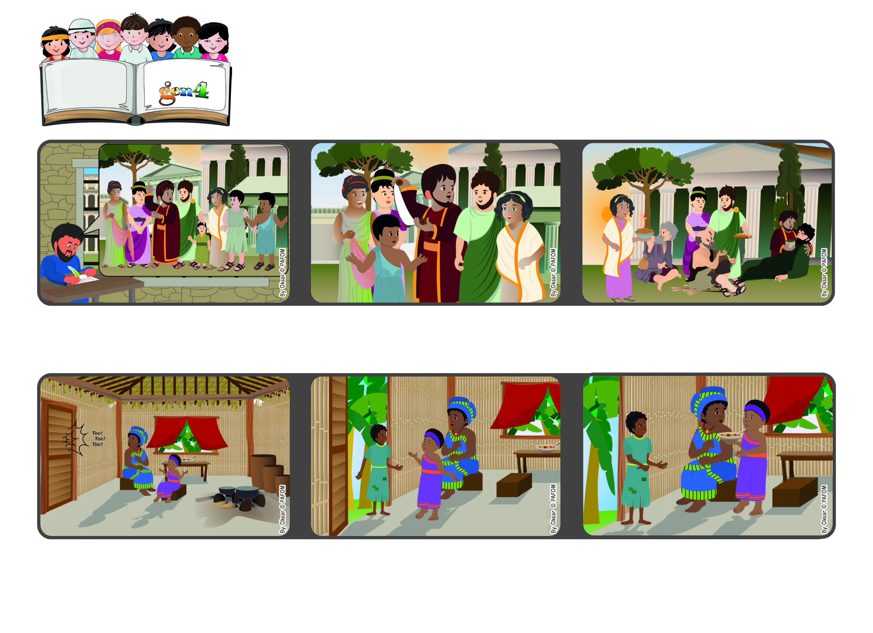

**March 2023**

**Word of Life**

**“Live as children of light, for the fruit of the light is found in all**

**that is good and right and true.” (Eph 5:8-9)**

**Let’s give God’s light to others**

**with our love**

**Paul reminds his friends in Ephesus that by living the words of Jesus, our heart is full of the light of love, like true children of God.**

**So he encourages them to be good, love everyone always and help anyone who is in need.**

**Lewa remembered that Jesus was in the heart of every person and so she asked her mom: “Can we give her the food we prepared for dinner?” That’s what they did and afterwards they were very happy.**

**Lewa went to answer it and she saw a very skinny girl who asked her for some food because she hadn’t eaten anything all day long.**

**The Apostle Paul was in prison in Rome. He wrote to the Christians in Ephesus, where he had lived and had spoken to many people about Jesus.**

**Experience of Lewa from the Ivory Coast. One afternoon Lewa was at home with her mom. They heard someone knocking on their door.**

**© PAFOM, Drawings and text provided by the Gen4 Center.**

**The Gen4 are the young children of the Focolare Movement, which was founded by Chiara Lubich.**