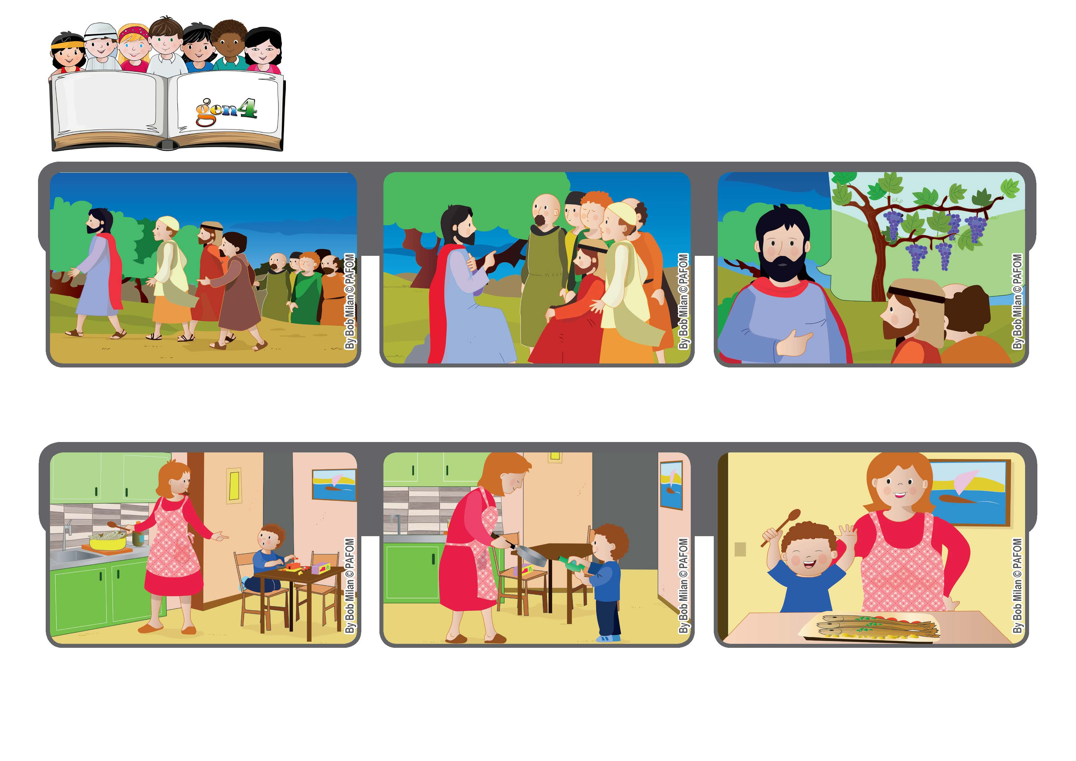
We are new buds
May 2020
Word of Life
“You have already been cleansed by the word that I have spoken to you.” (Jn 15:3)
One night my mom was very tired and she asked me to help her prepare the dinner. I didn’t want to.
If you remain in me, that is, if you listen to my words, I will live in you and you will bear much fruit. Those who don’t remain in me are like dried branches that are thrown away. (see Jn 15:1-7)
But then I remembered the Cube of Love. That morning when I rolled it, it came up “Make yourself one with others.” So I decided to help her.
We prepared trout cooked in whiskey because we didn’t have any cooking wine in the house. We really had a good time together.
After the Last Supper, Jesus started talking with the apostles. Judas Iscariot had already left them and he would soon betray Jesus.
It was a tragic moment. Jesus had some important things to tell them, words they would never forget. One was: “I am the vine and you are my branches.”
© PAFOM, Drawings and text provided by the Gen4 Center.
The Gen4 are the young children of the Focolare Movement, which was founded by Chiara Lubich.

