**We are new buds**

**May 2020**

**Word of Life**

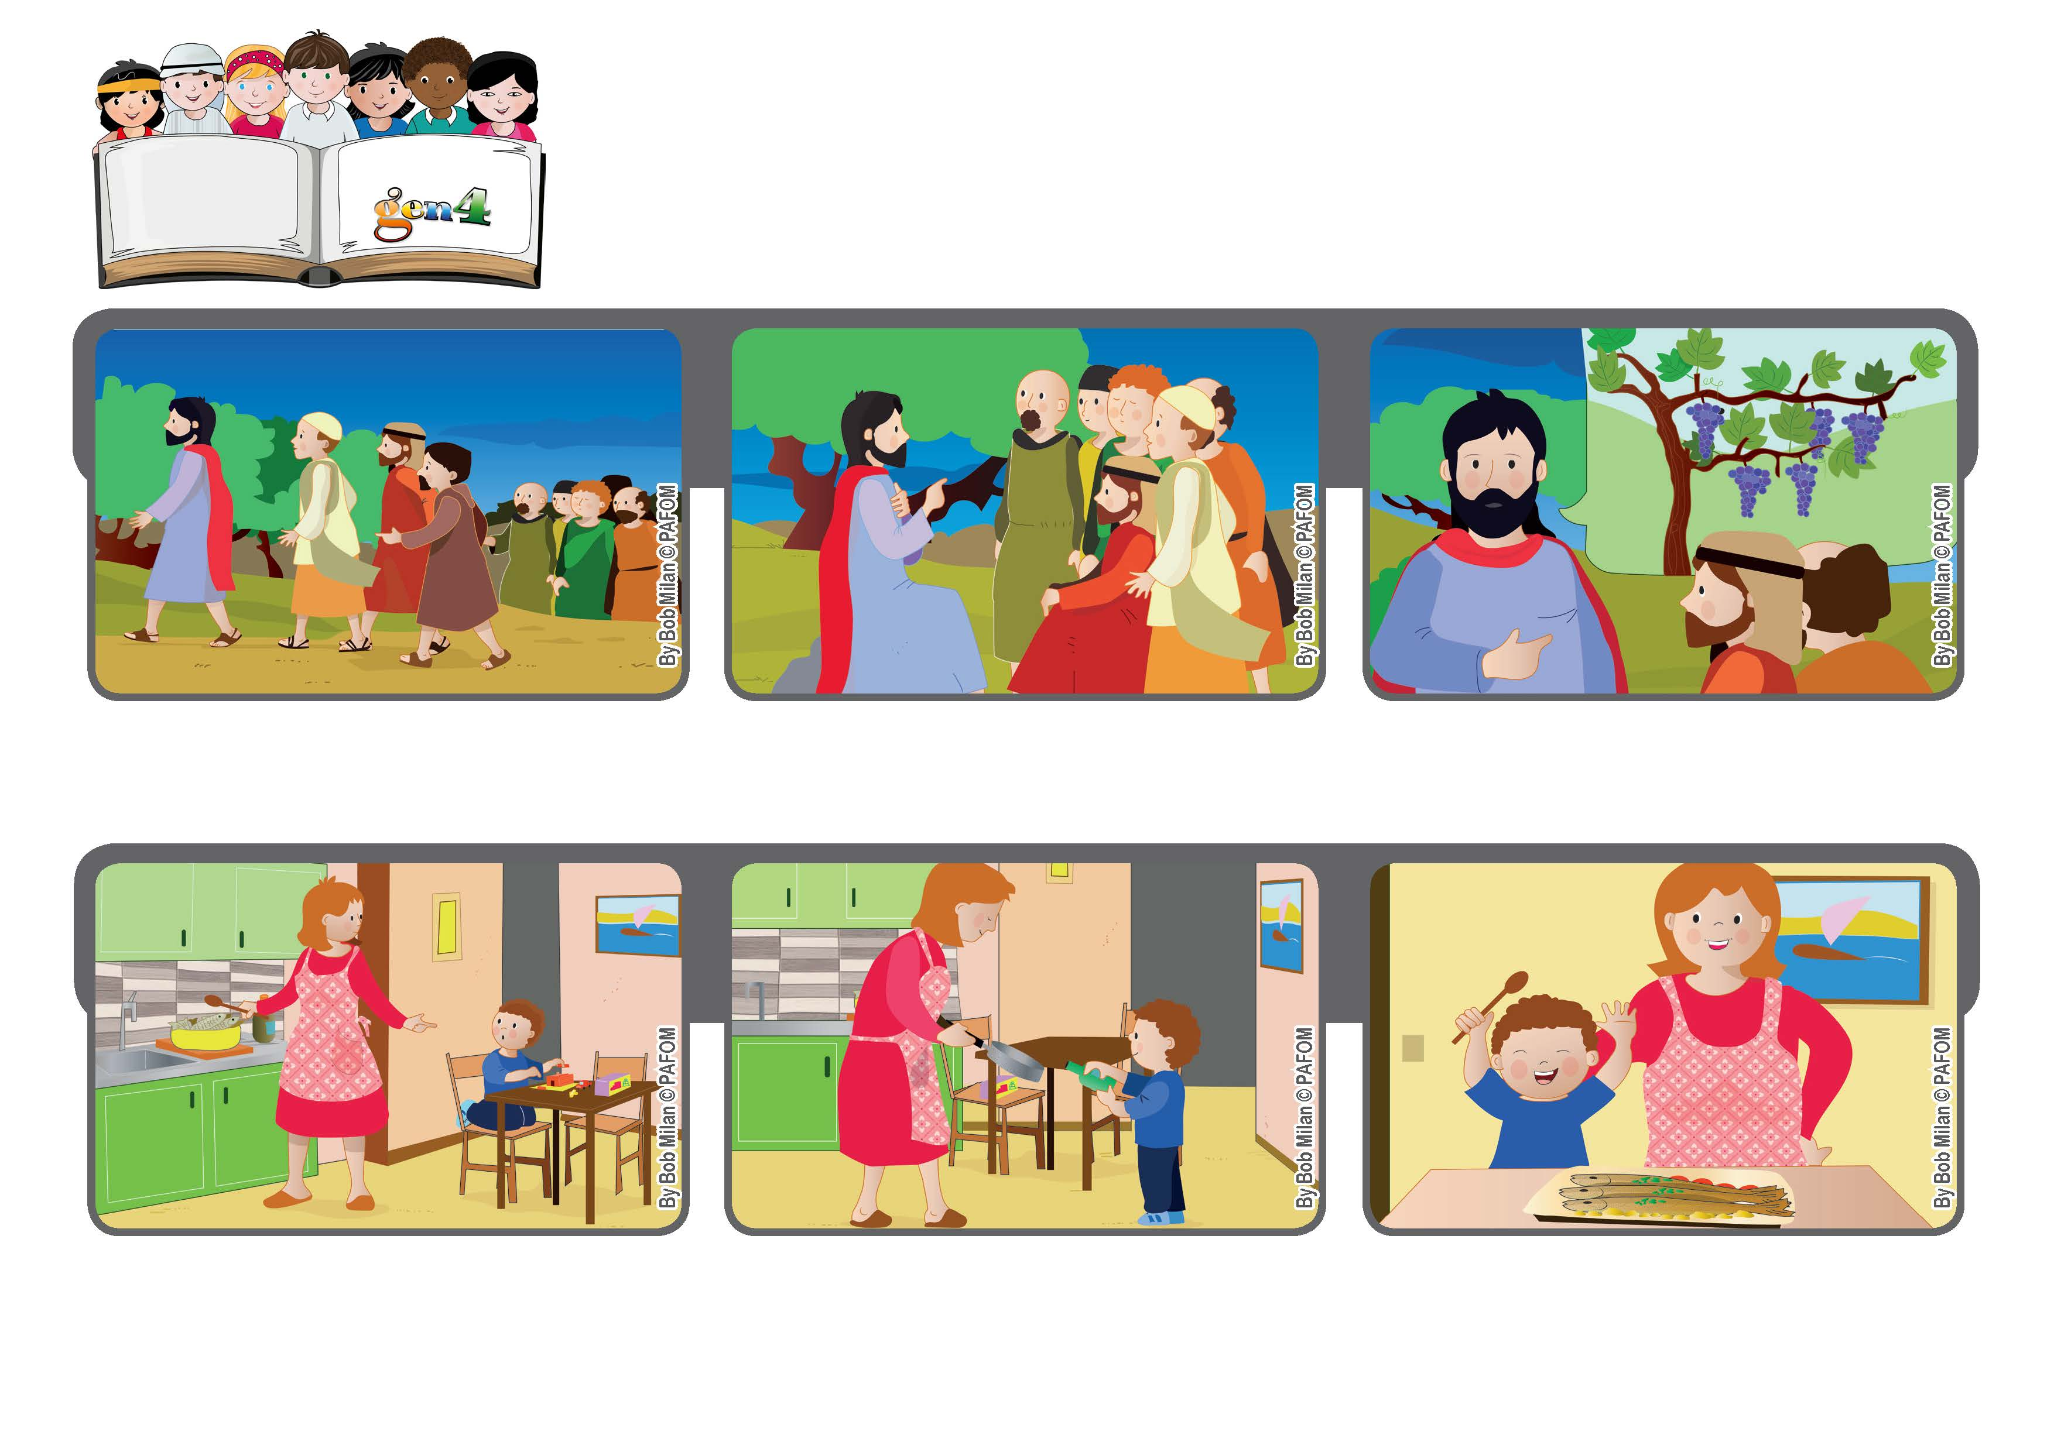

**“You have already been cleansed by the word that I have spoken to you.” (Jn 15:3)**

**One night my mom was very tired and she asked me to help her prepare the dinner. I didn’t want to.**

**If you remain in me, that is, if you listen to my words, I will live in you and you will bear much fruit. Those who don’t remain in me are like dried branches that are thrown away. (see Jn 15:1-7)**

**But then I remembered the Cube of Love. That morning when I rolled it, it came up “Make yourself one with others.” So I decided to help her.**

**We prepared trout cooked in whiskey because we didn’t have any cooking wine in the house. We really had a good time together.**

**After the Last Supper, Jesus started talking with the apostles. Judas Iscariot had already left them and he would soon betray Jesus.**

**It was a tragic moment. Jesus had some important things to tell them, words they would never forget. One was: “I am the vine and you are my branches.”**

**© PAFOM, Drawings and text provided by the Gen4 Center.**

**The Gen4 are the young children of the Focolare Movement, which was founded by Chiara Lubich.**