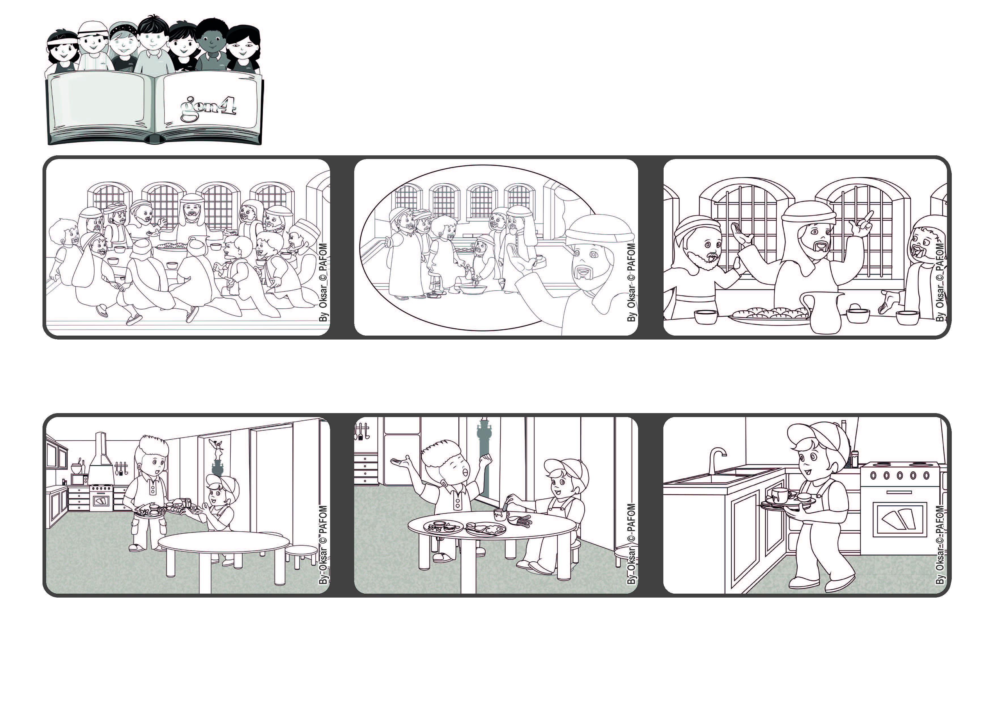

**Word of Life**

**May 2022**

**“I give you a new commandment, that you love one another” (Jn 13:34).**

**Let’s love one another**



**One day, my mother wasn’t home and my older brother fixed dinner for me.**

**After we ate, I saw that he was tired and wanted to rest.**

**So I ran to the kitchen and washed the dishes. Experience of Pablo from Mexico.**

**He told them: “Love one another.” This is the same kind of love that is found in heaven, where everyone loves one another.**

**Jesus explained why he had done that and then gave the disciples his last and most important commandment.**

**During the Last Supper, Jesus was at the table with his disciples. He had just washed their feet.**

**© PAFOM, Drawings and text provided by the Gen4 Center.**

**The Gen4 are the young children of the Focolare Movement, which was founded by Chiara Lubich.**