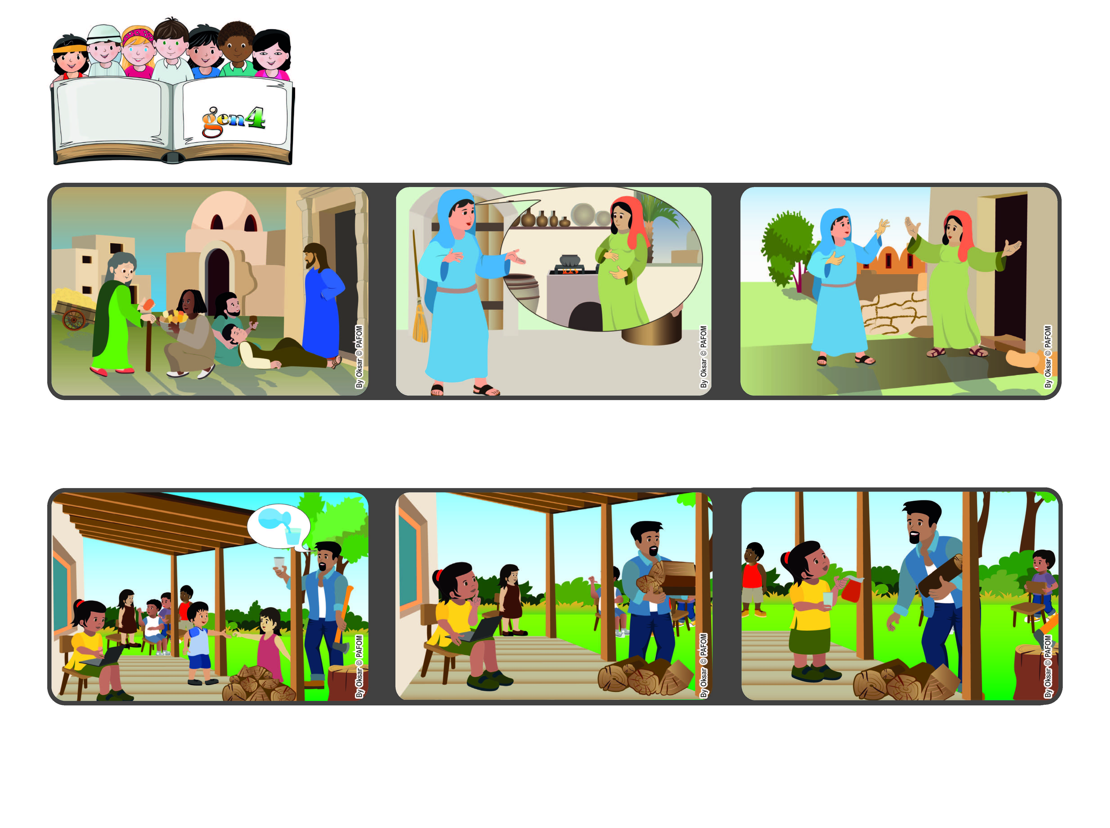

Word of Life
May 2023
Let’s compete in loving!
Love one another with mutual affection; outdo one another in showing honor.” (Rm 12:10)

(from the Mass of the Visit of Mary to Elizabeth, May
But then I thought that my Dad needed help because he couldn’t move at that moment. So I got up and I was really happy to bring him a glass of water.”
…who was also expecting a baby, even though she was already quite old. Mary immediately started off on a trip to visit her and help her. Mary taught us to be the first to love everyone!
In one of his letters to the first Christian communities, Saint Paul encouraged them to love one another and to compete to see who could love the most.
That’s what Mary, the mother of Jesus did. When she heard from the angel that she would have a child, she didn’t think of herself but remembered her cousin, Elizabeth….
None of us listened to him, because we were all busy doing other things. I was doing my homework and I didn’t feel like interrupting it, because I wanted to finish quickly so I could go out and play.
Beatriz from Brazil shared this experience: “In my family there are many children and my parents often ask us to help them. One afternoon my father asked someone to bring him a glass of water.
© PAFOM, Drawings and text provided by the Gen4 Center.
The Gen4 are the young children of the Focolare Movement, which was founded by Chiara Lubich.

