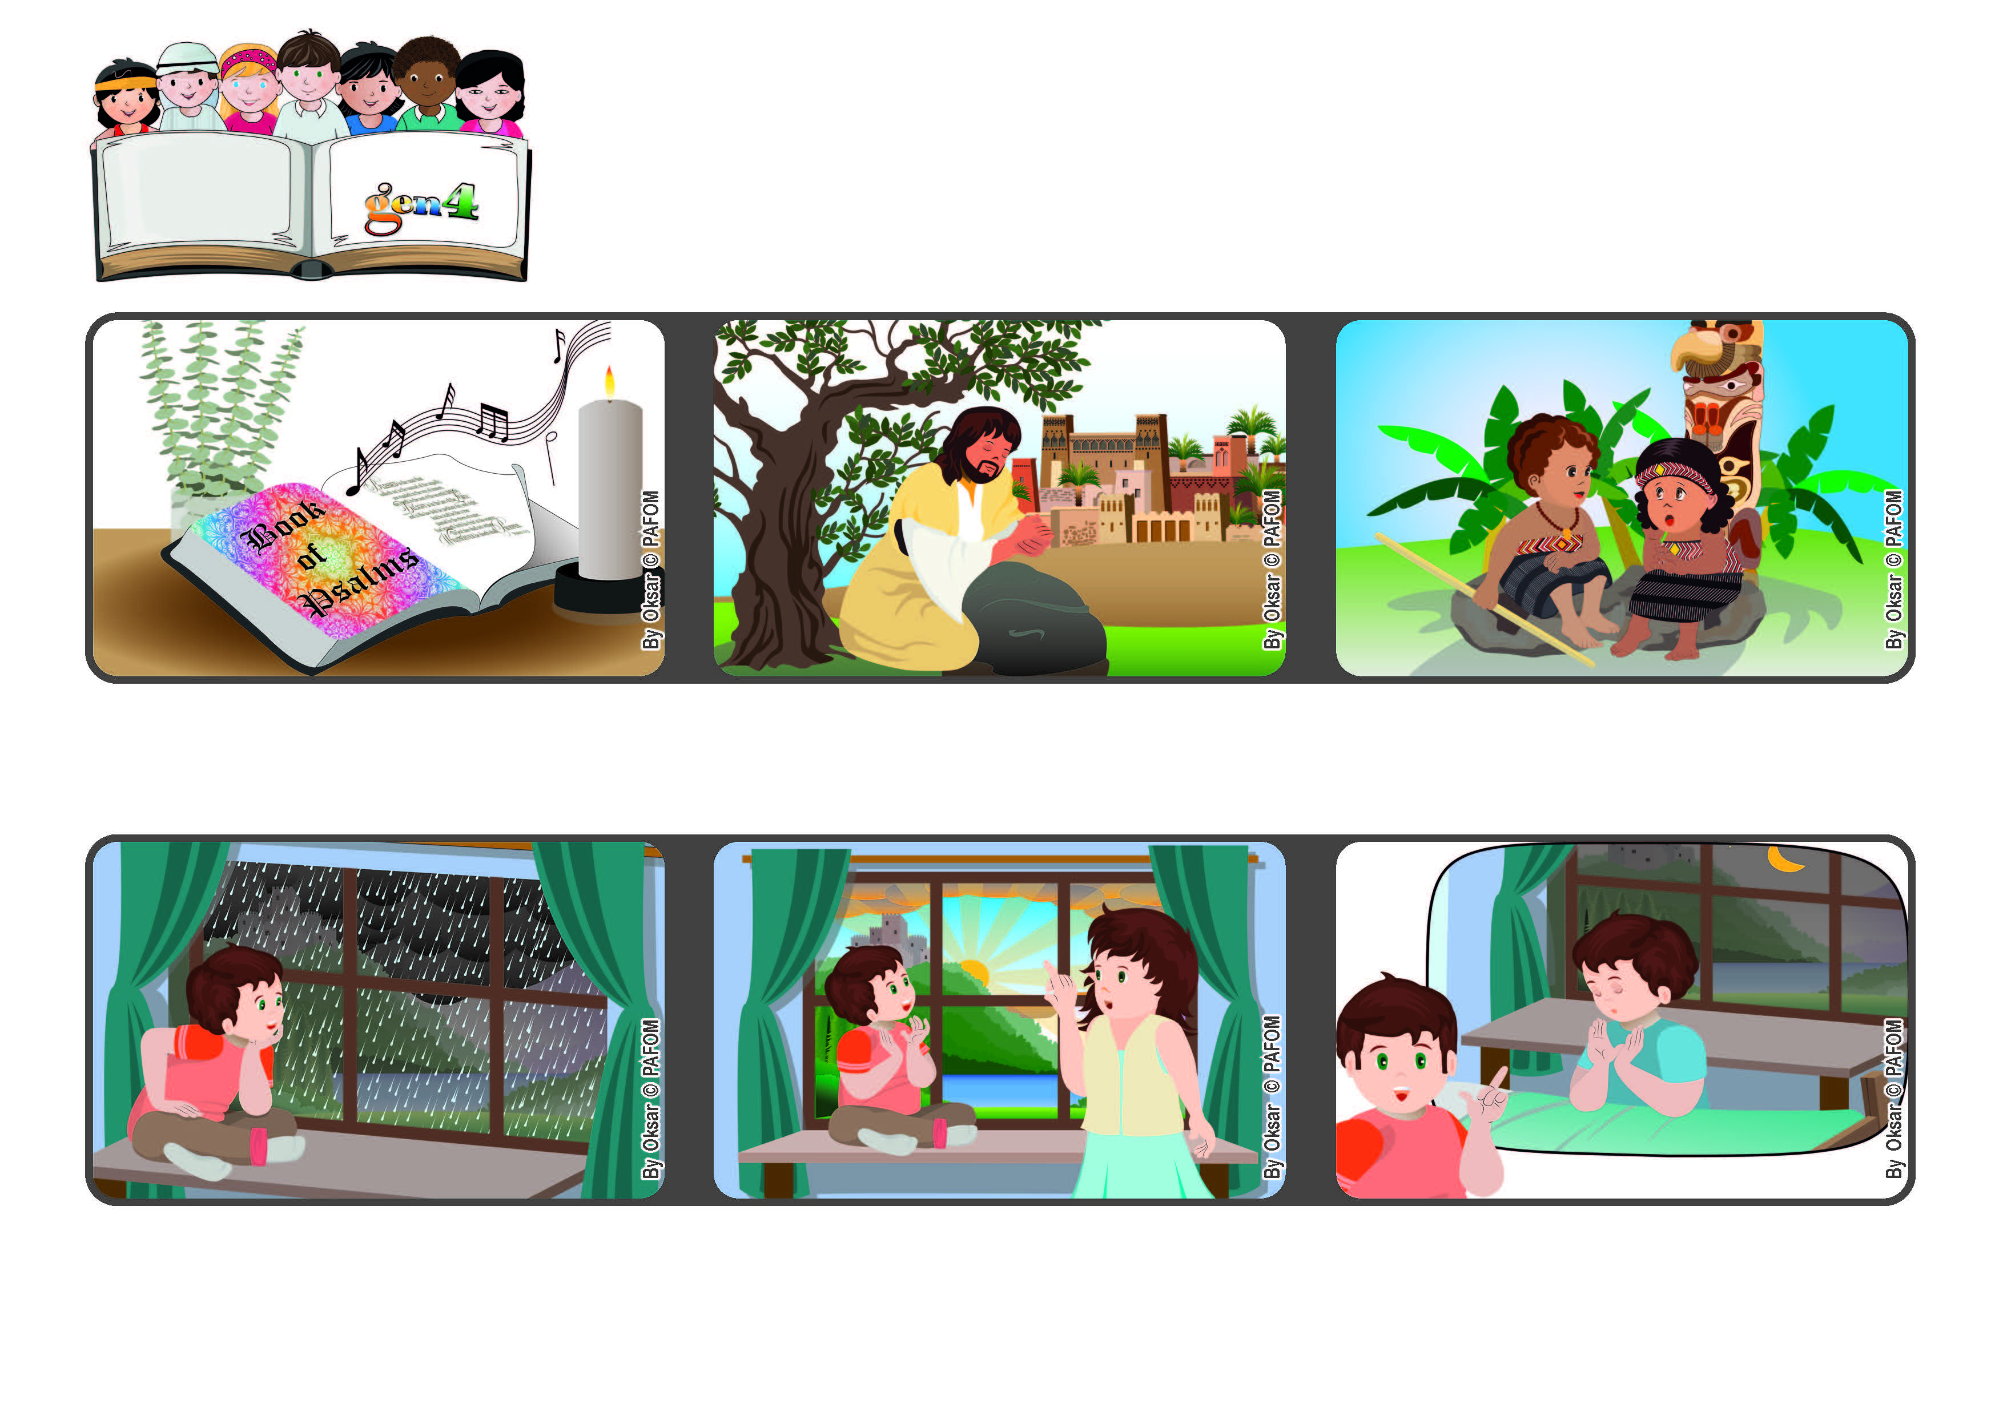



**June 2022**

**Word of Life**

**“You are my Lord; I have no good apart from you.” (Ps 16:2)**

**Jesus, what can I do for you today?**

**Do you think it’s because every night before I go to sleep I tell him that I love him very much? Francesco from Italy**

**After a few moments I called my mother and told her, “Look at the sun peeking out from behind the clouds! It’s really such a nice gift that Jesus is giving me!”**

**One day I was looking out the window and saw that it was raining a lot and there were lots of gray clouds.**

**When we love people around us, it helps us to experience God’s presence in our hearts and we feel like talking to him. God never leaves us alone.**

**Jesus also taught us how to pray, telling us that God is a kind Father who loves everyone.**

**In the book of Psalms in the Bible, there are some beautiful prayers. One of them says: “You are my Lord; I have no good apart from you.”**

**© PAFOM, Drawings and text provided by the Gen4 Center.**

**The Gen4 are the young children of the Focolare Movement, which was founded by Chiara Lubich.**