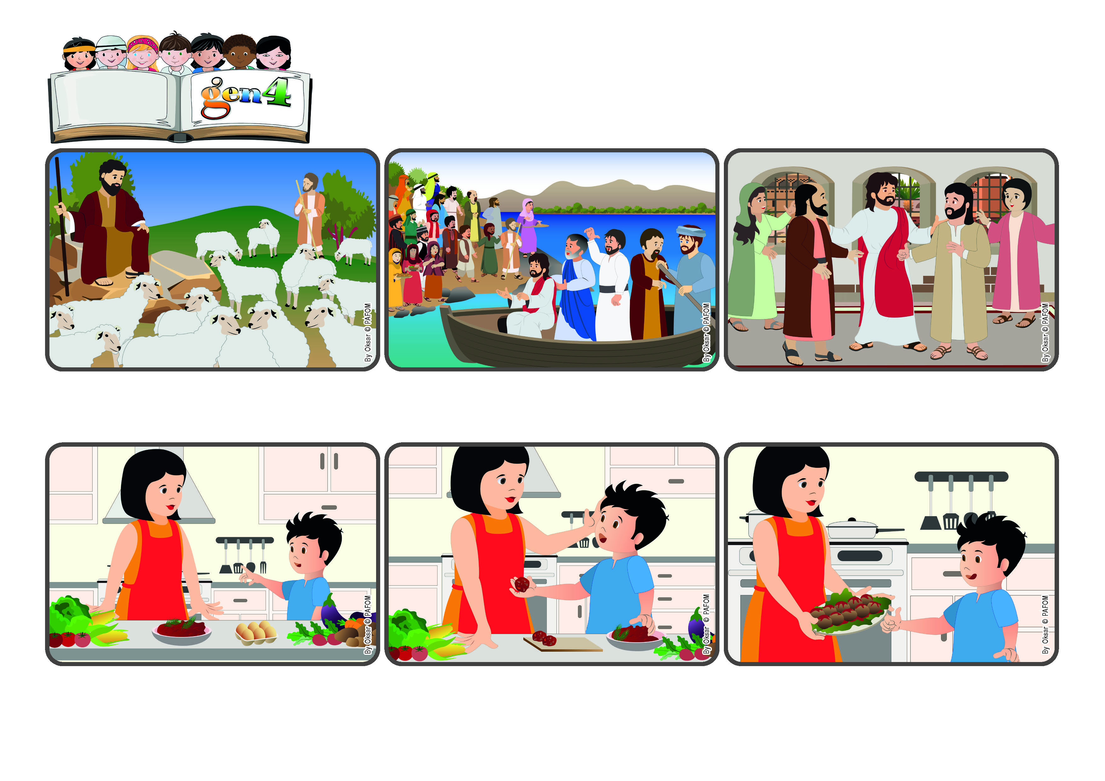

**“The Lord is my shepherd, I shall not want” (Ps 23:1).**

(from the liturgy of July 21, 16th Sunday of Ordinary Time)

**Let’s take care of the people around us**

**Word**

**of Life**

**During our vacation, my mom still had to cook for us. I saw she was a little tired, so I asked if I could help her. She said yes, that I could help her make the meatballs.**

**I started right away, following her directions. I mixed together the eggs and meat and all the spices together and then I made the meatballs. My mom cooked them and that evening we had a really good meal.**

**My mom was very happy and she didn’t even seem tired anymore. After that I made meatballs with her other times so she wouldn’t be tired, and also because she doesn’t like to mix the ingredients with her hands! (Damion from Holland)**

**Jesus is always near to each one of us and takes care of us. He knows us and calls us by name. He doesn’t want any of us to feel alone or get lost. He loves us and helps us to take care of those who are near us.**

**There are many sheep to look after, but they are peaceful and are eating the grass. The shepherd sits on a rock close by. He guards them and watches carefully so that no wolves come to attack them. He loves his sheep and takes good care of them.**

**This is how Jesus acts with his friends. One day he saw that they were tired and so he invited them to go by boat to a peaceful spot. But when they got there, there was a crowd of people waiting for Jesus. So Jesus took care of them, too, teaching them many things.**

**© PAFOM, Drawings and text provided by the Gen4 Center.**

**The Gen4 are the young children of the Focolare Movement, which was founded by Chiara Lubich.**