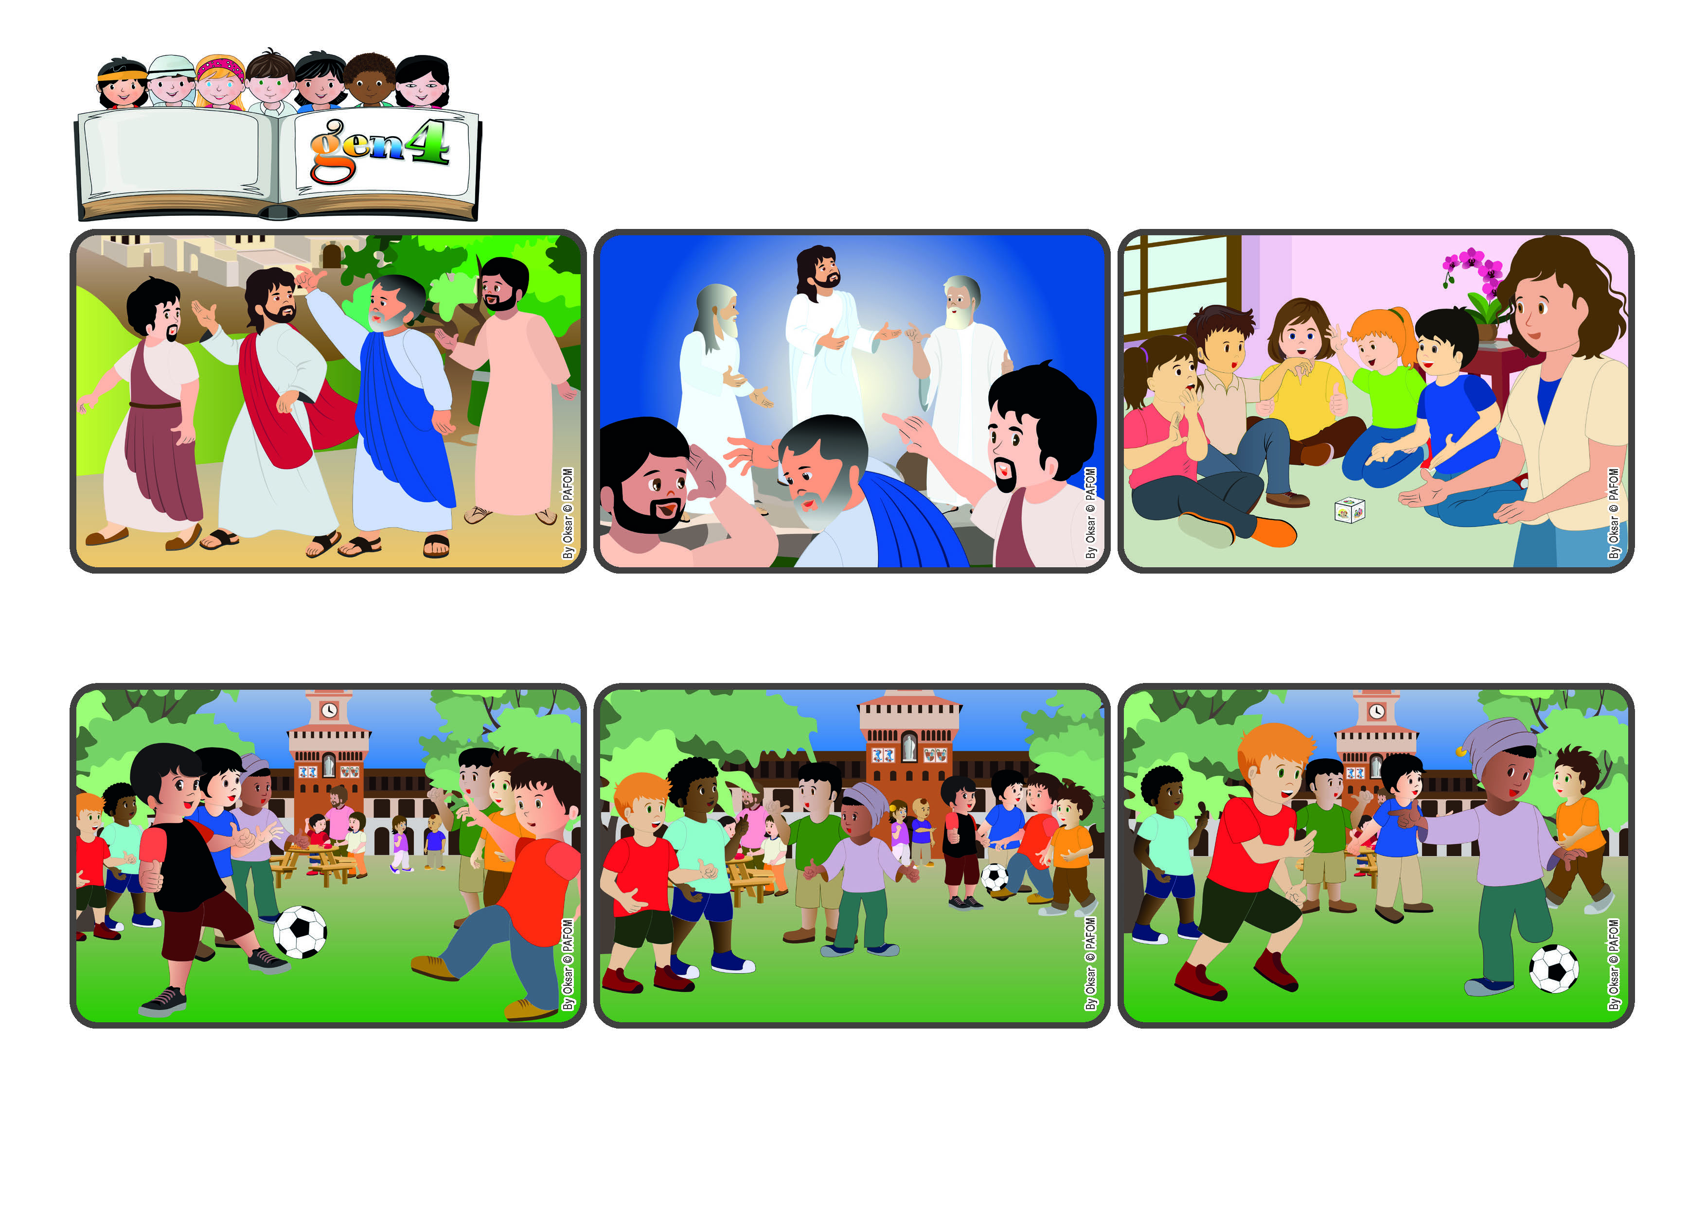

**It’s so beautiful to be with Jesus!**

**“Lord, it is good for us to be here!” (Mt 17:4)**

(From the liturgy of August 6, the feast of the Transfiguration.)

**Word**

**of Life**

**They were a little shy but gradually they joined them, attracted by the way the Gen 4 played with love. Giulio saw them and passed them the ball. Then they started playing happily and didn’t want to stop! At the end, they asked: “Can we come back again tomorrow to play?”**

**But two children were standing on the side by themselves. The Gen 4 stopped playing and asked one another: “Why don’t we go over and ask them to play?” They all agreed. Giulio and Filippo went over and asked: “Do you want to play with us?”**

**The Gen 4 of Milan were having their meeting. Even when they were playing, they tried to help one another so that Jesus would always be present with them. It was a very nice day and many other children were playing in groups outside, too.**

**Jesus often told his apostles about the kingdom of his Father, which is where he came from. But it wasn’t easy for them to understand exactly what it was like. So one day Jesus took Peter, James and John with him and went up on a mountain.**

**This is what happens to us when we really love one another and feel that Jesus is present among us. We want to stay there forever! With our love we can carry this light to many other people, so that the kingdom of God will shine out in the whole world!**

**What happened there? The face of Jesus became as bright as the sun and his clothes were shining like a light. Moses and Elijah appeared and were talking with him. Peter cried out: “Lord it is good for us to be here! I will build three tents for you!”**

**© PAFOM, Drawings and text provided by the Gen4 Center.**

**The Gen4 are the young children of the Focolare Movement, which was founded by Chiara Lubich.**

**Mariapolis is a meeting of several days when people live the Gospel together and put into practice the new commanement: “Love one another.”**