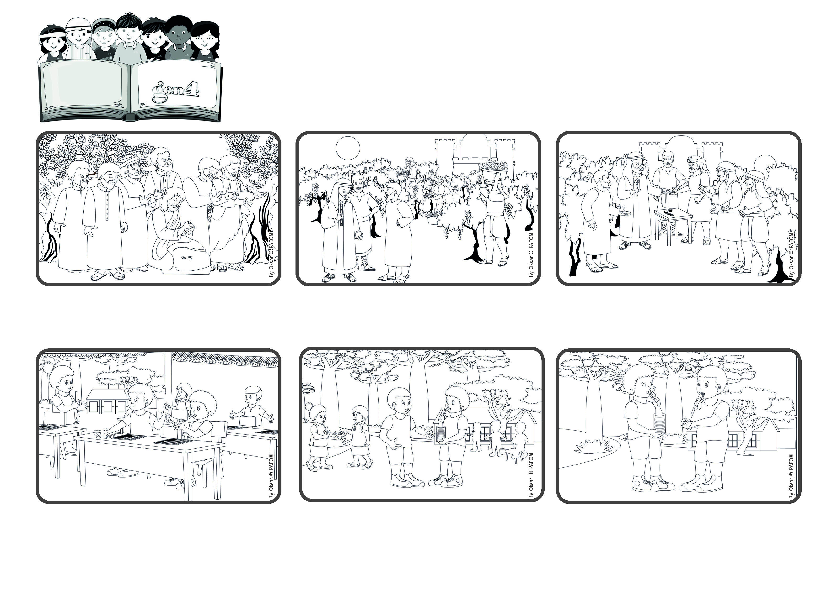

**Let’s thank God every day for helping**

**us to love everyone.**

**“Every day I will bless you, and praise your name for ever and ever” (Ps 145:2).**

(From the Liturgy of the Mass on the 25th Sunday of Ordinary Time)

**September 2023**

**Word of Life**



**In my heart I said ”No!” and just kept on eating it. But he stood there waiting. Then I remembered that I wanted to act like Jesus who loves everyone, even those who don’t know how to love yet, and so I gave him a nice, big piece! From that day on, he started to share his things with me.**

**Maurice from Madagascar tells his experience: At school I like to share whatever I have with my classmates. Instead Felipe is very selfish and won’t give anything to anyone. One day I was writing on my chalk board and realized that my chalk was almost used up.**

**I asked Felipe if I could have one of his many pieces of chalk but he wouldn’t give me one. I was really angry at him. The next day during recess I bought a nice snack with the money my mother had given me. Felipe came over to me and asked for a piece of it.**

So when the work finished for the day, each one of them received a silver coin for their work. Those who had worked all day long complained about this to the owner, but he answered: “Why are you jealous? I paid you exactly what I promised. Can’t I give the same to those who came last?” This tells us how much God loves all his children!

One day Jesus told a story about the owner of a vineyard. All day long he kept hiring men to work for him. Some worked from early in the morning, some only in the afternoon and some came only a few hours before the end of the day, but the owner promised them all the same pay.

In the Bible there are many prayers to praise God. The People of Israel had many reasons to thank God since he had helped them in many difficult moments. Then when Jesus came on earth, he showed us even more how much God loves us.

**© PAFOM, Drawings and text provided by the Gen4 Center.**

**The Gen4 are the young children of the Focolare Movement, which was founded by Chiara Lubich.**