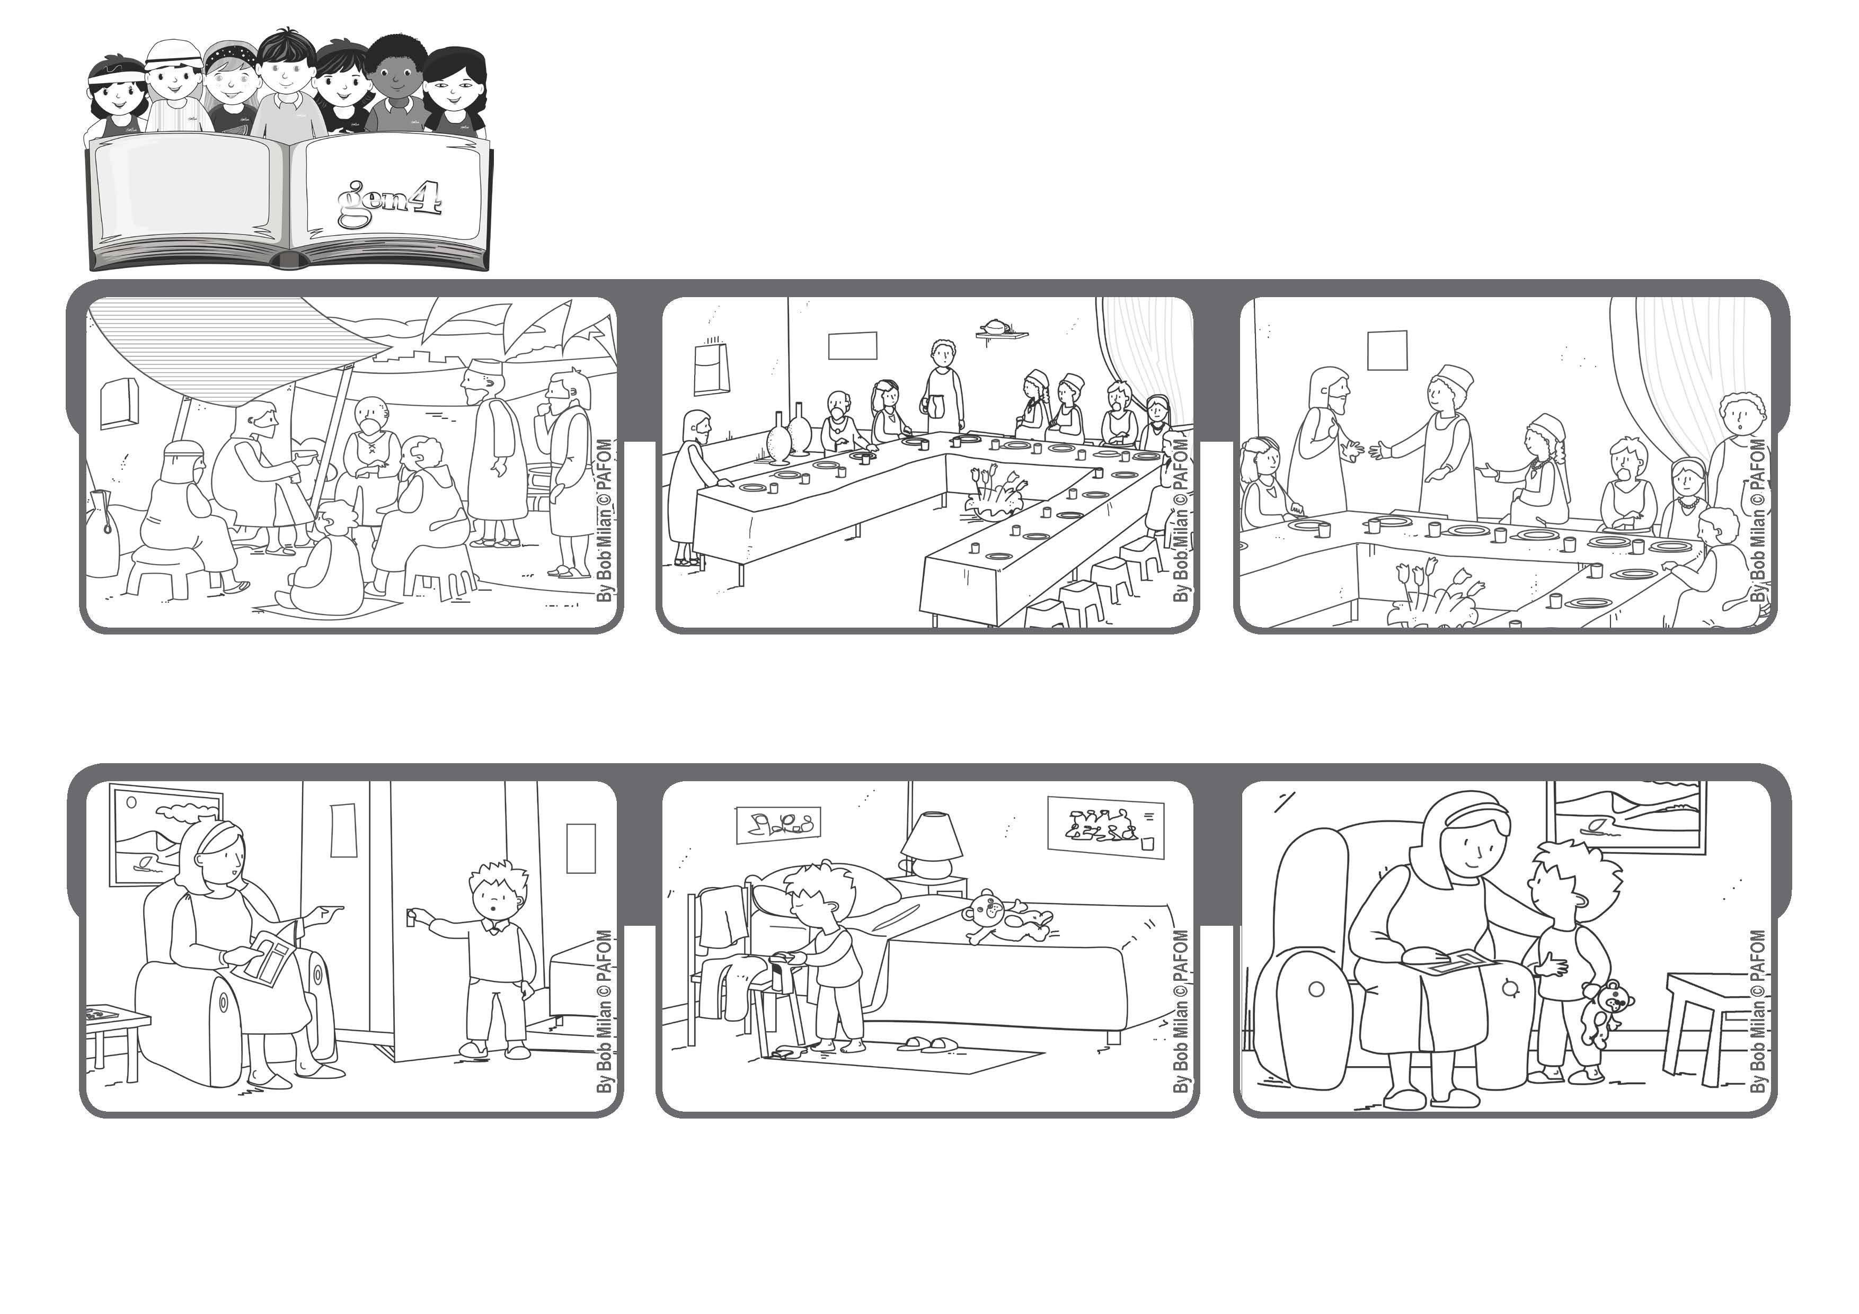
October 2020
“For all who exalt themselves will be humbled, and those who humble themselves will be exalted” (Lk 14:11).
Be like Jesus
Word of Life
Anthony accepted and went to get ready for bed by himself.
He said that if you are invited to a wedding feast, don’t take the best seat, but rather go to the back of the room.
Even though he was God, Jesus chose to be the servant of everyone. He asks his followers to be humble and he gives them an example.
When the person who invited you arrives and sees you sitting in back, he will say, “My friend, come up here in front” and you will be very happy.
(read Luke 14:8-10)
The experience of Antonio from Italy: One evening Antonio asked his mother to help him put on his pygamas, but his mom was tired and told him to do it by himself.
Then he went back to give his mom a kiss and told her: “Mommy, offer your tiredness to Jesus. I didn’t want to do my homework either, but then I thought about it and decided to do it.”
© PAFOM, Drawings and text provided by the Gen4 Center.
The Gen4 are the young children of the Focolare Movement, which was founded by Chiara Lubich.

