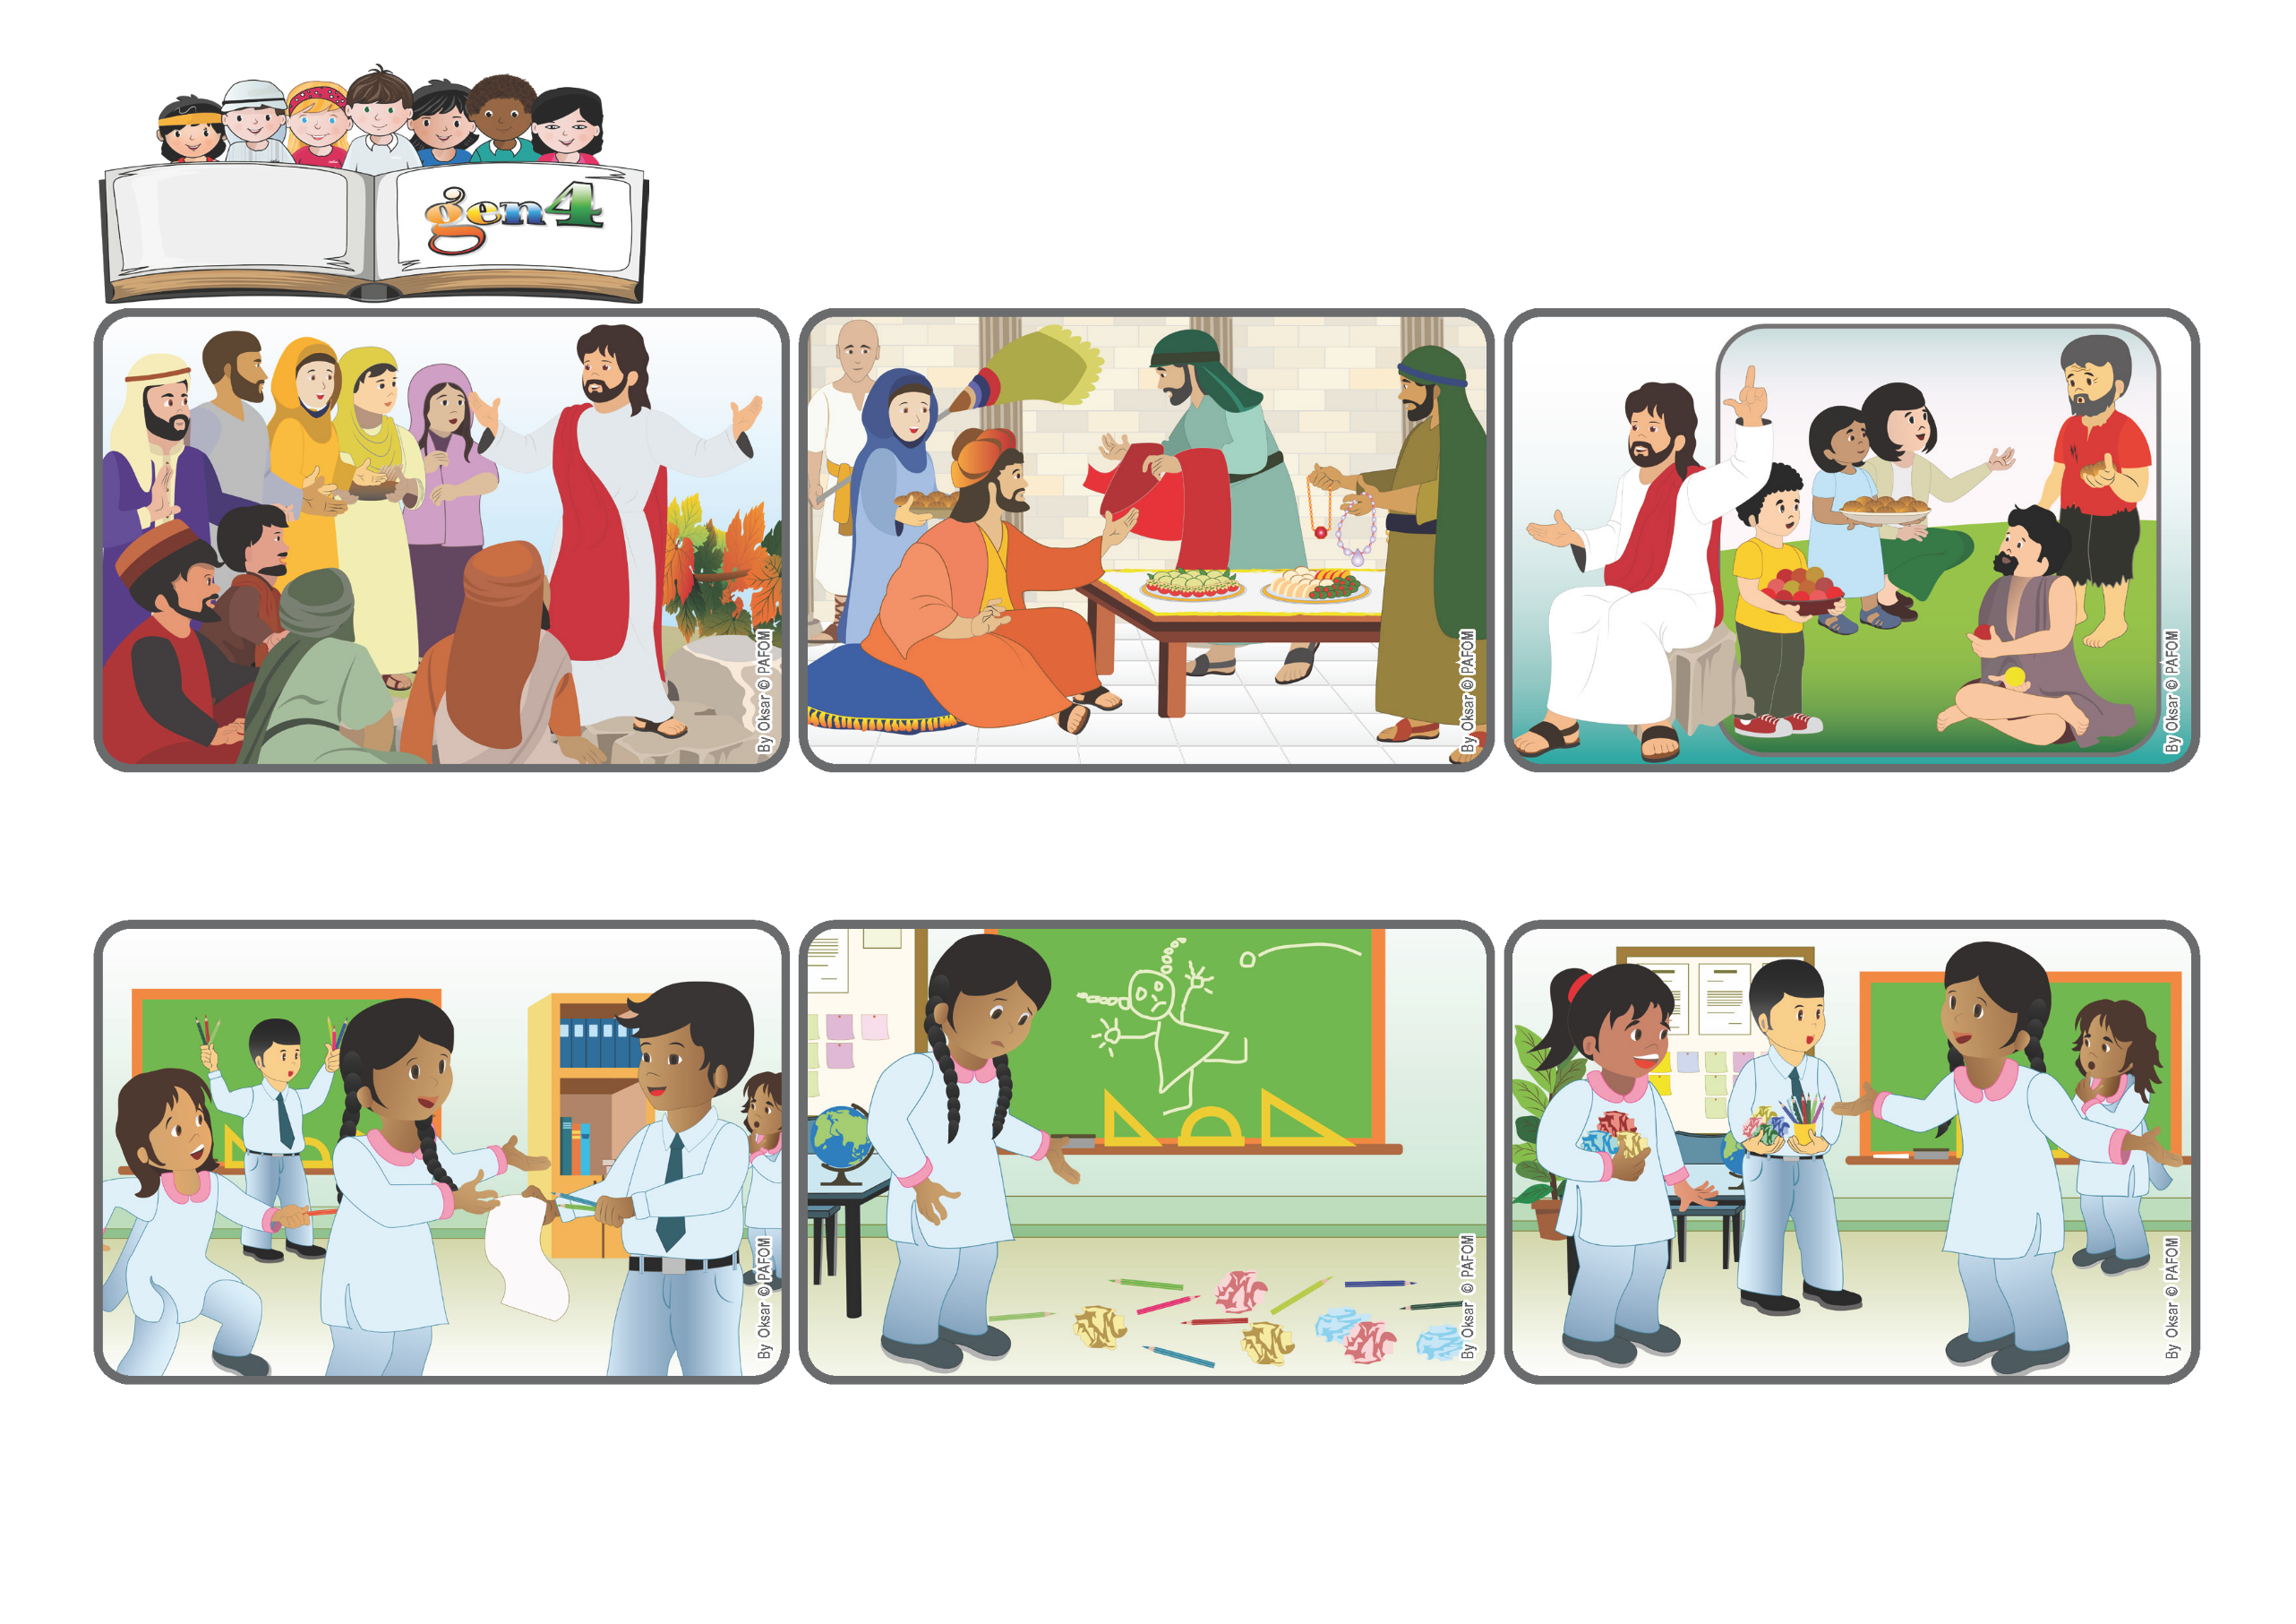

**Let’s work for peace**

**«Blessed are the peacemakers, for they will be called children of God » (Mt 5:9).**

**Word**

**of Life**

(From the liturgy of Saturday, November 1, All Saints Day)

**Samina from Pakistan said: “One day at school, we had a drawing lesson towards the end of the morning. We were all a little tired and some children started playing with paper and pencils instead of paying attention to the lesson.**

**Right away the classroom got messy with lots of paper and pencils on the floor. I felt bad about that. The teacher had left the room for a moment, but she was coming back. I tried to stop the other children, telling them to quit fooling around!**

**But they all started fighting with me instead! I was very sad but I tried to love each one of them. Little by little peace returned and they said they were sorry. We all felt happy again. It was so nice to go back to being friends again!**

**That’s what he was telling them! He said that those who are really happy are the ones who are meek, with pure hearts, who want to do what is right, who help others when they have problems and always try to bring peace. These are the ones who will be called “children of God!”**

**There was a big crowd following Jesus and so he had to go up on a hill so that they could hear him better. He wanted to tell them some things that were very important, but difficult to understand because exactly the opposite of what most people think.**

**Even back then, many people thought that to be happy you had to have many things, think only of yourself, boss others around, and so on. Rich people usually didn’t help poor people. Instead, according to Jesus, who are the happiest people?**

**© PAFOM, Drawings and text provided by the Gen4 Center.**

**The Gen4 are the young children of the Focolare Movement, which was founded by Chiara Lubich.**