****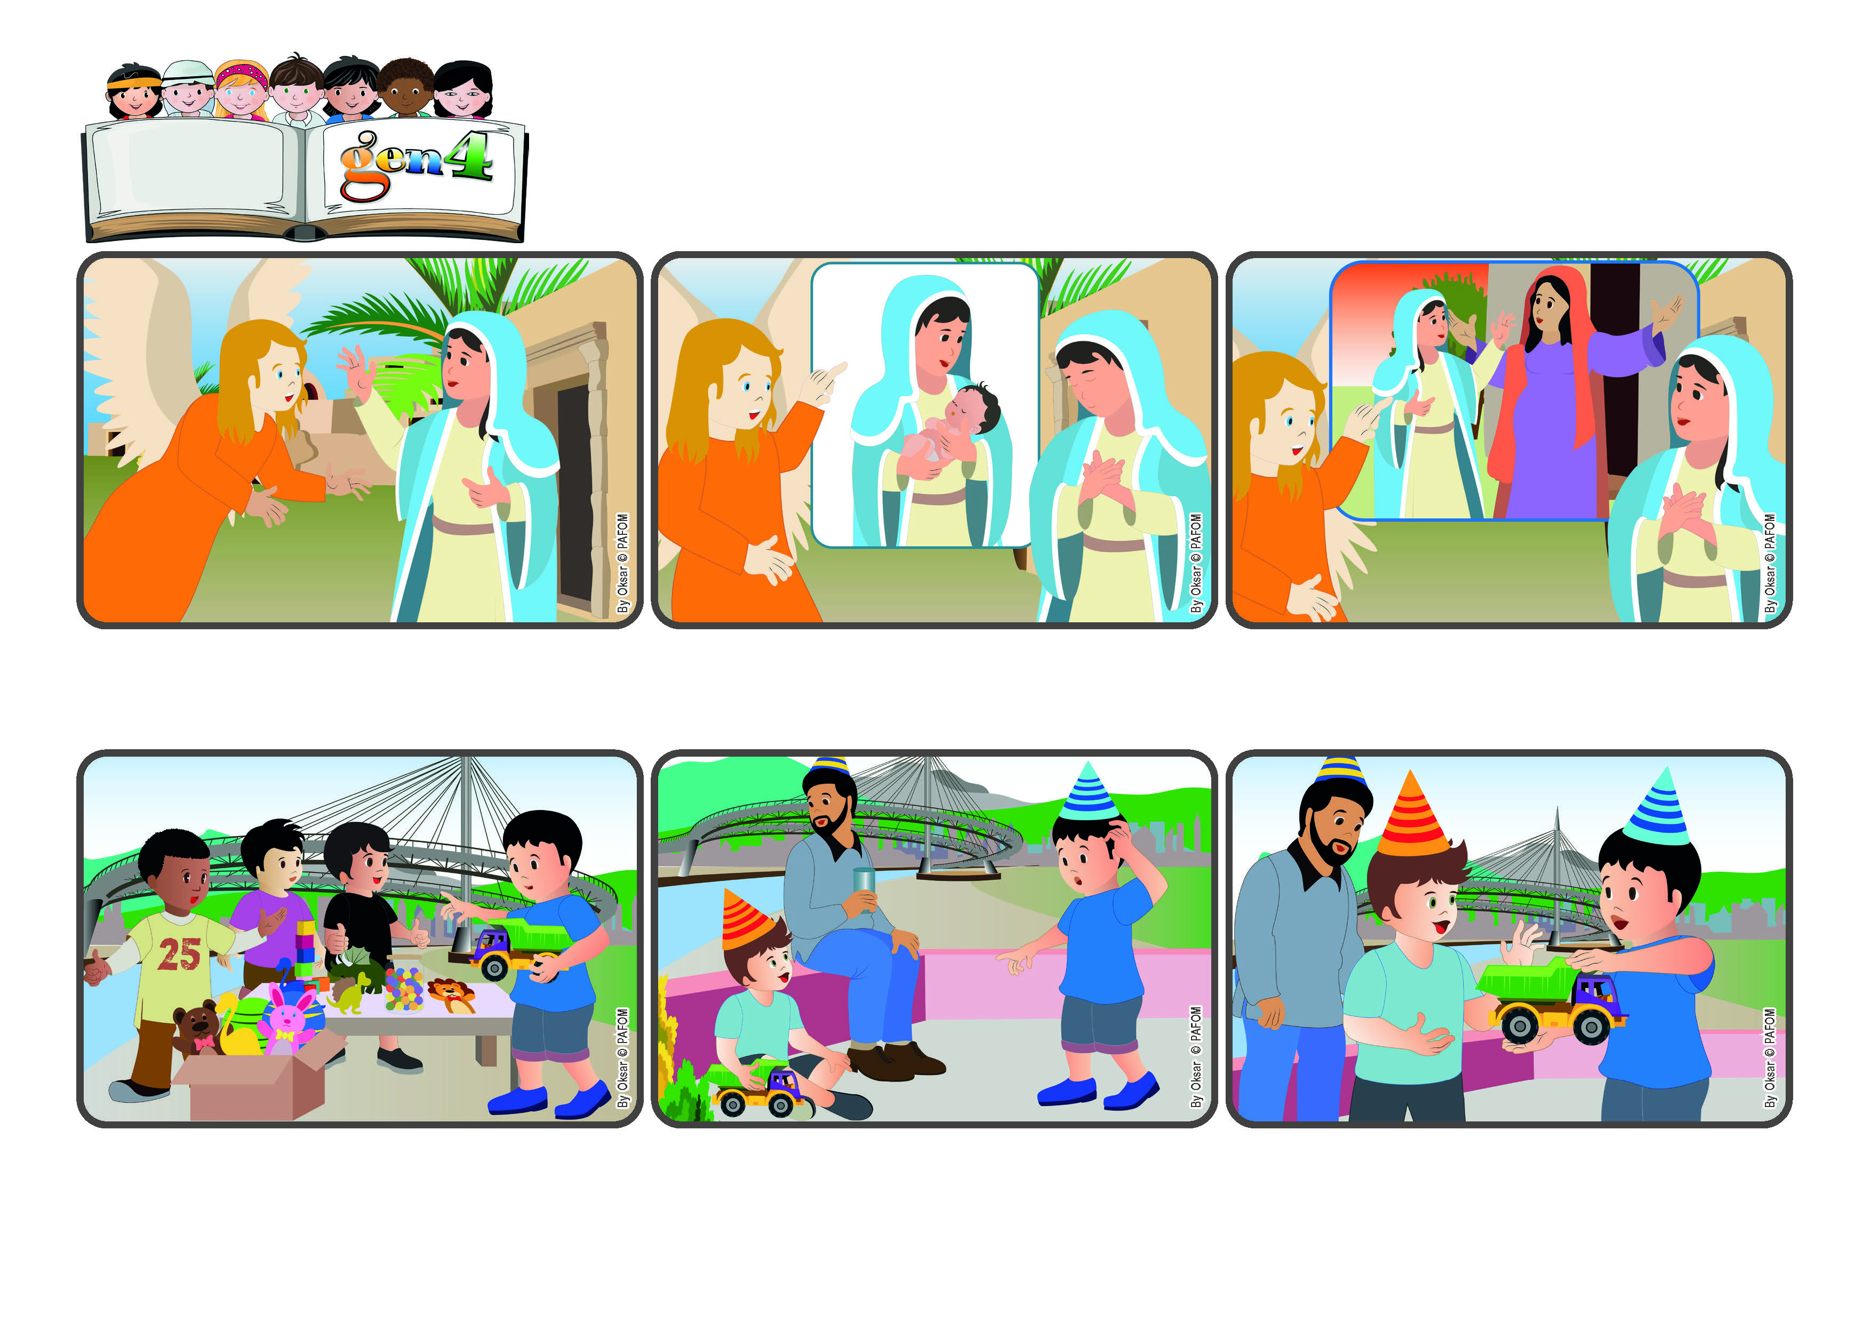

**"Nothing will be impossible with God" (Lk 1:37).**

**God does amazing things! Everything is possible for him.**

(DECEMBER 2024, from the liturgy of December 8, the Second Sunday of Advent

and the feast of the Immaculate Conception)

**Word**

**of Life**

**A few days later it was my little cousin’s birthday. He came to my house and we played all day long with that truck. In the evening he wanted to take it home, but his dad told him, “No, you have to leave it here. It’s not yours.”**

**We Gen 4 brought lots and lots of toys to sell to help those who are poor. I bought a ticket, too, and I got a very nice truck! I asked myself: “How could that Gen 4 give up such a good truck? I wouldn’t be able to do that!”**

**Mary lived in Nazareth, a small town in Palestine. She was alone at home, quietly praying to God present in her heart. But then what happened? Gabriel, an angel sent by God, appeared to her.**

**Gabriel told her: “Don’t be afriad. God sent me to tell you that you will become the mother of Jesus, the Son of God.” Mary was very surprised and asked: “But how can this happen?” Gabriel reassured her, saying: “Nothing is impossible for God.”**

**Then he told her that her cousin, Elizabeth, was also going to have a baby, even though she was already very old. With great love, Mary answered: “Yes, if God wants it, I want it too!” And she kept on loving everyone, even taking a long trip to help her cousin Elizabeth.**

**My cousin insisted and his dad said: “Ask if you can take it home for just a few days.” I was listening to Jesus in my heart and so I immediately answered: “Of course you can take it. And do you know what? I’ll give it to you – it’s yours now!” Jesus really helps us do impossible things! (the experience of a boy from Pescara, Italy)**

**© PAFOM, Drawings and text provided by the Gen4 Center.**

**The Gen4 are the young children of the Focolare Movement, which was founded by Chiara Lubich.**