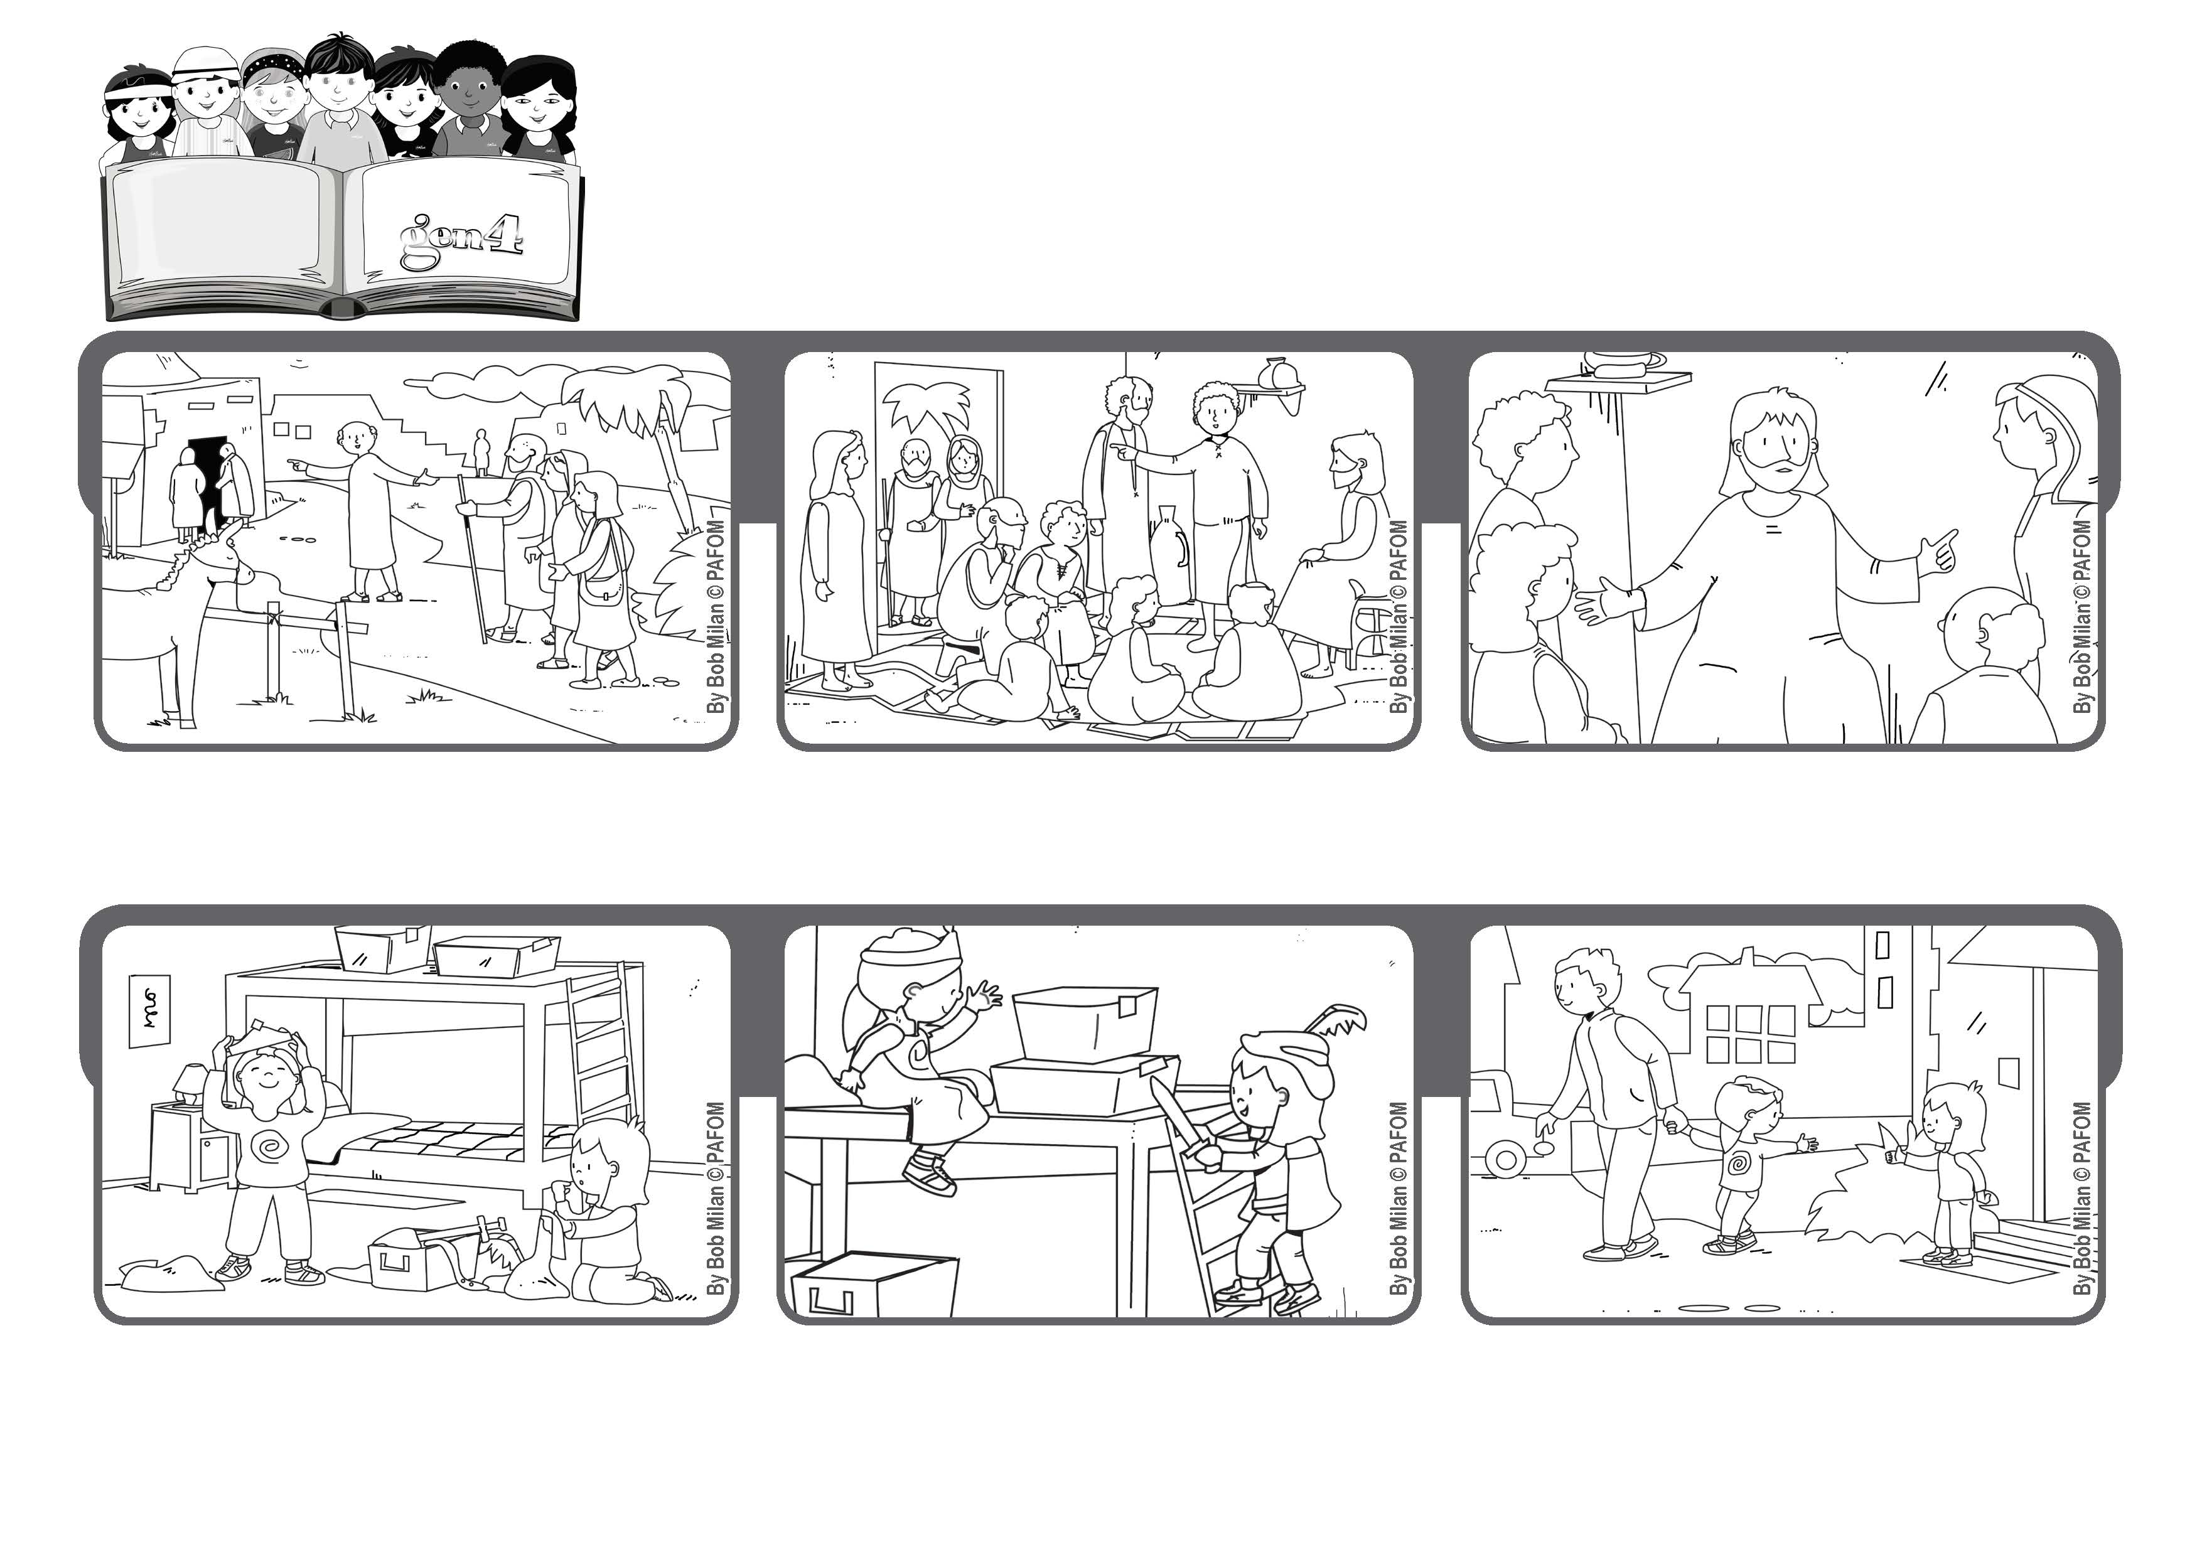
July 2020
Word of Life
“Whoever does the will of my Father in heaven is my brother and sister and mother.” (Mt 12:50)
Be the brother or sister or mother of Jesus
The apostles told Jesus, “Your mother and your relatives are outside and want to talk to you.”
The mother of Jesus and some of his relatives were looking for him because they wanted to talk to him.
Jesus pointed to those around him and said, “Whoever does the will of my Father in heaven is my brother and sister and mother.”
Paola went to visit her friend Noemi and they started to play a game of being a prince and a princess. Paola said, “I want to be the princess!”
Noemi wanted to be a princess too, but out of love for Paola, she accepted being the prince.
They had a good time playing and when it was time for Paola to go home, she thanked Noemi for her act of love. Experience of Noemi from Italy
© PAFOM, Drawings and text provided by the Gen4 Center.
The Gen4 are the young children of the Focolare Movement, which was founded by Chiara Lubich.

