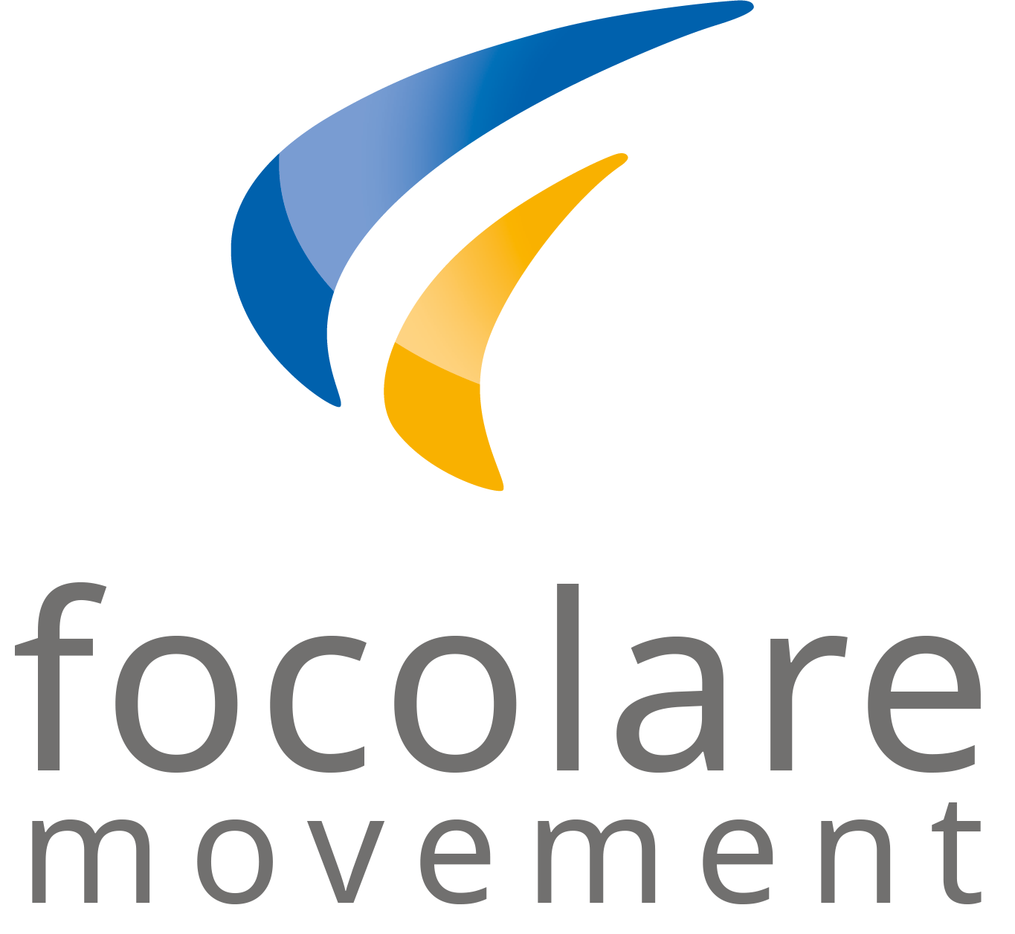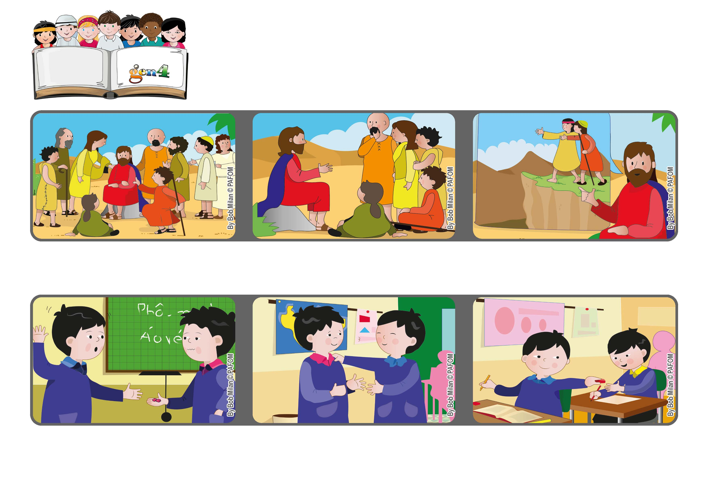
February 2021
“Be merciful, just as your Father is merciful.” (Lk 6:36)
Forgive
Word of Life
Experience of Paolo from Vietnam: Paolo lent his eraser to Kim who gave it back to him broken in half.
He helped them and then told them to forgive others just as our heavenly Father forgives us.
Many people ran to hear Jesus and to be cured.
Kim said he was sorry, but Paolo was sad. Then he decided he could forgive him.
He added that if we don’t do that we are like a blind person leading another blind person and they both fall into a hole! (see Lk 6:36-39)
The next day Paolo gave a piece of the eraser to another boy who had lost his!
© PAFOM, Drawings and text provided by the Gen4 Center.
The Gen4 are the young children of the Focolare Movement, which was founded by Chiara Lubich.

