**Word of Life**

**February 2022**

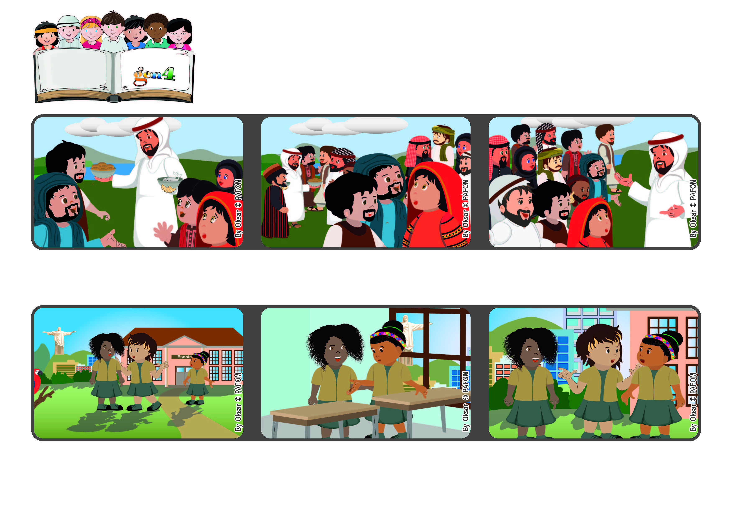

**“Anyone who comes to me I will never drive away” (Jn 6:37)**

**Jesus is always waiting for us**

**First, I asked her if what I heard was true. She was very sad and told me it was not.**

**Jesus reminded them that God had sent him to help everyone, to forgive everyone and not to lose anyone.**

**However, some people didn’t understand who Jesus was. They didn’t believe in him and started saying bad things about him.**

**Jesus had just performed the miracle of multiplying the bread and fish. The people were so enthusiastic that they kept looking for him.**

**I decided that we shouldn’t break our friendship over that and so I asked them to apologize to one another. They did and now we are all very good friends.**

**Experience of Benta from Brazil: One of my friends said something bad about another girl. When we went back into the classroom, I went up to that girl.**

**© PAFOM, Drawings and text provided by the Gen4 Center.**

**The Gen4 are the young children of the Focolare Movement, which was founded by Chiara Lubich.**