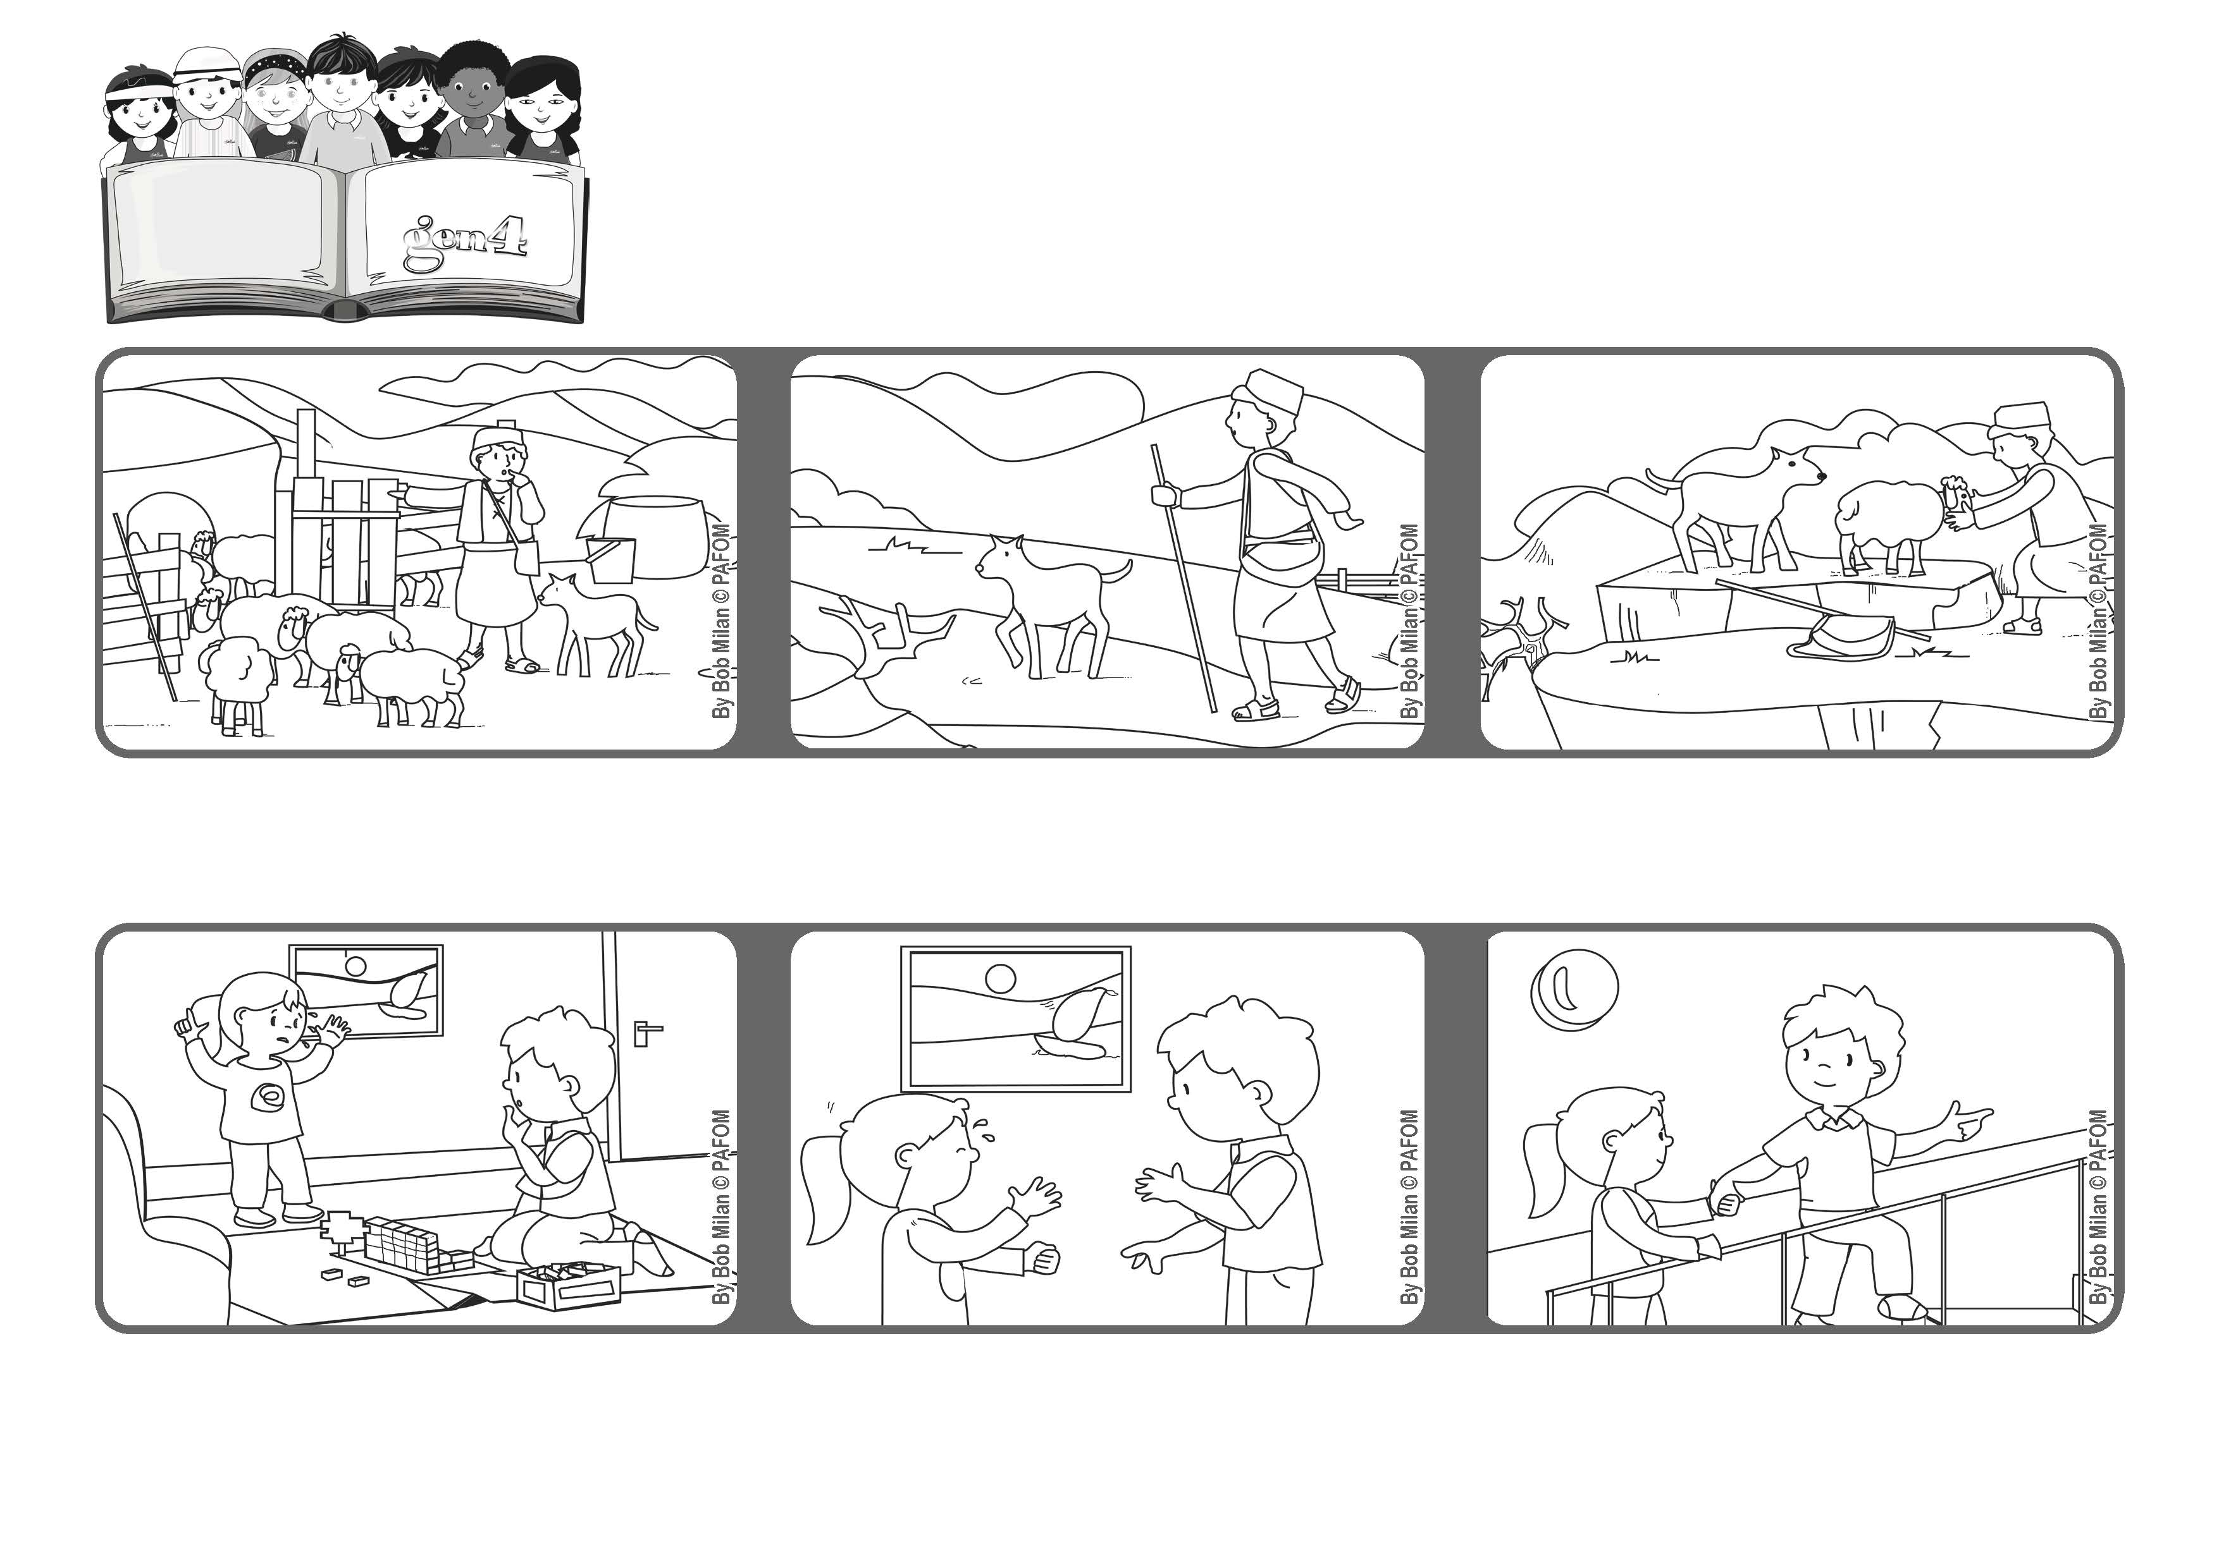

**April 2021**



**“I am the good shepherd.**

**The good shepherd lays down his life for the sheep” (Jn 10:11).**

**Take care of the weakest ones**

**Word of Life**

**Jesus is like a good shepherd who knows his sheep and takes care of them.**

**When he got home, he realized that one lamb was missing and so he ran back to find it.**

**Even though he was tired from working all day, he looked and looked until he found it.**

**She said she wanted our mother, but she was on the second floor and couldn’t hear her crying.**

**One day I was at home, playing with my construction kit. My little sister started crying.**

**So I tried to make her feel better. I look her hand and helped her go up the stairs to where our mother was working. (Bob – Canada)**

**© PAFOM, Drawings and text provided by the Gen4 Center.**

**The Gen4 are the young children of the Focolare Movement, which was founded by Chiara Lubich.**