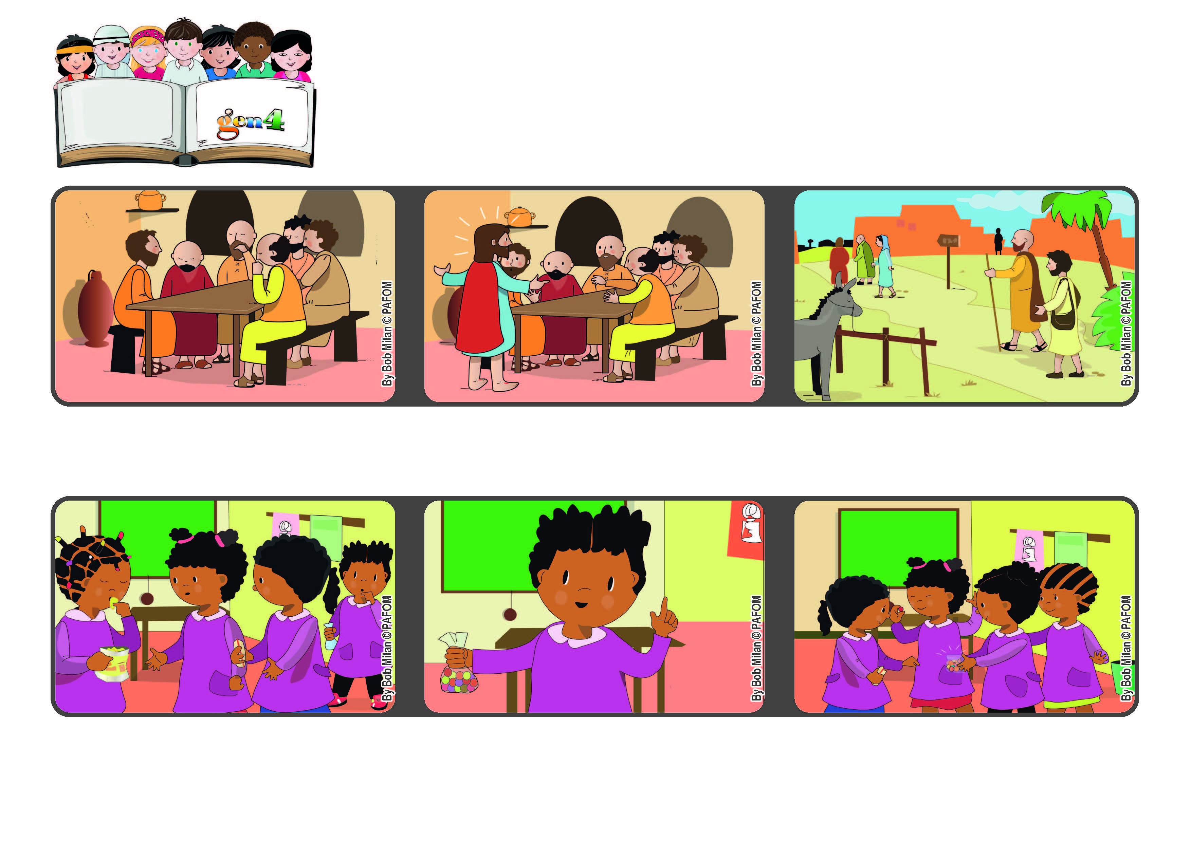



**Word of Life**

**April 2022**

**“Go into the whole world and proclaim**

**the good news to the whole creation” (Mk 16:15).**

**Let’s make everyone happy**

**Peter and the other apostles went all over the world to tell each and every person about the love of Jesus and the happiness that he gives us.**

**The Risen Jesus appeared in their midst and reassured them. He gave them to courage to go out and tell others what they had seen and heard.**

**After Jesus died, his apostles stayed together. They were sad when they thought about all that had happened.**

**I distributed the candy among my classmates. They were very happy – and so was I!”. Nicole from the Central African Republic**

**But she kept eating them by herself. Then I remembered that I had some candy in my bag so I decided I could share it with them.**

**“A girl in my class had a bag of potato chips and she was eating them. My friends who were very hungry asked if they could have a little.**

**© PAFOM, Drawings and text provided by the Gen4 Center.**

**The Gen4 are the young children of the Focolare Movement, which was founded by Chiara Lubich.**