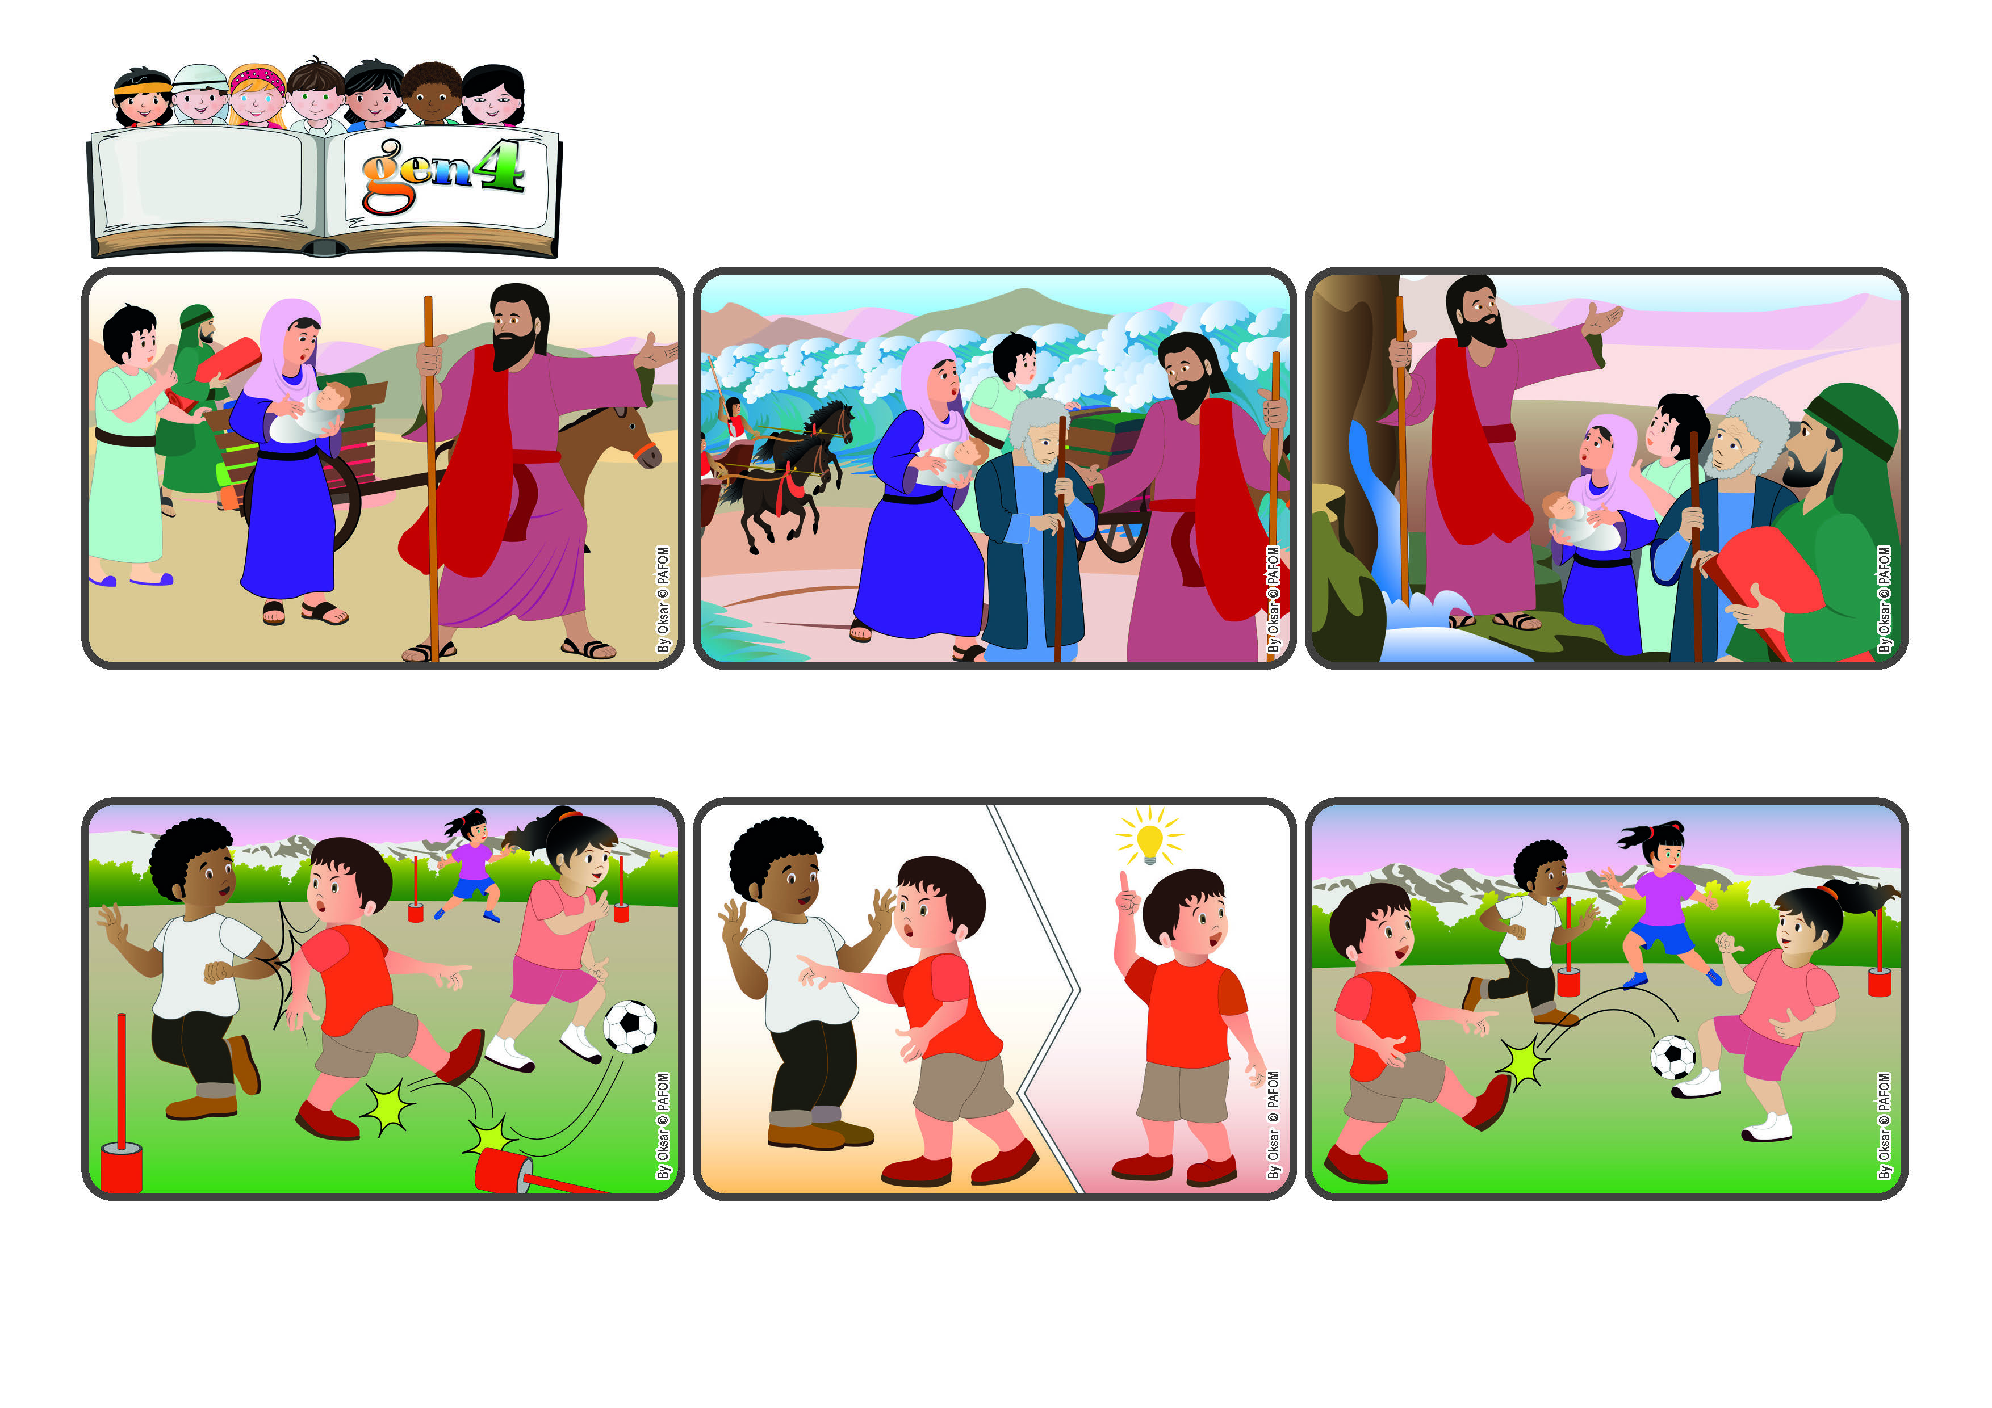

**Word**

**of Life**

**«I am about to do a new thing; now it springs forth, do you not perceive it? » (Is 43:19).**

(From the liturgy of April 6th, the fifth Sunday in Lent)

**Let’s try to discover God’s gifts!**

**God gave me the opportunity to choose. I felt that playing with love would make all of us happy, even the other team, and it would create peace among us. That was the gift I could give! In fact, the game ended with everyone being happy!**

**They had the sea in front of them, and behind them the soldiers of Pharaoh were coming after them on horses. Then God told Moses to raise his staff over the water. The sea divided in two so that the people could pass through it. Then it flowed back over all of Pharaoh’s soldiers and chariots.**

**Now the people of Israel were free and could look toward the future. God encouraged them to keep going and to discover all the gifts he had prepared for them. God always offers us new opportunities – it’s up to us to discover them!**

**Moses listened to God’s voice and encouraged the Israelites to leave Egypt, where the Pharoah made them work like slaves. Shortly after they left, however, the people found themselves in trouble.**

**I was so mad! I decided that I would start elbowing the other players, too, to block them from making a goal. Then I felt in my heart that this wasn’t right and that if I acted like that, I wouldn’t be happy.**

**We were playing a great game! My team was really good and I was about to make a fantastic goal when a member of the other team hit me with his elbow and made the ball change direction.**

**© PAFOM, Drawings and text provided by the Gen4 Center.**

**The Gen4 are the young children of the Focolare Movement, which was founded by Chiara Lubich.**