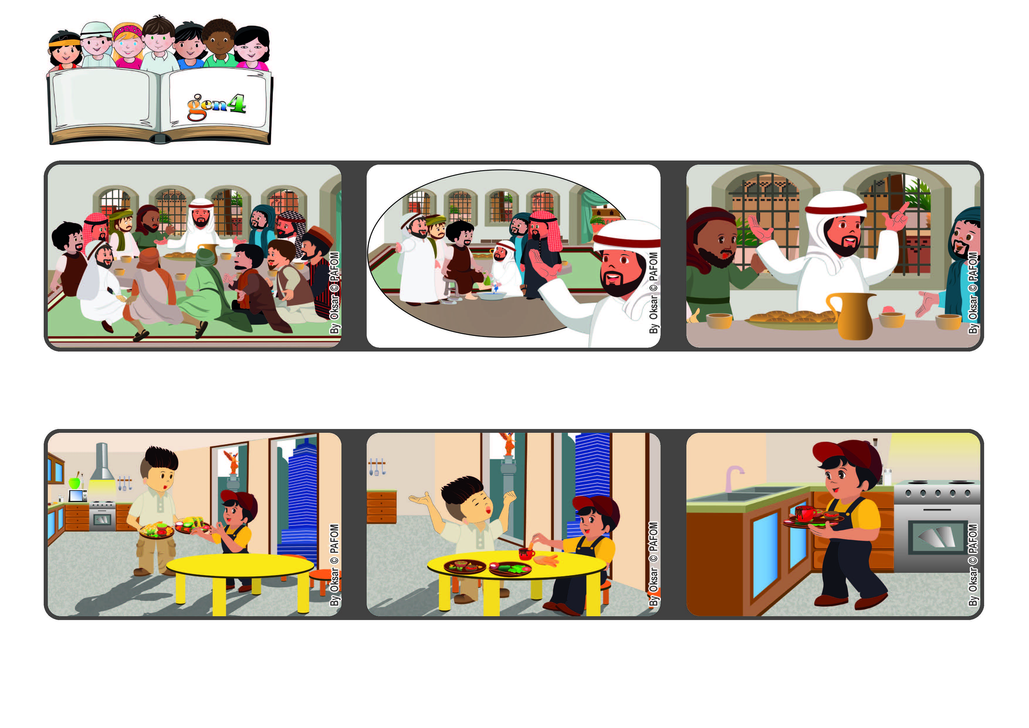

Word of Life
May 2022
“I give you a new commandment, that you love one another” (Jn 13:34).
Let’s love one another
One day, my mother wasn’t home and my older brother fixed dinner for me.
After we ate, I saw that he was tired and wanted to rest.
So I ran to the kitchen and washed the dishes. Experience of Pablo from Mexico.
He told them: “Love one another.” This is the same kind of love that is found in heaven, where everyone loves one another.
Jesus explained why he had done that and then gave the disciples his last and most important commandment.
During the Last Supper, Jesus was at the table with his disciples. He had just washed their feet.
© PAFOM, Drawings and text provided by the Gen4 Center.
The Gen4 are the young children of the Focolare Movement, which was founded by Chiara Lubich.

