**“Not everyone who says to me, ‘Lord, Lord,’ will enter the kingdom of heaven, but only the one who does the will of my Father in heaven.” (Mt 7:21)**

**Listen to his words and put them into practice!**

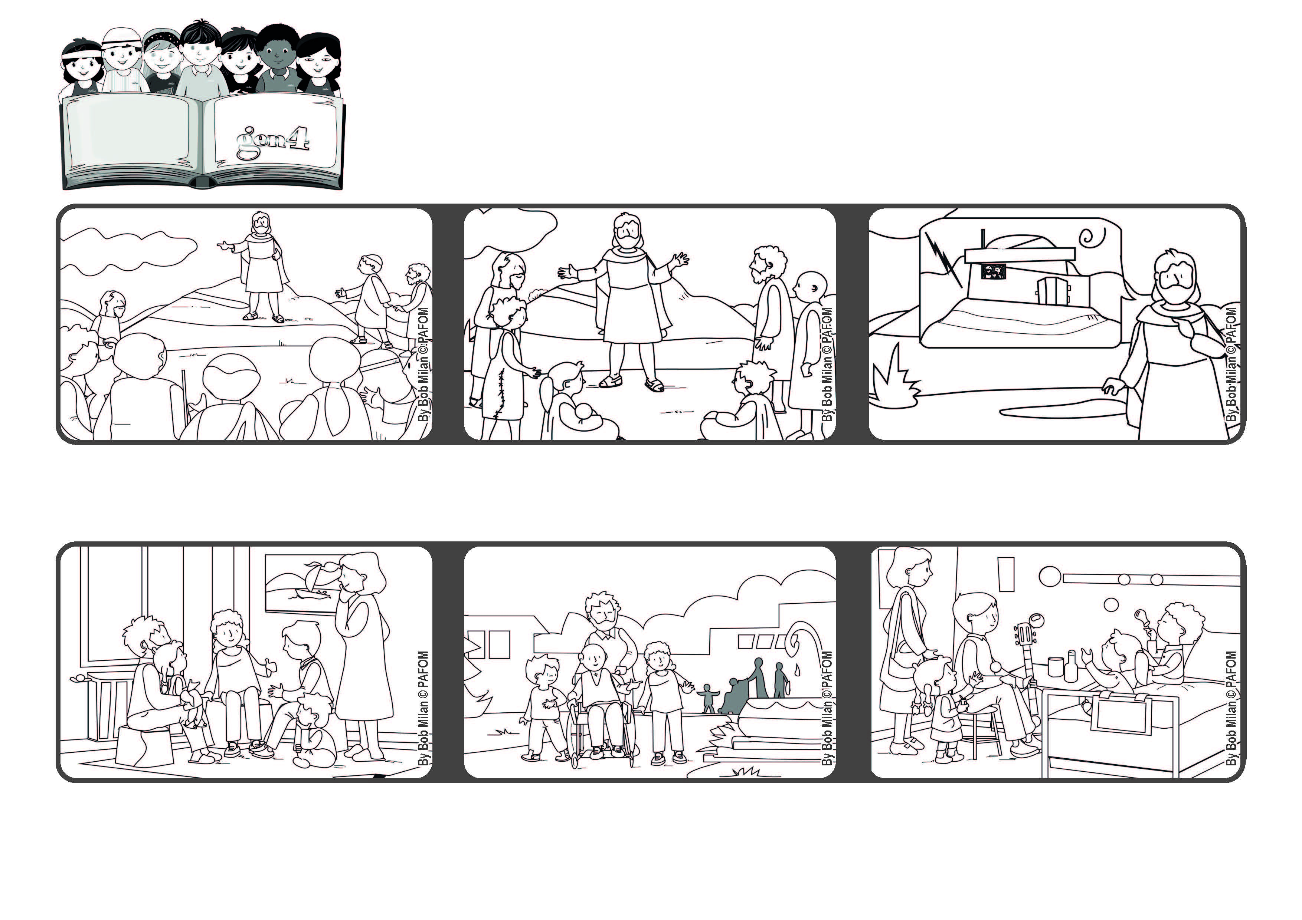

**Word of Life**

**June 2021**



**An experience of a group of friends in Heidelberg, Germany: We decided that once a month we would give “an hour of happiness” to someone who is sad or alone or sick.**

**We went to visit a group of elderly people and took them in their wheelchairs to the nearby park.**

**Another time we went to a children’s hospital and played with them. They were super-happy and we were even happier!**

**After Jesus told the people about the beatitudes, he reminded them that God loves everyone and is always right next to each one of us.**

**Jesus shows us a very good way to respond to God’s great love for us. It is to do his will, which means to love everyone.**

**Whoever listens to what he teaches and puts it into practice is like a man who builds his house on rock. It will resist any storm and will never be destroyed.**

**© PAFOM, Drawings and text provided by the Gen4 Center.**

**The Gen4 are the young children of the Focolare Movement, which was founded by Chiara Lubich.**