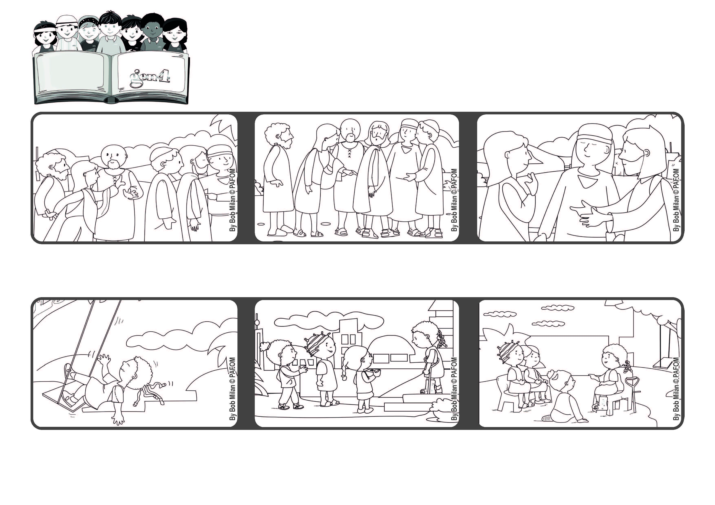

**Everything is possible for God!**

**“Take heart, daughter, your faith has made you well.” (Mt 9:22)**

**Word of Life**

**July 2021**



**Then Jesus turned around and saw her and said, “Take heart, daughter, your faith has made you well.” When Jesus looked at her, she was cured and felt God’s great love for her.**

**She didn’t call out to Jesus, she didn’t say anything. She just went close to him and touched the edge of his clothes. She thought: “If I just touch his cloak, I will be cured.”**

**Lucia from Tanzania: One of our friends was playing in her back yard and got hurt badly. Right away we prayed together for her.**

**After going to church, we all went to visit her. When we got there, even though she was in a lot of pain, she got up and came to welcome us with great joy.**

**She told us all her acts of love and we told her ours. Before leaving we prayed together and then we went home with our hearts full of happiness.**

**Jesus was walking along, followed by a lot of people. In the crowd was a woman who had suffered for years from a serious illness.**

**© PAFOM, Drawings and text provided by the Gen4 Center.**

**The Gen4 are the young children of the Focolare Movement, which was founded by Chiara Lubich.**