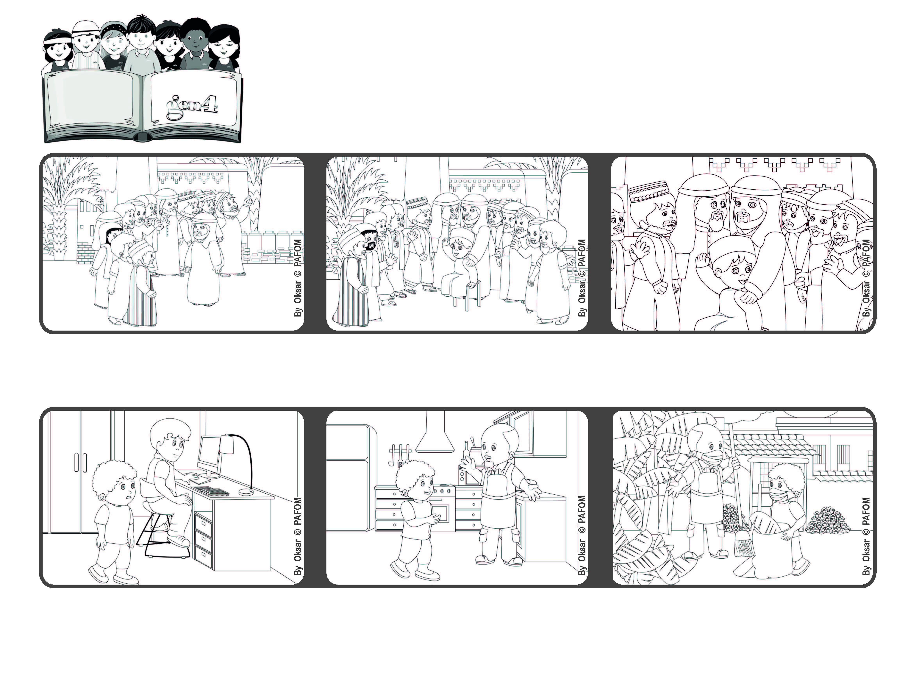

**“Whoever becomes humble like this little child**

**is the greatest in the kingdom of heaven.” (Mt 18:4)**

**Let’s love like God our Father**

**Word of Life**

**August 2021**



**Then he told his disciples: “Whoever becomes humble like this little child will be the greatest in the kingdom of heaven.”**

**Jesus called over a little child and set the child in front of them.**

**Samuel from Colombia had to stay at home because of COVID. He couldn’t even go to school. It was hard for everyone staying at home to use the computer, so he just felt like doing nothing.**

**Then he noticed that his Dad was trying to help all his children and was cooking and cleaning the house.**

**So Samuel started to do his homework and also to help his Dad do the housework.**

**The disciples of Jesus wanted to know who would have the best place in heaven.**

**© PAFOM, Drawings and text provided by the Gen4 Center.**

**The Gen4 are the young children of the Focolare Movement, which was founded by Chiara Lubich.**