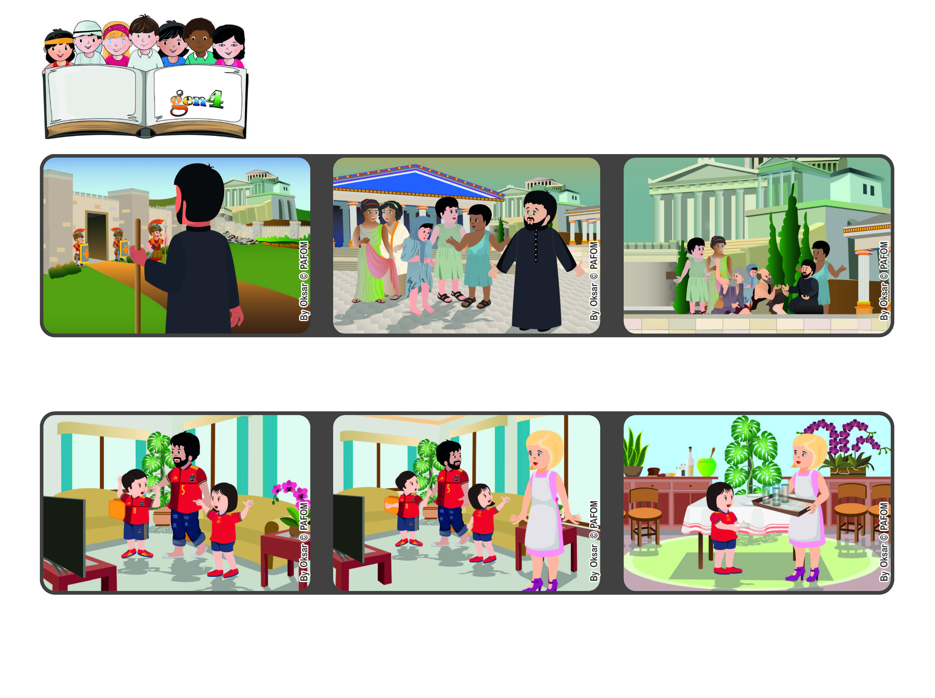

**September 2022**

**Word of Life**

**“For though I am free with respect to all, I have made myself a slave to all,**

**so that I might win more of them.” (1Cor 9:19)**

**Free to love**

**I really wanted to watch the game, but I thought, “There is Jesus in my mom who needs to be loved.” So I jumped up and went to the kitchen to set the table. My mom was happy and then our team won, 4-0!!!**

**My mom came home and asked us: “Doesn’t anyone care about me? I get home tired from work and then I even have to cook the dinner! Who will help me - at least to set the table?**

**Saint Paul the apostle travelled great distances to tell people about how much Jesus loves them. In one of his trips, he came to the city of Corinth in Greece.**

**That’s why he said that even though he was free, he always tried to be at the service of those in need.**

**He realized that some of those who are recently become Christians didn’t know how they were supposed to act. Paul told them that the most important thing is to always love everyone, especially those who are the weakest.**

**Cecilia from Madrid in Spain had this experience: One night, my dad, my brother and I were watching a soccer game on TV.**

**© PAFOM, Drawings and text provided by the Gen4 Center.**

**The Gen4 are the young children of the Focolare Movement, which was founded by Chiara Lubich.**