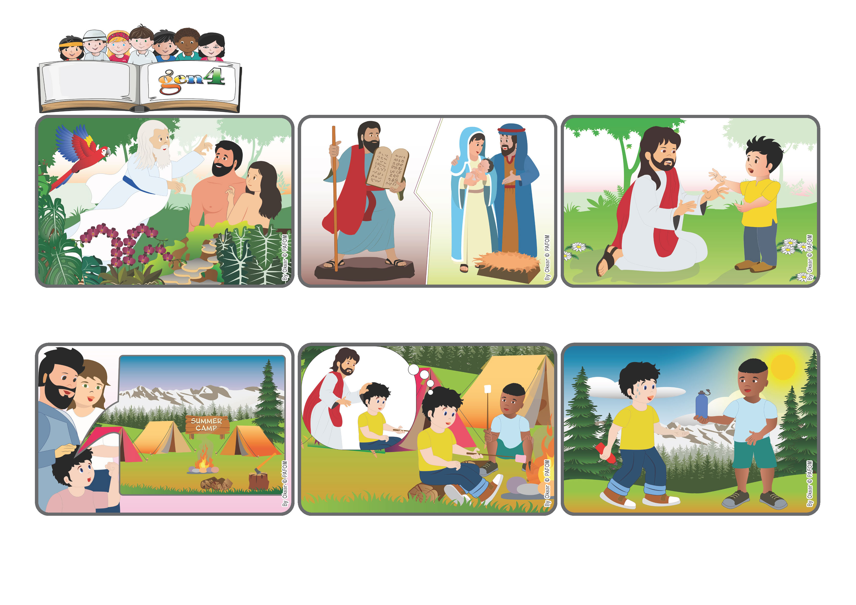

**Word**

**of Life**

**«My help comes from the Lord, who made heaven and earth » (Ps 121:2).**

(From the liturgy of October 19, the 29th Sunday in Ordinary Time)

**God’s love is always with us**

**Yes, God created us and he is always with us to help us discover how to live in peace with others and with the world. That’s why he gave us the Ten Commandments and then he sent his own son, Jesus, who helped us understand that God is our Father.**

**God loves us and “made heaven and earth” so that we would have a beautiful home to live in. He never leaves us alone. Even if we do something wrong, he keeps helping us to start over again to love.**

**Jesus is always nearby, he listens to us, he consoles us, he helps us solve our problems. Being with him we experience the love of God, our Father, who takes care of us and helps us to love one another like brothers and sisters.**

**Like one day I was very thirsty, but my water bottle was empty. I thought to myself: ‘Jesus, you love me and take care of me. Can you please send me some water?’ Just then a friend of mine came up and offered me a drink. It’s really true that Jesus takes care of us!”**

**The week passed by very quickly! When he got home, his mom asked him, “How did it go?” “Good,” Francesco answered. “When I felt a little sad, I knew that I wasn’t really alone, because Jesus was with me...**

**Francesco was very happy. He was going on summer camp to a very beautiful place in the woods. He can’t wait to go, even though he’s a little scared because it’s the first time he’ll be away from his parents.**

**© PAFOM, Drawings and text provided by the Gen4 Center.**

**The Gen4 are the young children of the Focolare Movement, which was founded by Chiara Lubich.**