**Word**

**of Life**



**December 2021**

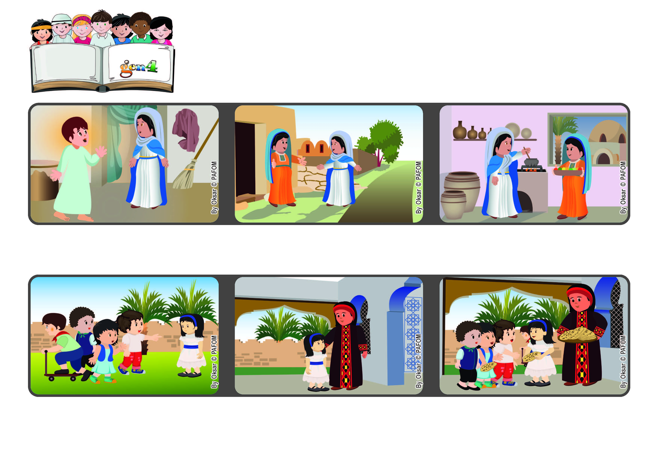

**“Blessed is she who believed that what the Lord told her would be fulfilled.” (Lk 1:45)**

**Believing what Jesus says makes us happy**

**I overcame my anger and did what she said. When the children came into the house, my mom gave them each a round Arab bread she had just baked. They took the bread home. Their parents were amazed at this act of love and asked to get to know us better.**

**I ran into the house crying. I was really angry and I told my mom: “I’m never going to play with those children again!” My mother told me: “Dry your tears, go back out and invite all of them to come to our house.”**

**Experience of Margaret from the Holy Land: When I was five years old, I often went outside in front of our house to play. But some children in the neighborhood called me names and one day one of them said some really bad things to me.**

**When Elizabeth saw Mary coming, she was full of joy and thanked her for saying “Yes” to what the angel had asked her. In fact Jesus was already growing inside her.**

**Elizabeth was fairly old and so Mary stayed and helped her with many concrete acts of love.**

**Mary heard that her cousin Elizabeth was expecting a baby. She look a long trip to see her.**

**© PAFOM, Drawings and text provided by the Gen4 Center.**

**The Gen4 are the young children of the Focolare Movement, which was founded by Chiara Lubich.**