**August 2020**

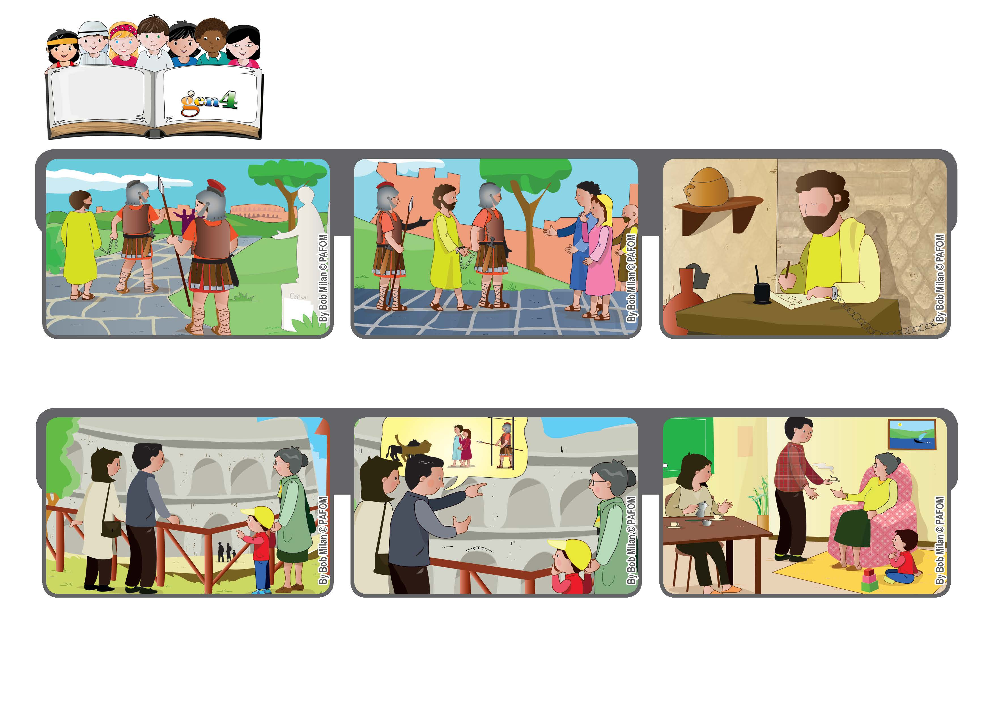

**“Who will separate us from the love of Christ?” (Rm 8:35)**

**“We are super-victorious!”**

**Word of Life**

**He was at the end of his life, but he told everyone that God never left him alone.**

**After travelling a lot, Paul finally arrived in Rome. The trip had been very difficult. He was starving, wounded and had to run away from people who wanted to kill him.**

**He wrote to the Christians who lived in Rome, “When we trust in God’s love, we are victorious!”**

**Edoardo recently moved to Rome in Italy. One day his grandmother came to visit him and the whole family went to see the Colosseum. Edoardo asked his dad, “What happened in there?”**

**His father told him that hundreds of years ago the first Christians were persecuted by the Romans and were thrown into the pit to be eaten by lions. Edoardo listened to him without saying anything.**

**When they got home, Edoardo told his mom and dad, “I’m ready to let the lions eat me for love of Jesus!”**

**© PAFOM, Drawings and text provided by the Gen4 Center.**

**The Gen4 are the young children of the Focolare Movement, which was founded by Chiara Lubich.**