

**January 2021**

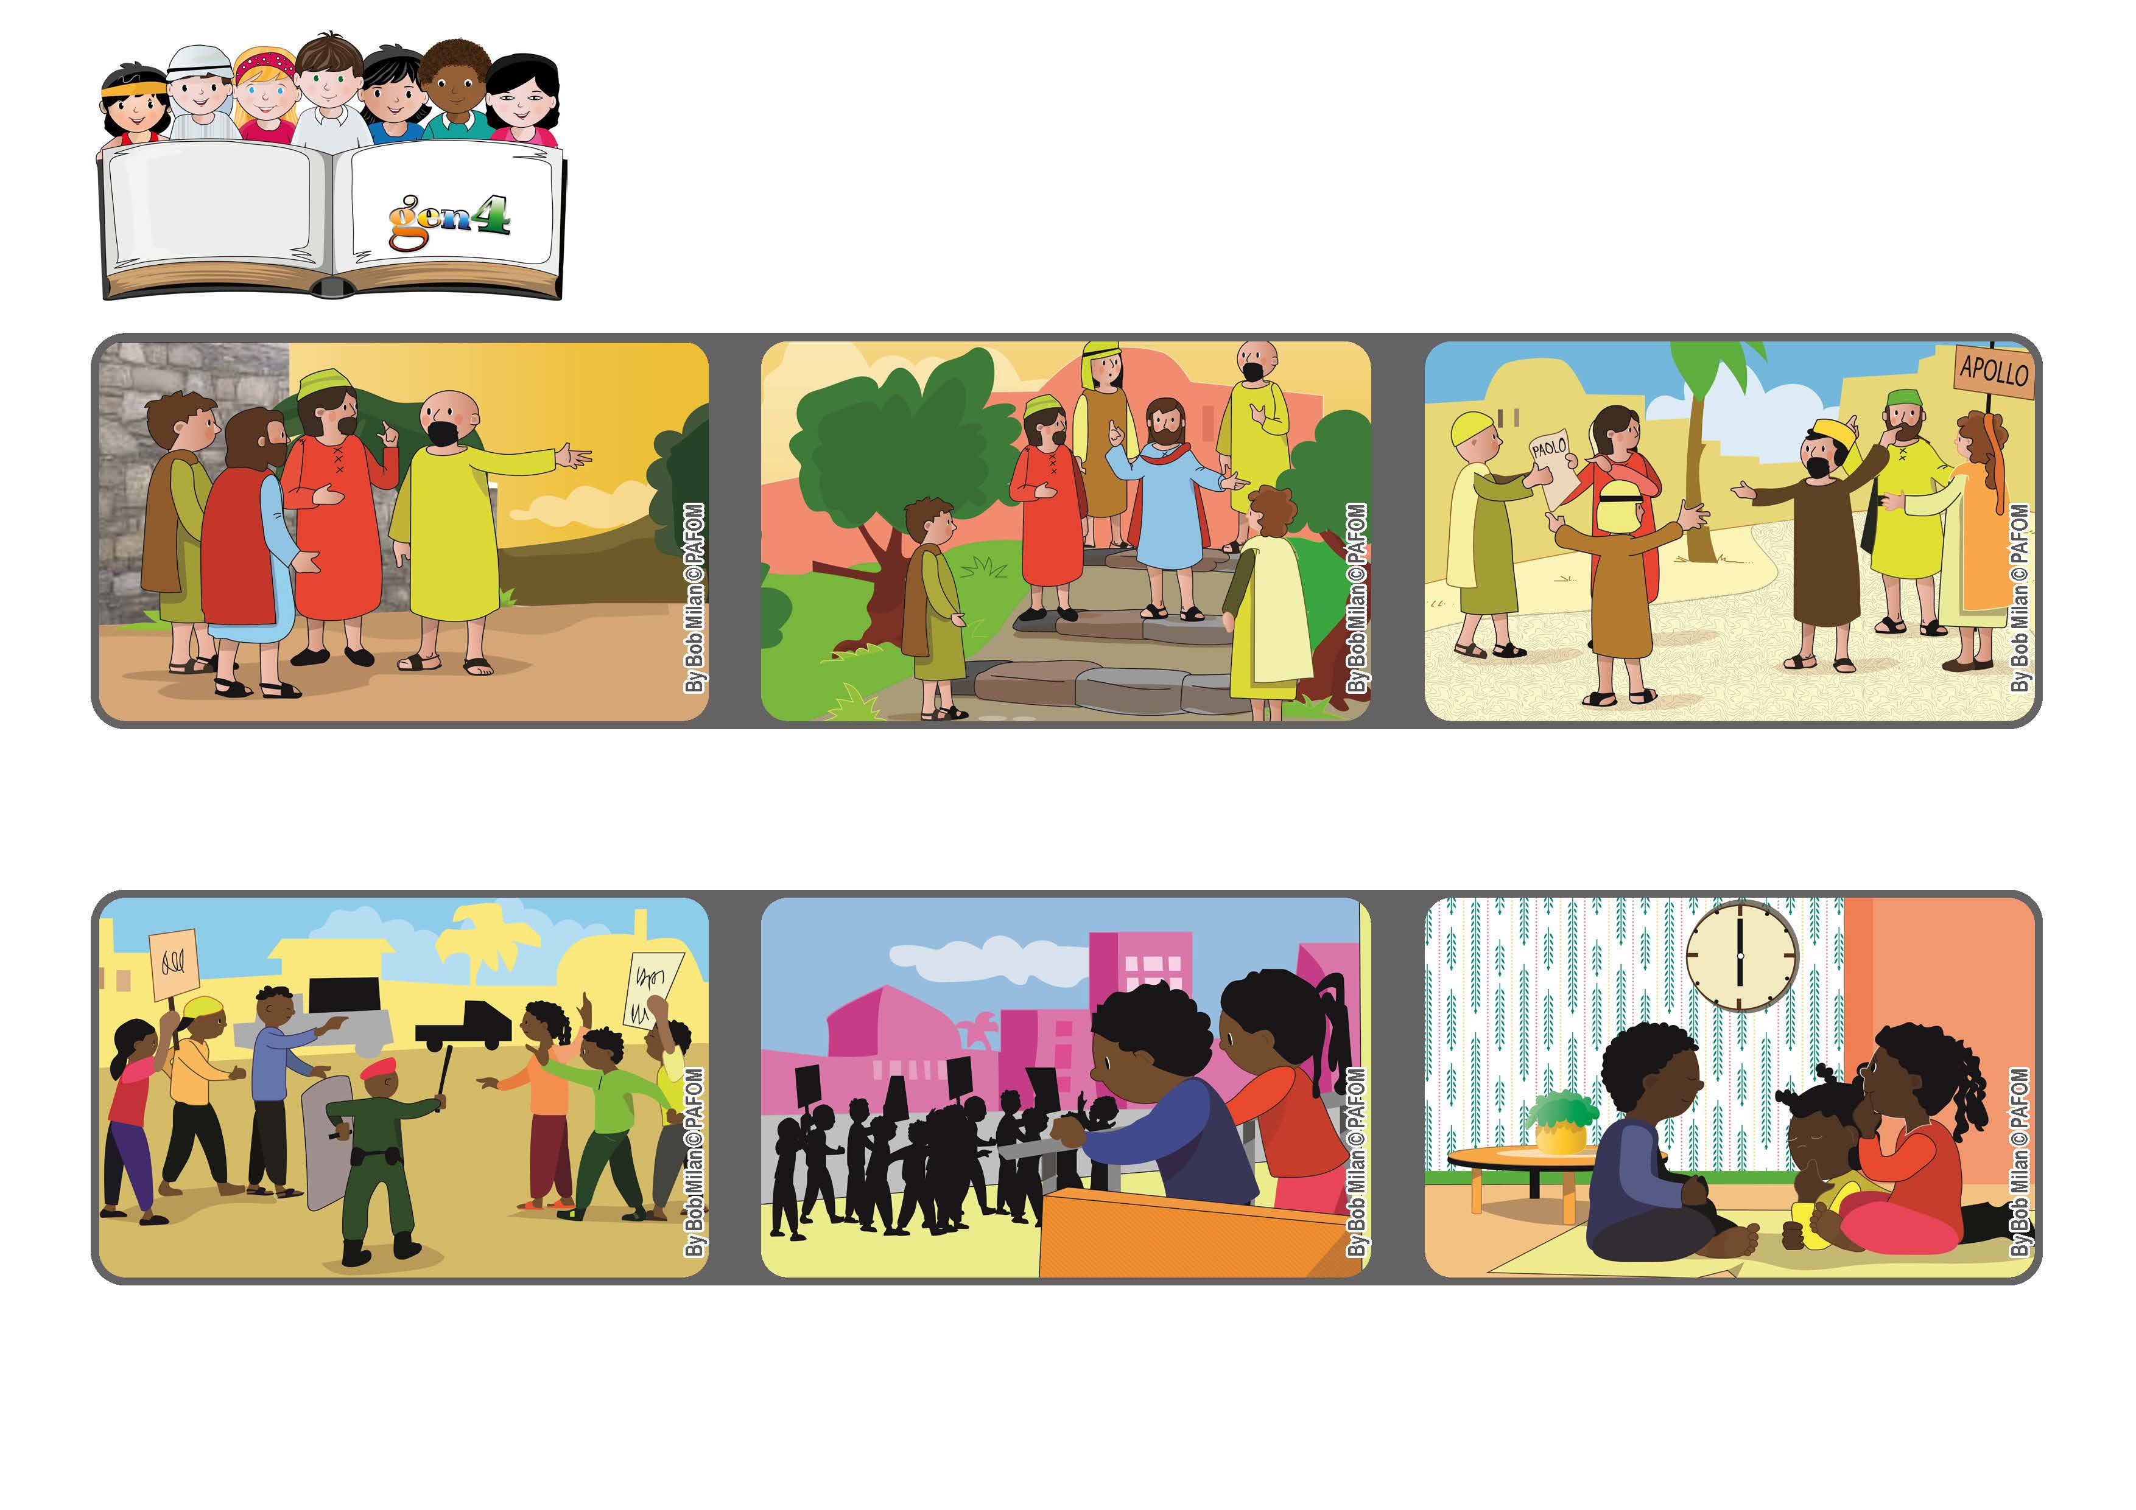

**“Abide in my love and you shall bear much fruit” (see Jn 15:5-9)**

**Always remain in God’s love**

**Word of Life**

**On Holy Thursday Jesus was walking with his friends from Jerusalem to the Garden of Olives.**

**They were going downhill following large stone steps. Jesus was praying and asking his Father for the gift of unity for his disciples and for all of us (see Jn 17:21).**

**Even though all people are children of God and therefore brothers and sisters, there have always been divisions among us. We have to trust God and keep asking him constantly for the gift of unity.**

**We Gen 4 decided to pray together for a peaceful election and so we met together at 6 pm every day for a whole week to pray in unity.**

**In our country, people are getting ready for the elections and so they often argue and fight with each other about the candidates.**

**We also prayed in our own homes. We felt great love in our hearts and also the joy that we were helping our country. (Paulette – Africa)**

**© PAFOM, Drawings and text provided by the Gen4 Center.**

**The Gen4 are the young children of the Focolare Movement, which was founded by Chiara Lubich.**