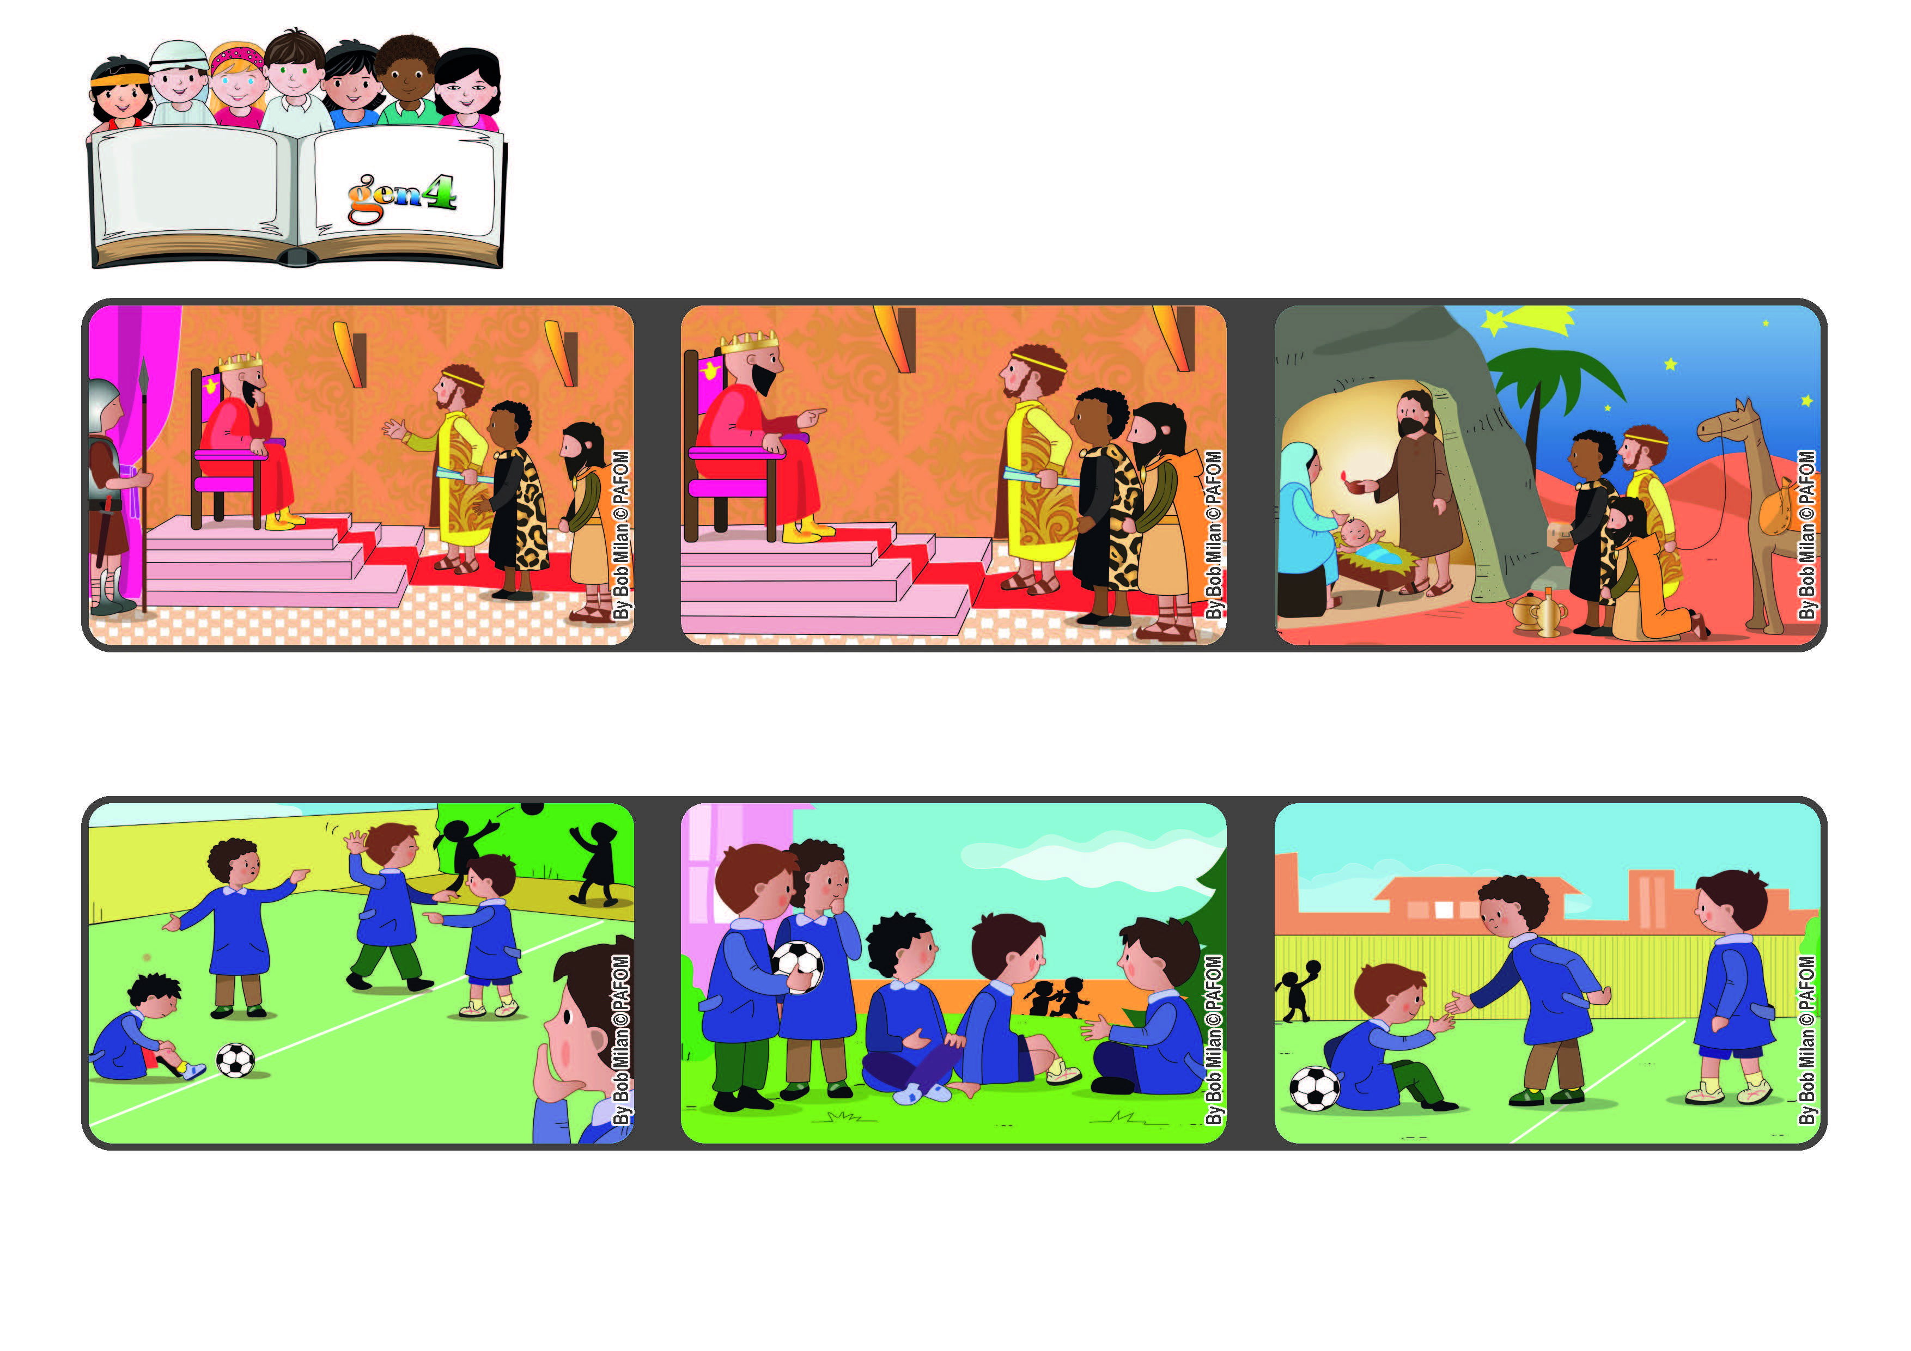



**January 2022**

**Word of Life**

**“We saw his star in the east, and have come to worship him” (Mt 2:2).**

**Let’s go together to see Jesus**

**The three wise men found the stable and adored Baby Jesus. They were warned in a dream not to go back to see Herod and so they went home by another road.**

**Herod was worried about this new “king” and so he told them that when they found him, to come back and tell him. It was a trick so that he could kill Jesus.**

**Three wise men arrived in Jerusalem and went to see King Herod to ask him: “Where is the king of Israel? We saw his star and we came to adore him.”**

**Now when they play, if someone is hurt, they remember that Jesus suffered a lot, and so they keep on playing without starting a fight.**

**I started telling them the stories about Jesus and the three wise men and the star of Bethlehem and other things.**

**Experience of Paolo from Brazil: When my friends play at school, they end up hurting one another and then they fight.**

**© PAFOM, Drawings and text provided by the Gen4 Center.**

**The Gen4 are the young children of the Focolare Movement, which was founded by Chiara Lubich.**