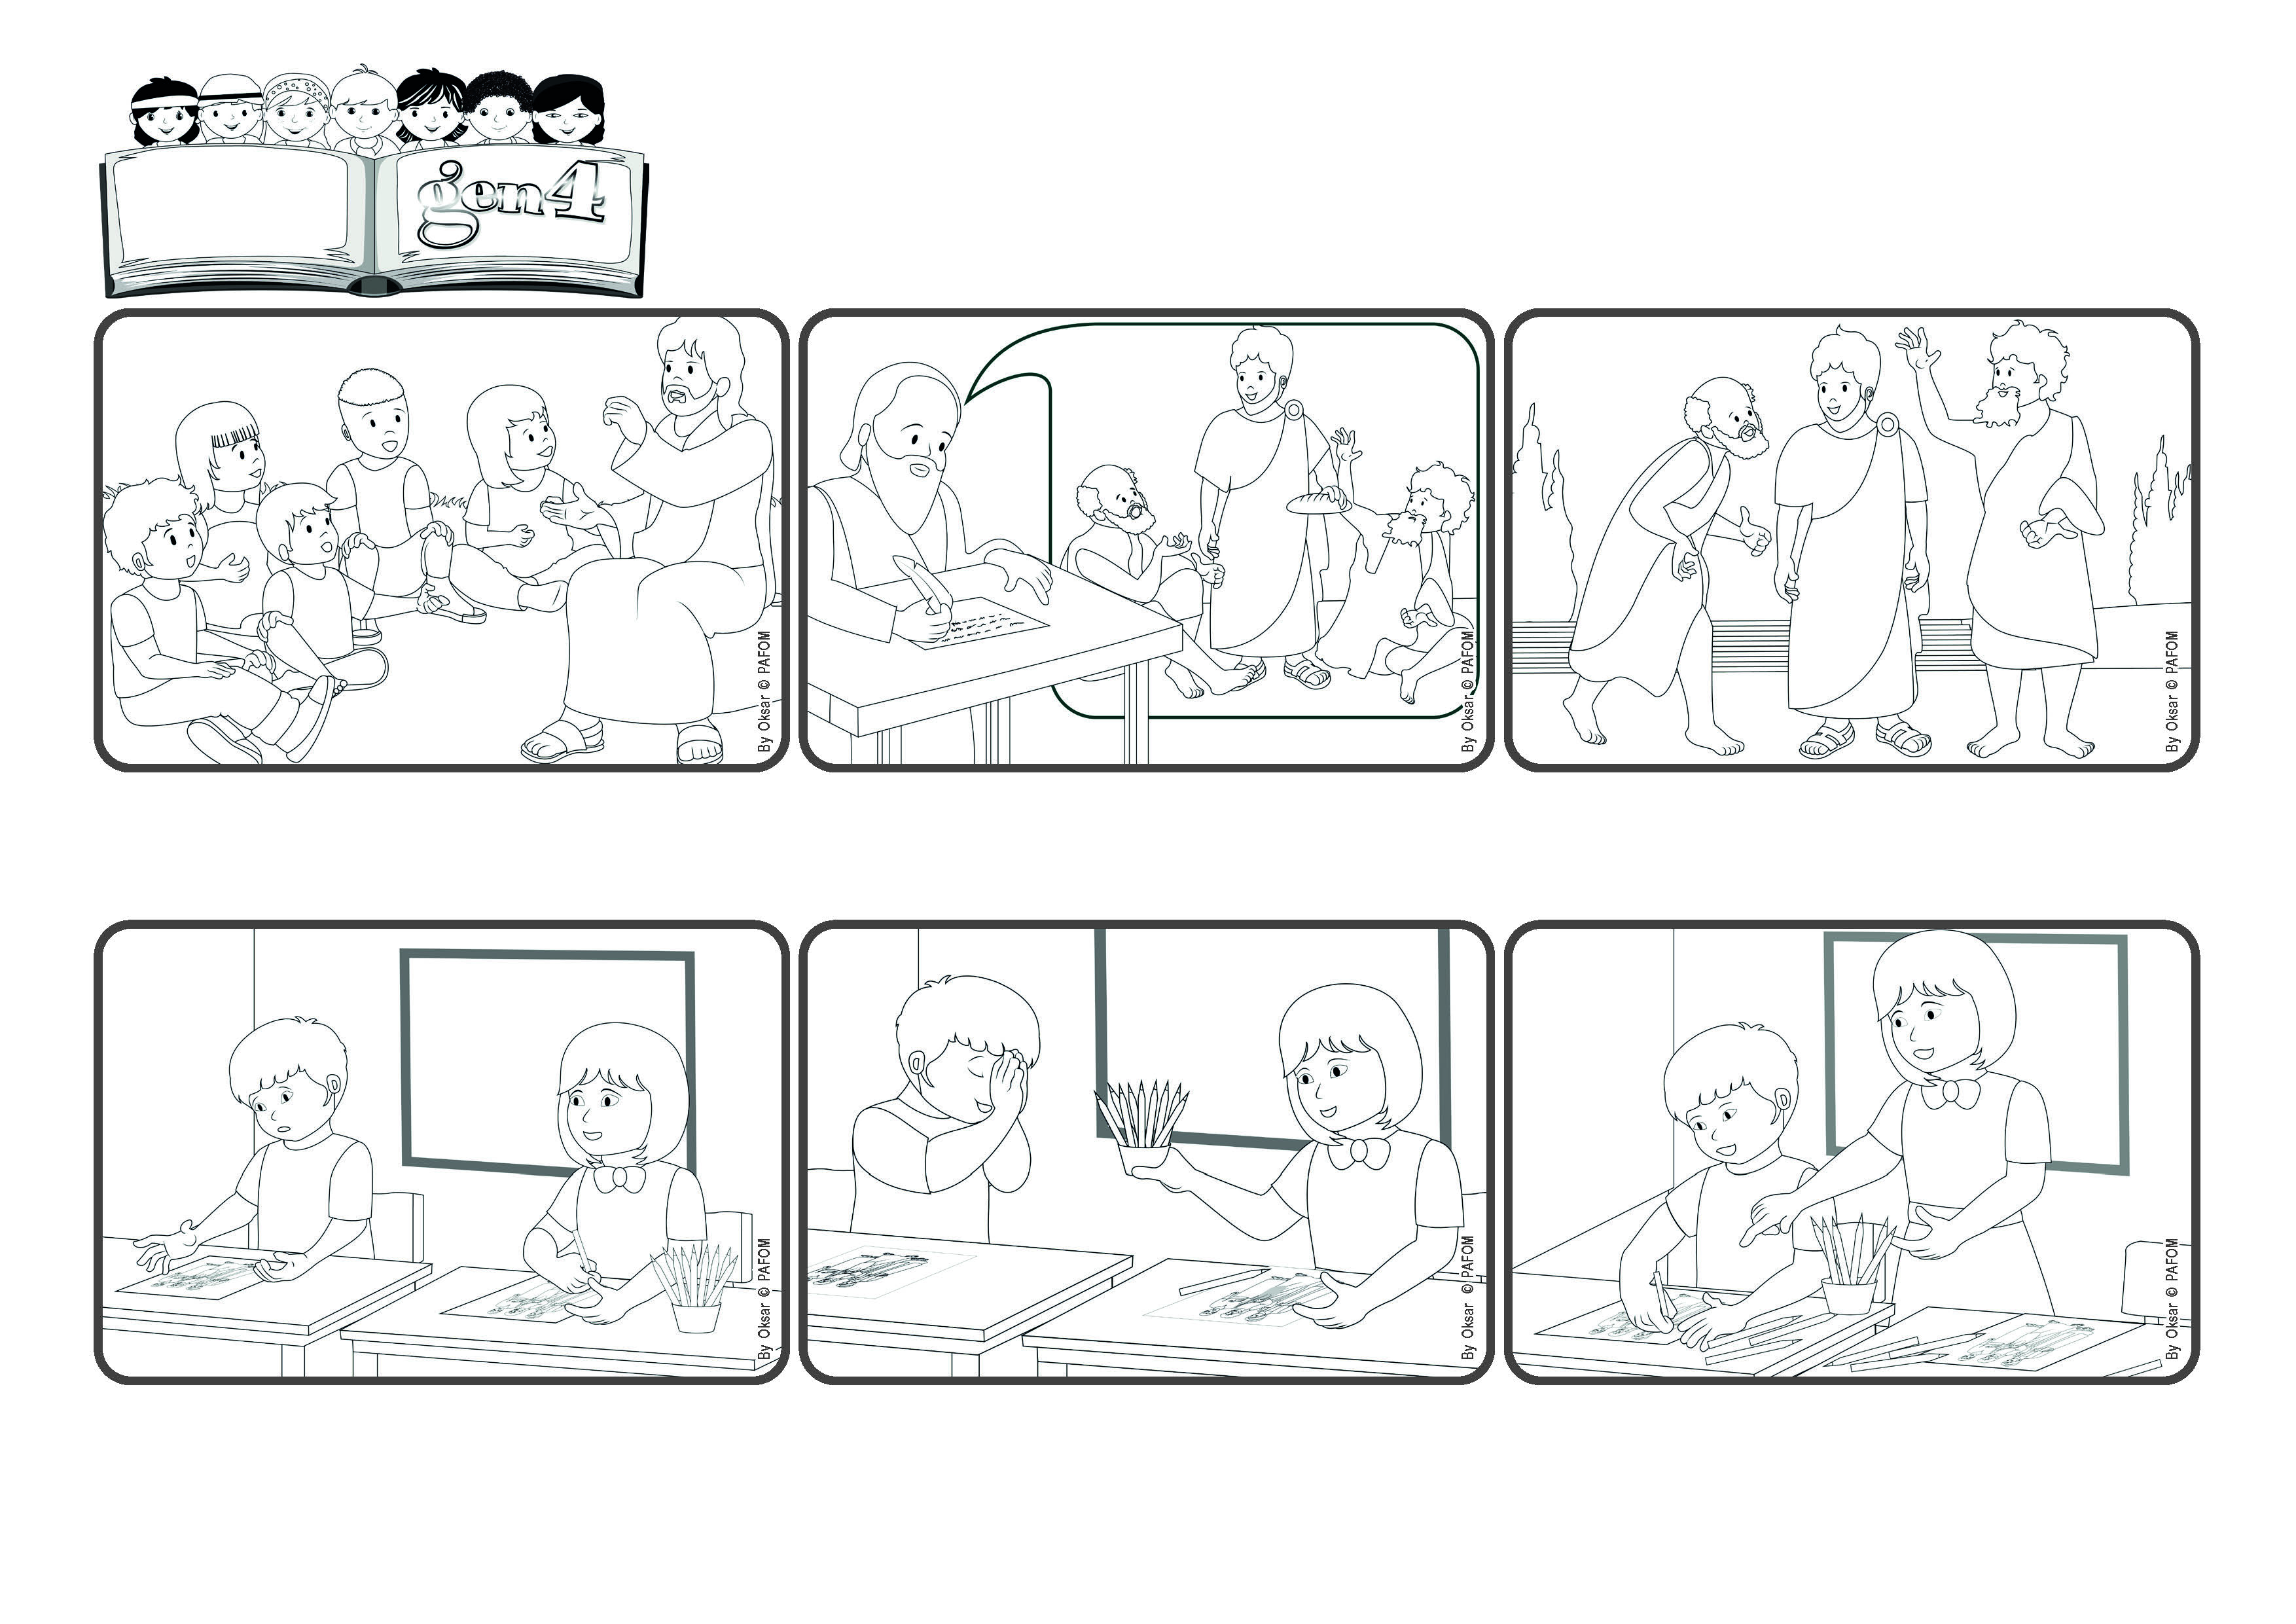

(February 2025 – Bible verse proposed as the theme of the year by the Lutheran Churches)

**«Test everything; hold fast to what is good» (1 Thes 5:21)**

**Let’s choose what is good**

**Word**

**of Life**



**The most important thing, he told them, was to be at peace with one another, helping those who were weak, correcting others with love, never getting even if someone hurts you, and instead always choosing what is good and holding fast to it.**

**After Jesus went back up into heaven, the apostles helped the first Christian communities to live in peace and to love one another. Saint Paul often wrote letters to them, giving them a lot of good advice.**

**When Jesus was on earth, he taught us to live the law of love, which is how we will live in heaven. By loving in each moment, we prepare ourselves to meet him where he is living with God the Father and is waiting for us.**

**I felt very happy because I had chosen the right thing to do by helping someone who was having a hard time. After that, there was more peace in our classroom, more love for one another and everyone was helping each other.**

**He had forgotten his crayons at home! I realized that he needed help, but my other classmates just pretended they didn’t notice. I couldn’t do that! I decided to share my crayons with him.**

**I live in Thailand and I am 8 years old. One day during art class, the teacher gave us a picture to color. As I started to work on it, I noticed that my friend was just staring at the paper with a sad look on his face.**

**© PAFOM, Drawings and text provided by the Gen4 Center.**

**The Gen4 are the young children of the Focolare Movement, which was founded by Chiara Lubich.**