

**March 2020**

**Word**

**of Life**

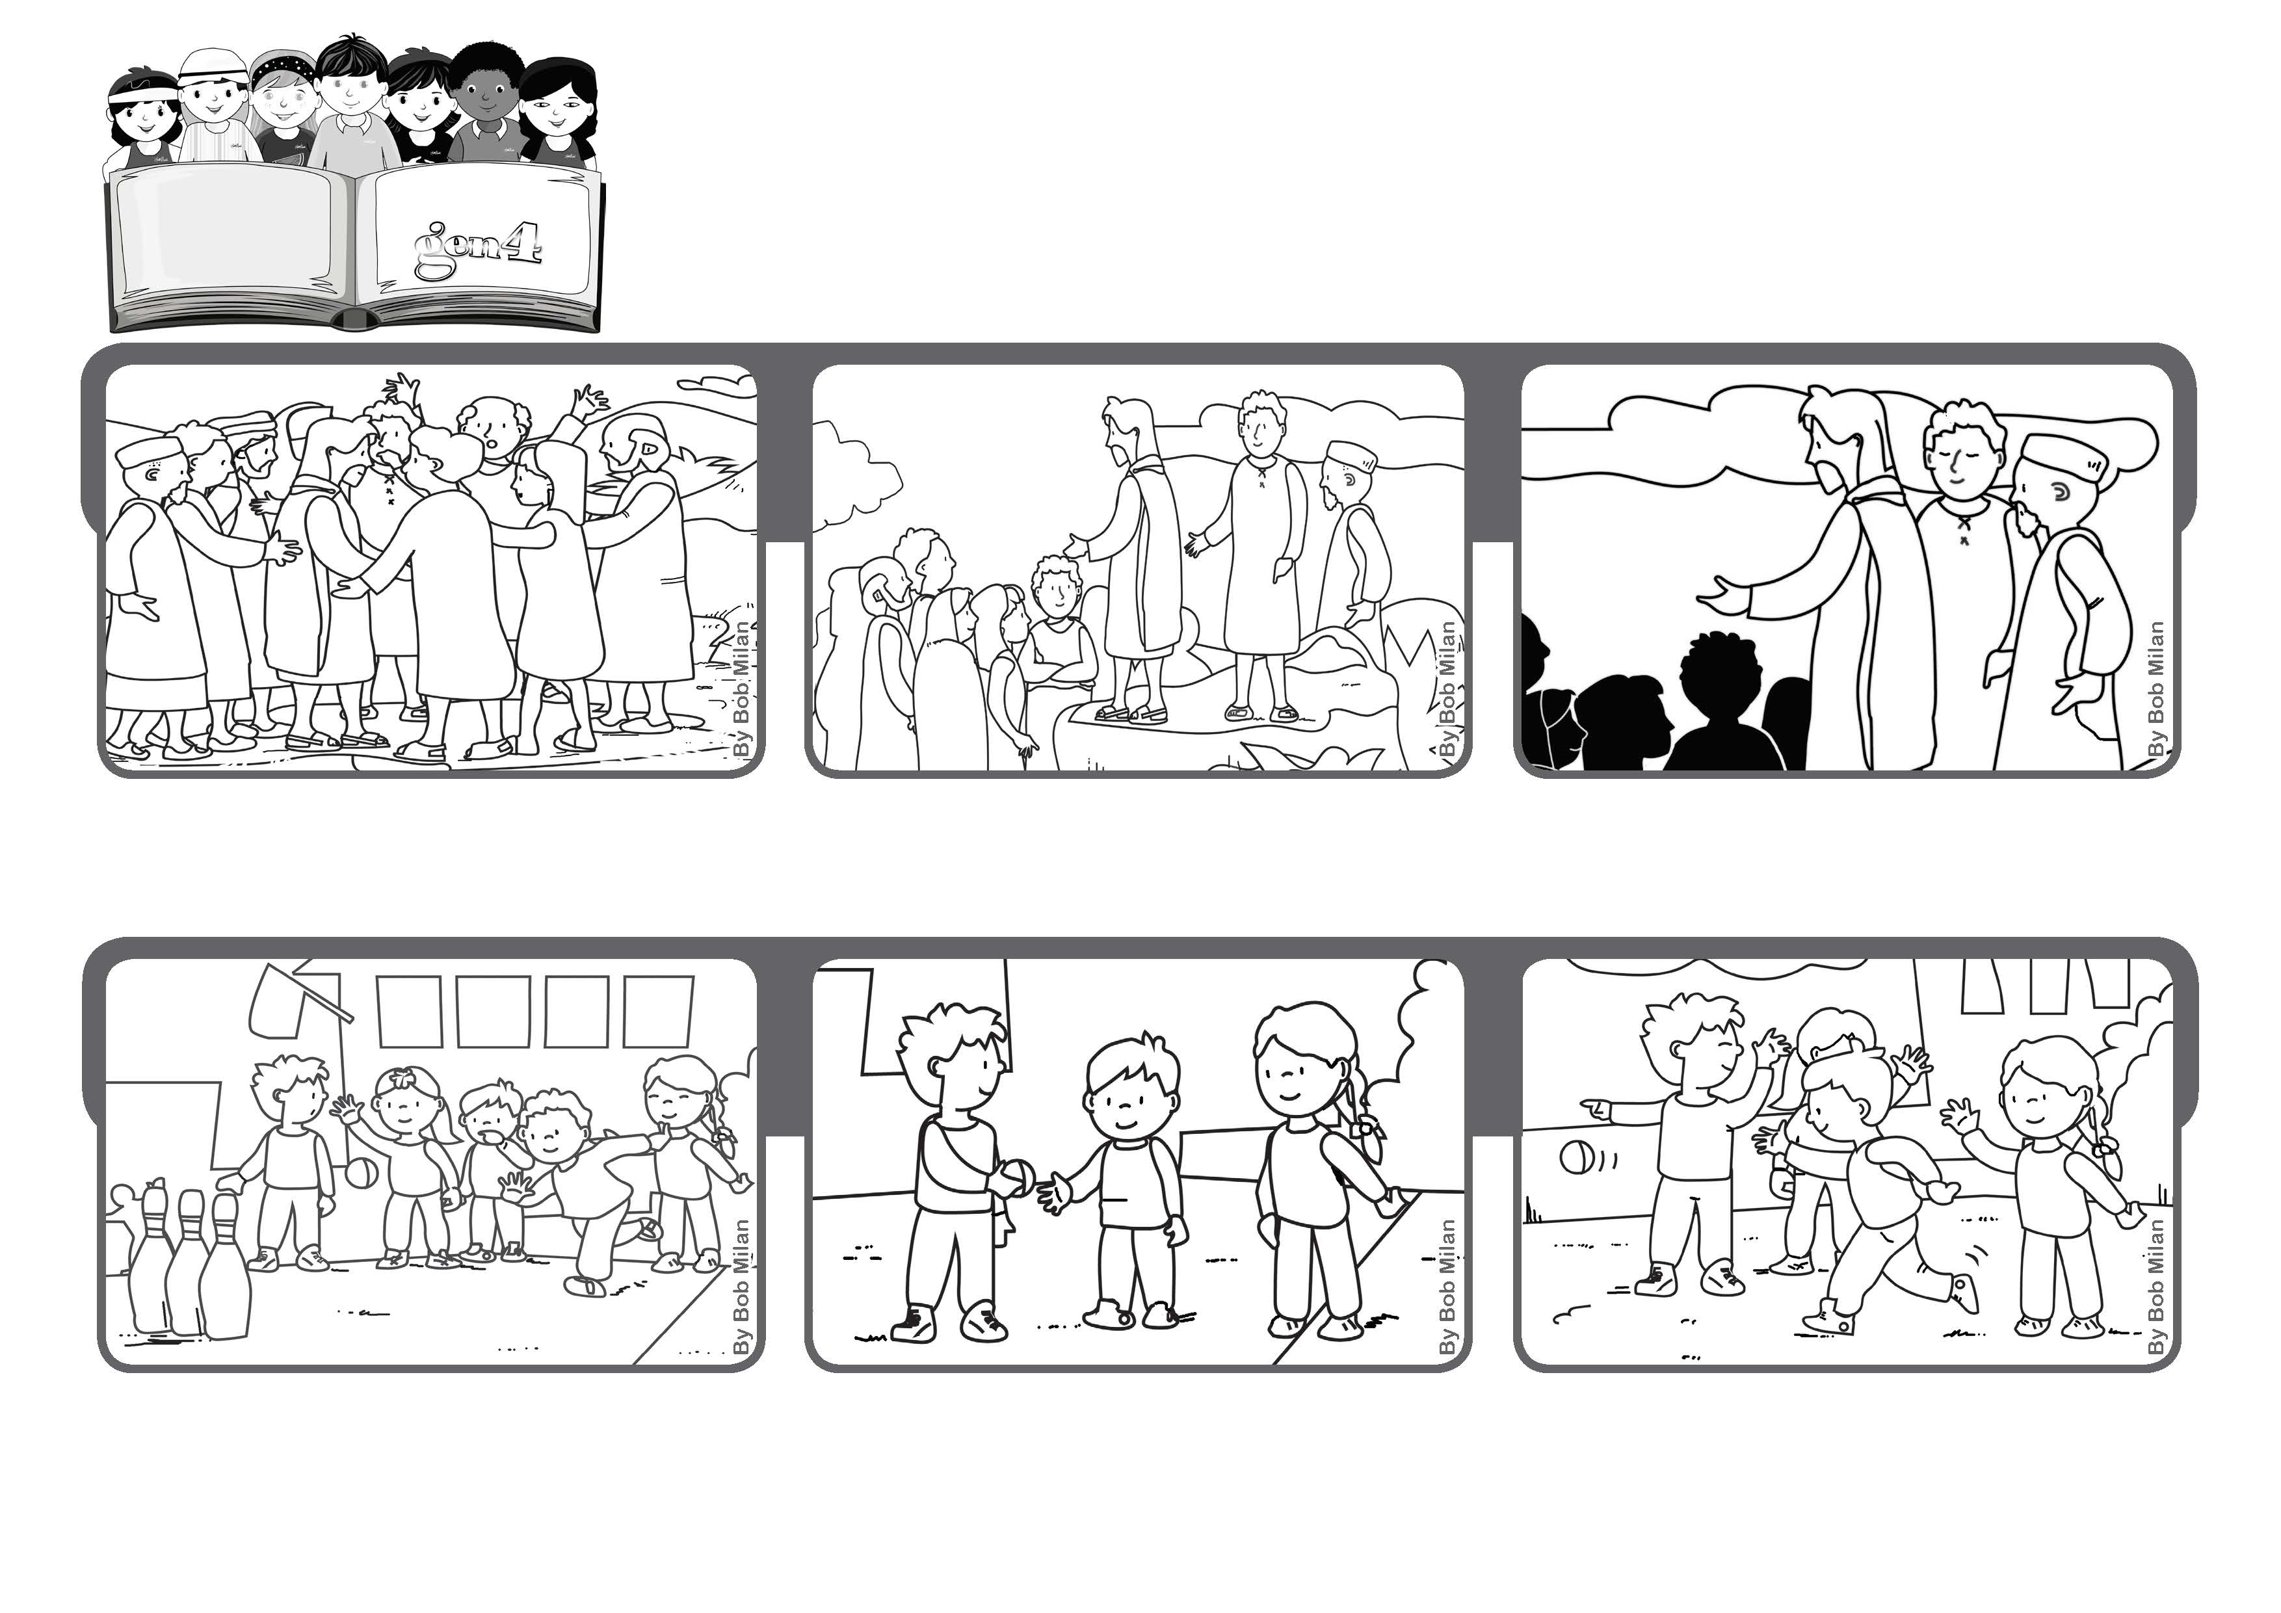

**“In everything do to others as you would have them do to you;**

**for this is the law and the prophets.” (Mt 7:12)**

**The Golden Rule**

**So when it was my turn I let him take my place. He was so happy to roll the ball. Maybe my team got one point less, but in my heart, there was one point more! (Gianni Italia)**

**At school we played games among all the classes. We had to roll the balls and knock over the pins.**

**I saw one little boy who never managed to get a ball and roll it.**

**© PAFOM, Drawings and text provided by the Gen4 Center.**

**The Gen4 are the young children of the Focolare Movement, which was founded by Chiara Lubich.**

**He concluded that day with the Golden Rule, which says, “Do to others as you would have them do to you.”**

**They went up to the top of a hill. It was a wonderful idea because then everyone could hear what Jesus was saying.**

**A lot of people were following Jesus and his disciples. How could he talk to all of them?**