
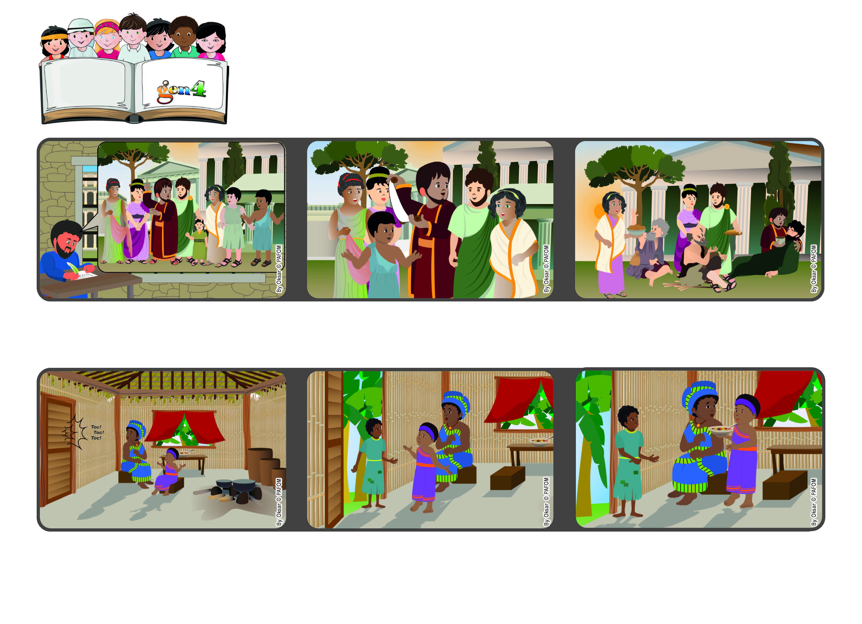
March 2023
Word of Life
“Live as children of light, for the fruit of the light is found in all
that is good and right and true.” (Eph 5:8-9)
Let’s give God’s light to others
with our love
Paul reminds his friends in Ephesus that by living the words of Jesus, our heart is full of the light of love, like true children of God.
So he encourages them to be good, love everyone always and help anyone who is in need.
Lewa remembered that Jesus was in the heart of every person and so she asked her mom: “Can we give her the food we prepared for dinner?” That’s what they did and afterwards they were very happy.
Lewa went to answer it and she saw a very skinny girl who asked her for some food because she hadn’t eaten anything all day long.
The Apostle Paul was in prison in Rome. He wrote to the Christians in Ephesus, where he had lived and had spoken to many people about Jesus.
Experience of Lewa from the Ivory Coast. One afternoon Lewa was at home with her mom. They heard someone knocking on their door.
© PAFOM, Drawings and text provided by the Gen4 Center.
The Gen4 are the young children of the Focolare Movement, which was founded by Chiara Lubich.

