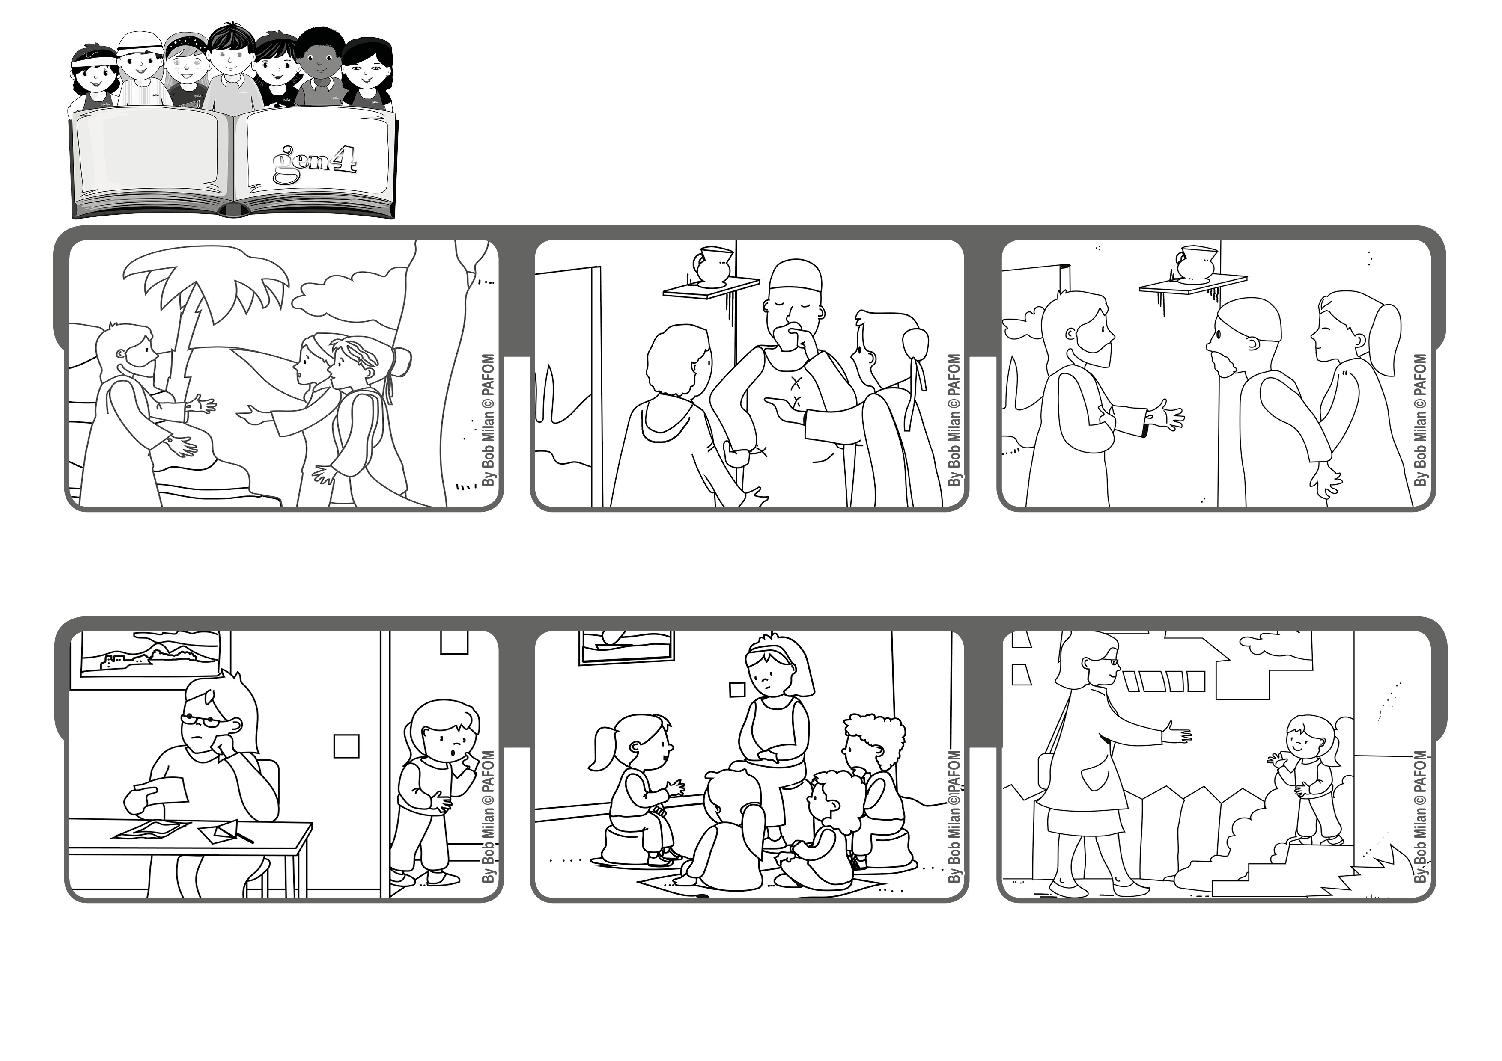
April 2020
Word of Life
“Blessed are those who have not seen and yet believe” (Jn 20:29).
“I believe!”
Isabel lives in Bolivia and her mom was very worried because she had lost her job and now they didn’t have enough money to live on!
At every Gen meeting, Isabel and the other Gen 4 asked Jesus for help. They were sure that he would hear their prayer.
And he did! Isabel told her mom: “Do you know why you found a job? Because we asked Jesus for it!”
Jesus rose from the dead, just as he had promised! He appeared to some women and then to his apostles and other followers.
Thomas was one of the twelve apostles but he wasn’t there when Jesus came. He said he wanted to see and touch him before he would believe.
© PAFOM, Drawings and text provided by the Gen4 Center.
The Gen4 are the young children of the Focolare Movement, which was founded by Chiara Lubich.
One day the apostles were all together and Jesus appeared to them again. Thomas realized the Jesus was really alive. He had risen from the dead!

