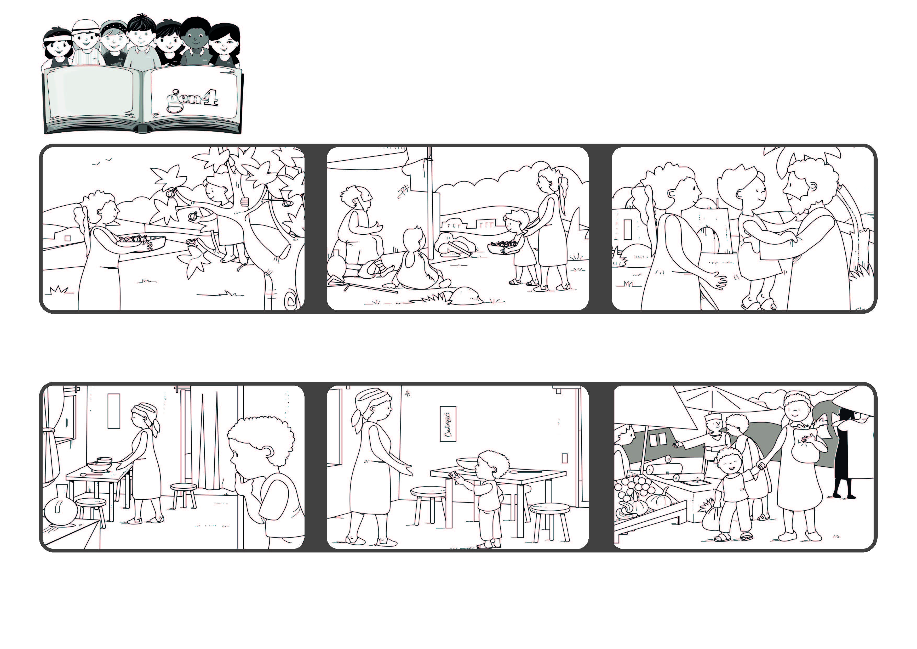
Word of Life
May 2021
“God is love and those who abide in love abide in God,
and God abides in them” (1Jn 4:16)
Never stop loving
The first Christians loved one another and helped anyone in need.
They shared all their things with those who were poor.
Because of their love, God was in their hearts and in their midst.
Elisabeth ran and got her coins and gave them to her mother.
Elisabeth lives in a country in Africa where there is a war going on. Some time ago she received some money as a gift. One night she saw her mom crying because she had no food to feed the family.
They went together to buy some vegetables to make soup for the whole family.
© PAFOM, Drawings and text provided by the Gen4 Center.
The Gen4 are the young children of the Focolare Movement, which was founded by Chiara Lubich.

