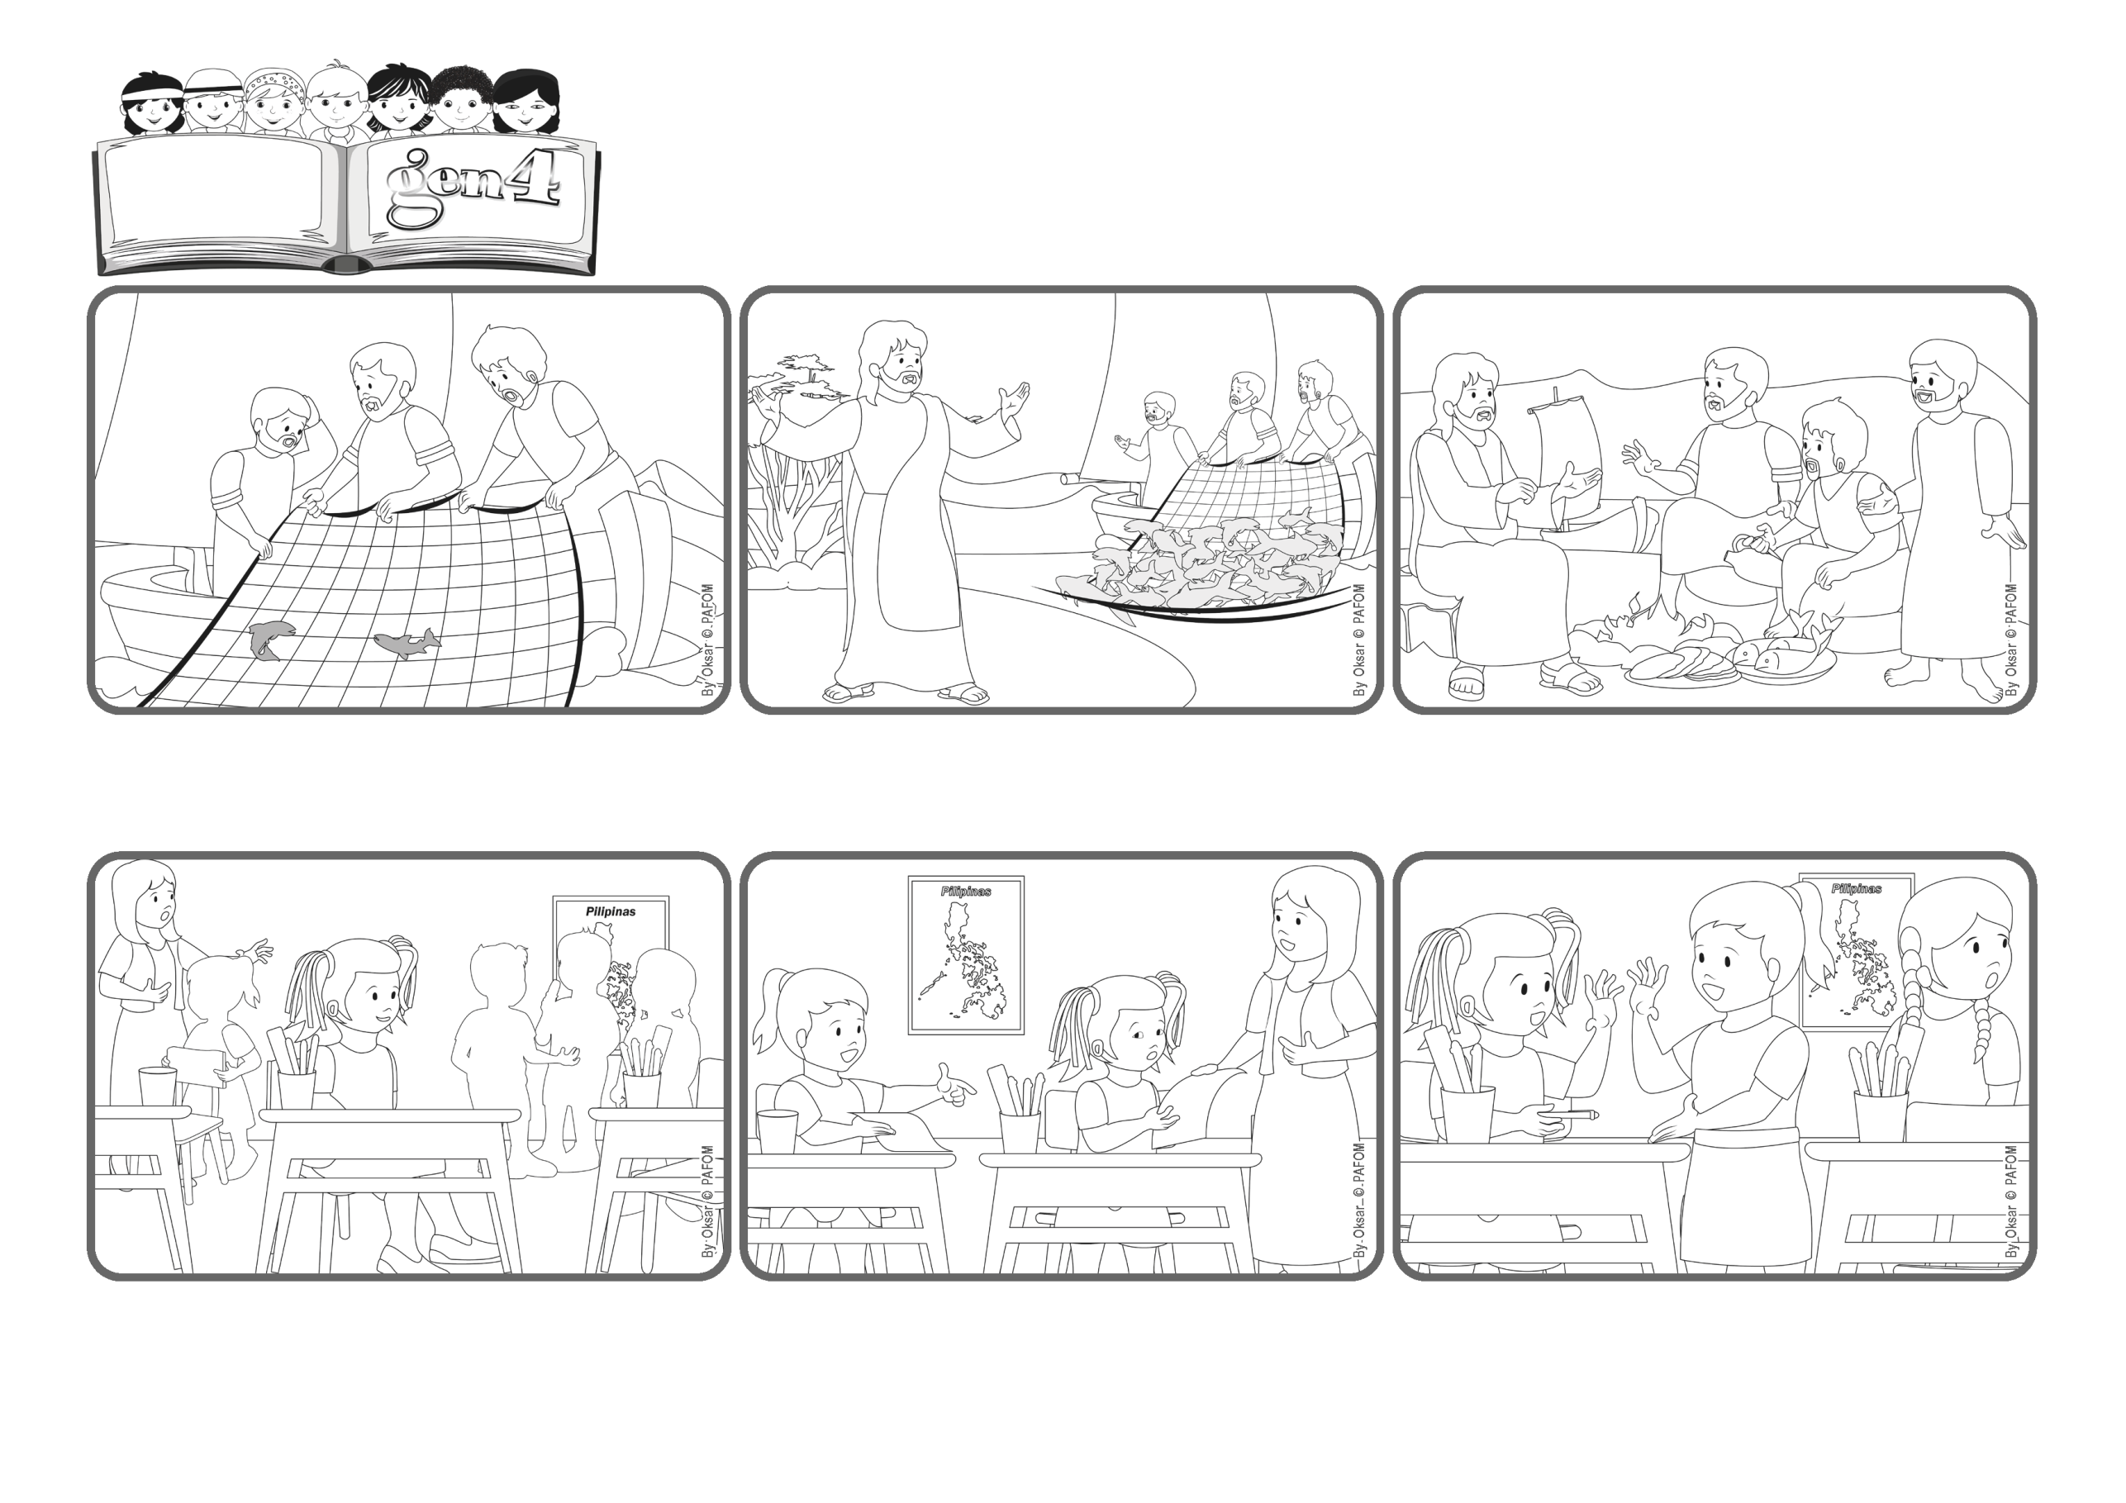

**«Lord, you know everything; you know that I love you.» (Jn 21:17)**

(From the liturgy of May 4, 2025, Third Sunday of Easter)

**Let’s tell Jesus that we love him!**

**Word**

**of Life**



**Someone was standing on the shore and called out to them: “Throw the nets on the other side of the boat!” They did it and the nets were full of fish! That’s when they recognized who it was – it was Jesus! Simon Peter jumped into the water and got to Jesus first, while the others followed in the boat.**

**After eating, Jesus asked Simon Peter: “Do you love me?” Peter answered, “Lord, you know that I love you!” In fact, Jesus knew that Peter loved him and so he asked him to take care of his people when he went back up to heaven.**

**Jesus had risen from the dead! What a joy it was for his friends to see him again! Even though he wasn’t with them all the time, the disciples were often together. One day they went fishing but they didn’t catch anything.**

**The other girls did the same. No one wanted to help her. Regina realized this girl couldn’t do the assignment without a pencil and so she thought: “There’s Jesus in that girl.” So she gave her a pencil and was happy that she had managed to love!**

**The teacher handed out an assignment and one of the girls who had been arguing with her before, asked Regina: “Can I borrow one of your pencils?” Regina didn’t even answer her because she was still upset and didn’t feel like loving her!**

**Regina from the Philippines had this experience. When her classmates came in after recess, some of them were still discussing what happened on the playground. In fact, there had been an argument during a game, and somehow even Regina was involved.**

**© PAFOM, Drawings and text provided by the Gen4 Center.**

**The Gen4 are the young children of the Focolare Movement, which was founded by Chiara Lubich.**