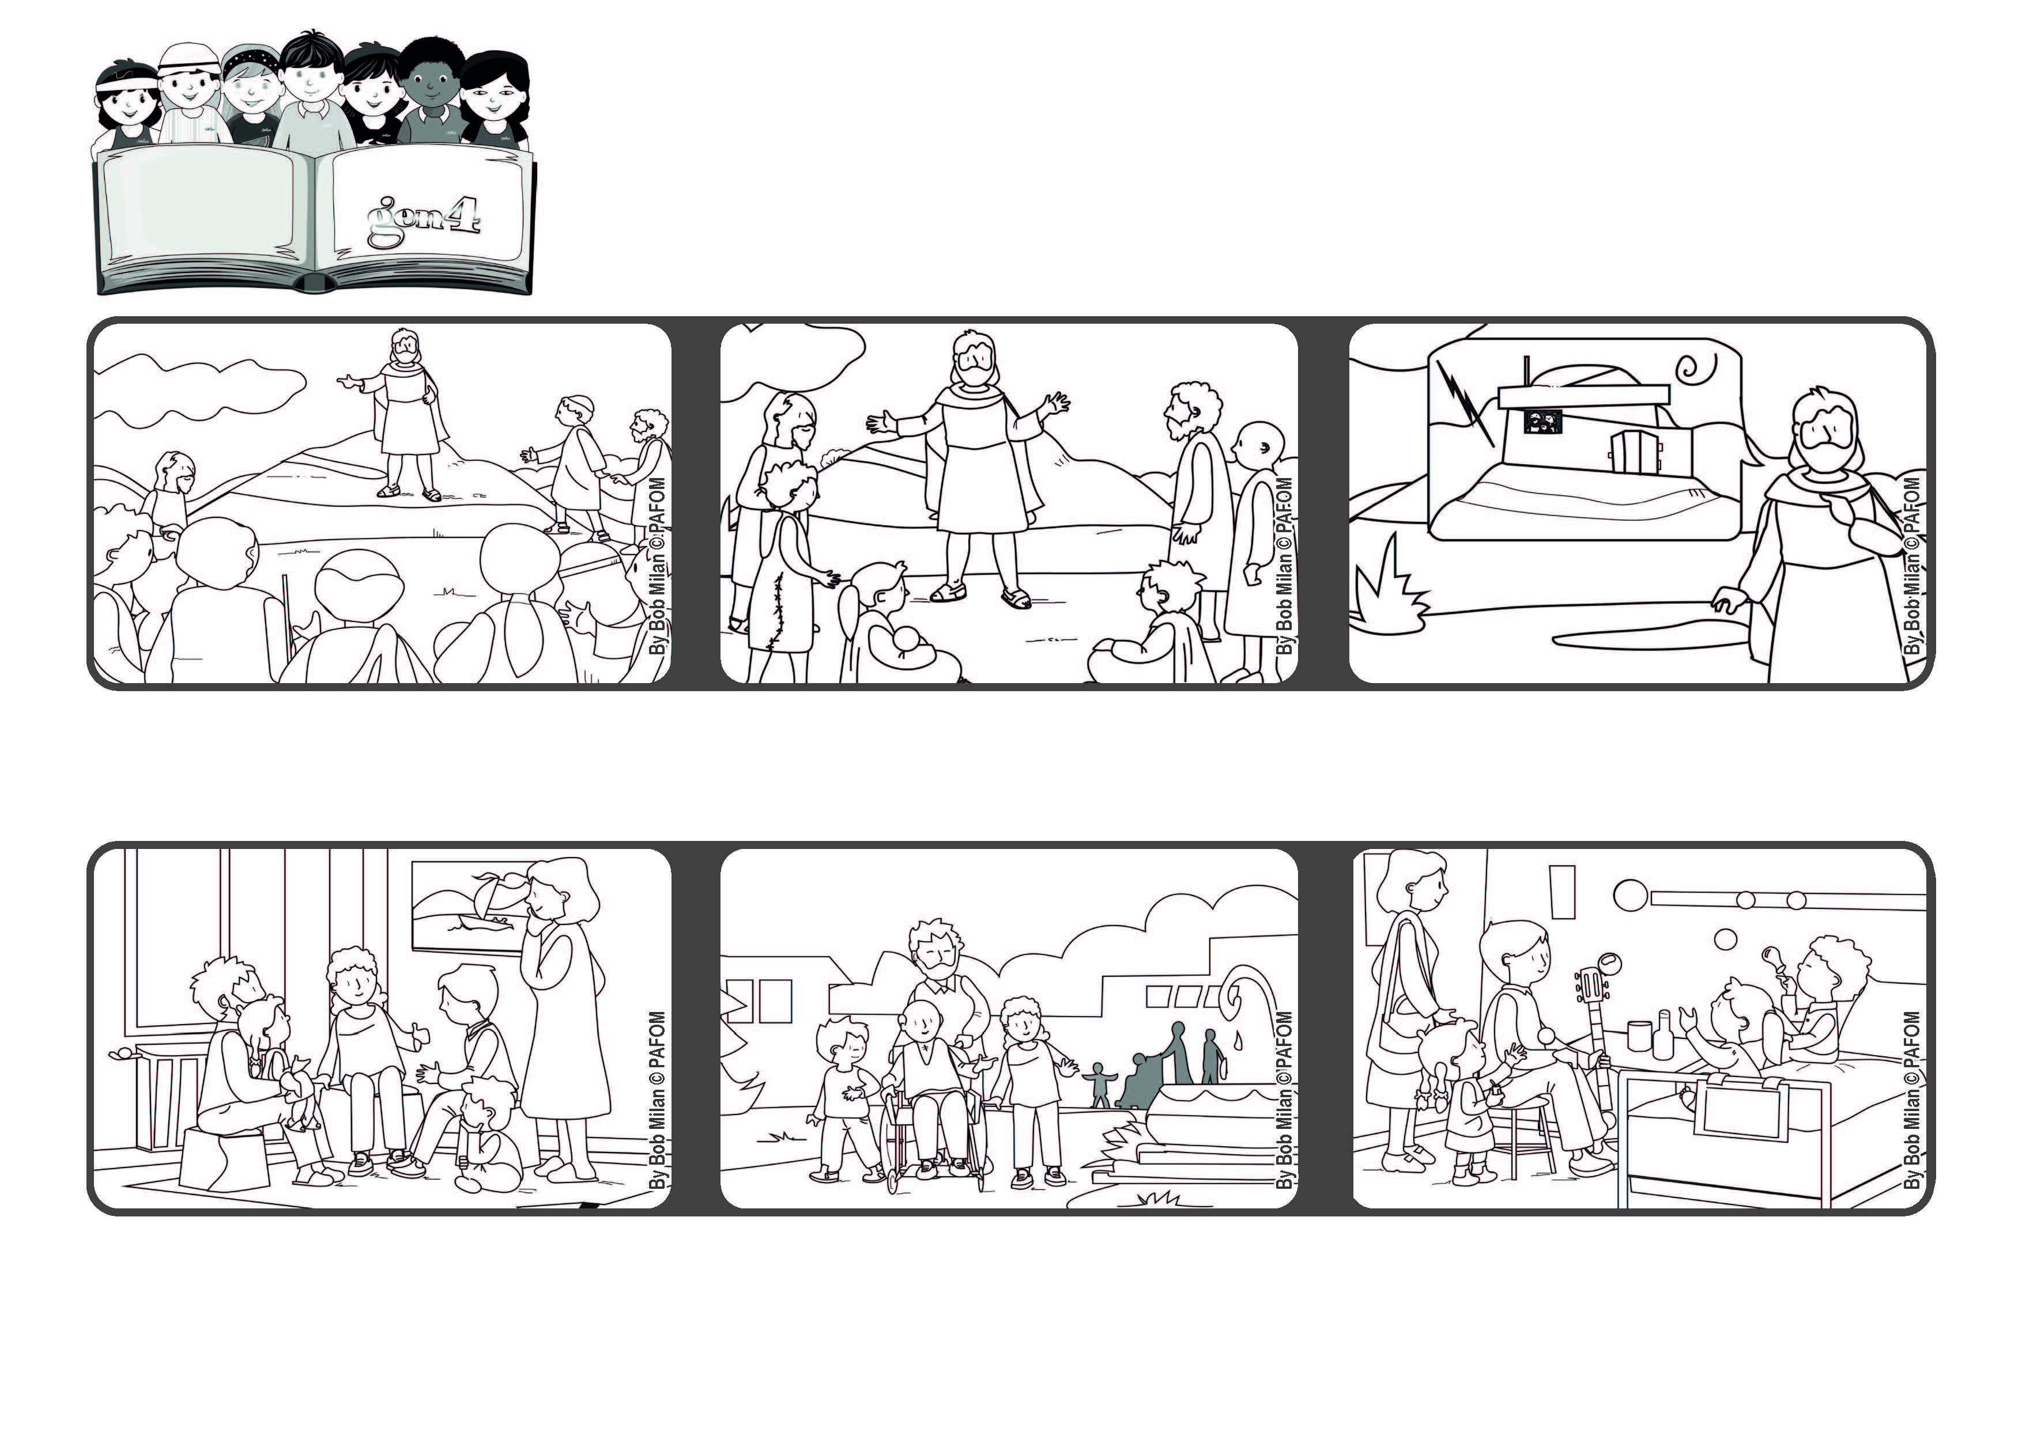
“Not everyone who says to me, ‘Lord, Lord,’ will enter the kingdom of heaven, but only the one who does the will of my Father in heaven.” (Mt 7:21)
Listen to his words and put them into practice!
Word of Life
June 2021
An experience of a group of friends in Heidelberg, Germany: We decided that once a month we would give “an hour of happiness” to someone who is sad or alone or sick.
We went to visit a group of elderly people and took them in their wheelchairs to the nearby park.
Another time we went to a children’s hospital and played with them. They were super-happy and we were even happier!
After Jesus told the people about the beatitudes, he reminded them that God loves everyone and is always right next to each one of us.
Jesus shows us a very good way to respond to God’s great love for us. It is to do his will, which means to love everyone.
Whoever listens to what he teaches and puts it into practice is like a man who builds his house on rock. It will resist any storm and will never be destroyed.
© PAFOM, Drawings and text provided by the Gen4 Center.
The Gen4 are the young children of the Focolare Movement, which was founded by Chiara Lubich.

