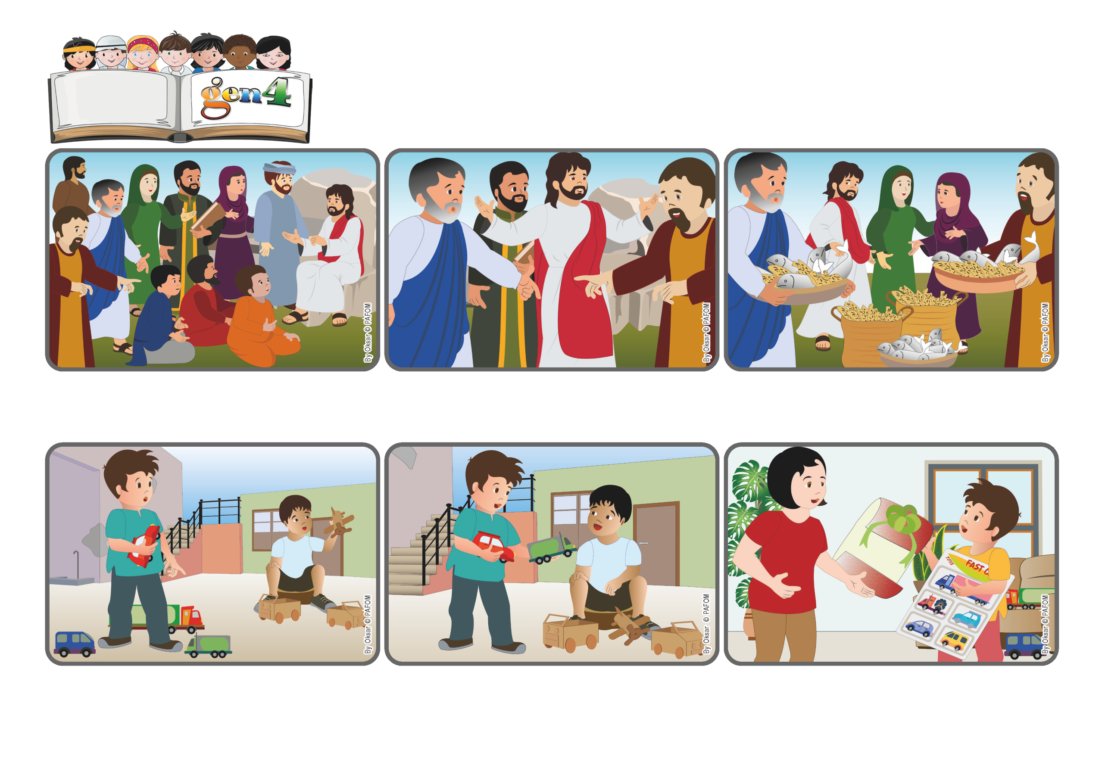

**Word**

**of Life**

**«You yourselves give them something to eat» (Lk 9:13).**

(From the liturgy of June 22, 2025, Solemnity of the Body and Blood of Christ)

**Giving generously works miracles**

**A few days later, his older sister came home and told him: “One of my friends gave this to me for you!” Daniel opened the package and found it full of little toy cars! Jesus had really multiplied the cars he had given away!**

**“It would be great if Jesus would give him some real toy cars!” Then he got an idea. He took two of the cars he was playing with and gave them to that other boy. Daniel was so happy! “Well, Jesus did give him some cars....”he thought, “...with my help!”**

**Daniel from Mexico really loves playing with his toy cars. One day he brought a few of them into the courtyard to play with them. Close by he saw another little boy playing with cars made from cardboard. He kept watching him and thought to himself:**

**They answered: “How can we do that? We only have five loaves of bread and two fish!” But for Jesus even that little bit of food was important. He blessed it, broke it in pieces, and told them to distribute it to the crowd. Everyone had enough to eat and there were even 12 baskets of food leftover!**

**The disciples were worried because it was getting late. They asked Jesus to tell the crowd to leave so they could find a place to eat and sleep overnight. Jesus instead was very much at peace and he told them: “You yourselves give them something to eat.”**

**Many people came to listen to Jesus. He cured many of them and spoke to them about the Kingdom of God. They felt so good being with him that no one wanted to go home! It was already evening, but everyone kept sitting there and listening to him.**

**© PAFOM, Drawings and text provided by the Gen4 Center.**

**The Gen4 are the young children of the Focolare Movement, which was founded by Chiara Lubich.**