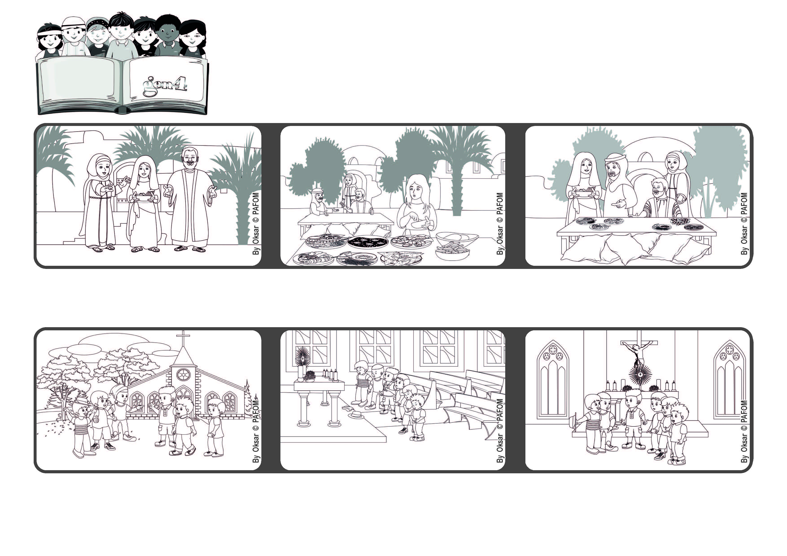

**Word of Life**

**July 2022**

**“There is need of only one thing.” (Lk 10:42)**

**What’s important? Only loving!**



**Before leaving the chapel, Luca said. “I didn’t hear Jesus, but I did understand that he loves us very much.”**

**We spent some moments of silence with Jesus, so that we could listen to him in our hearts. Then we prayed for peace and for all the poor people.**

**An experience of a group of Gen 4 in Italy: We had a very nice afternoon playing together and then we went into the chapel of the school.**

**Martha was a little bit upset about this because she wanted Mary to help her but Jesus explained to her that it’s also important to listen to the voice of God when he speaks to us.**

**One day Jesus was visiting their home. Martha was cleaning the house and then she prepared a good meal for Jesus. Mary instead stopped working to listen to Jesus.**

**Jesus had many friends and among them were Martha, Mary and Lazarus who lived in Bethany.**

**© PAFOM, Drawings and text provided by the Gen4 Center.**

**The Gen4 are the young children of the Focolare Movement, which was founded by Chiara Lubich.**