**Word of Life**

**September 2020**

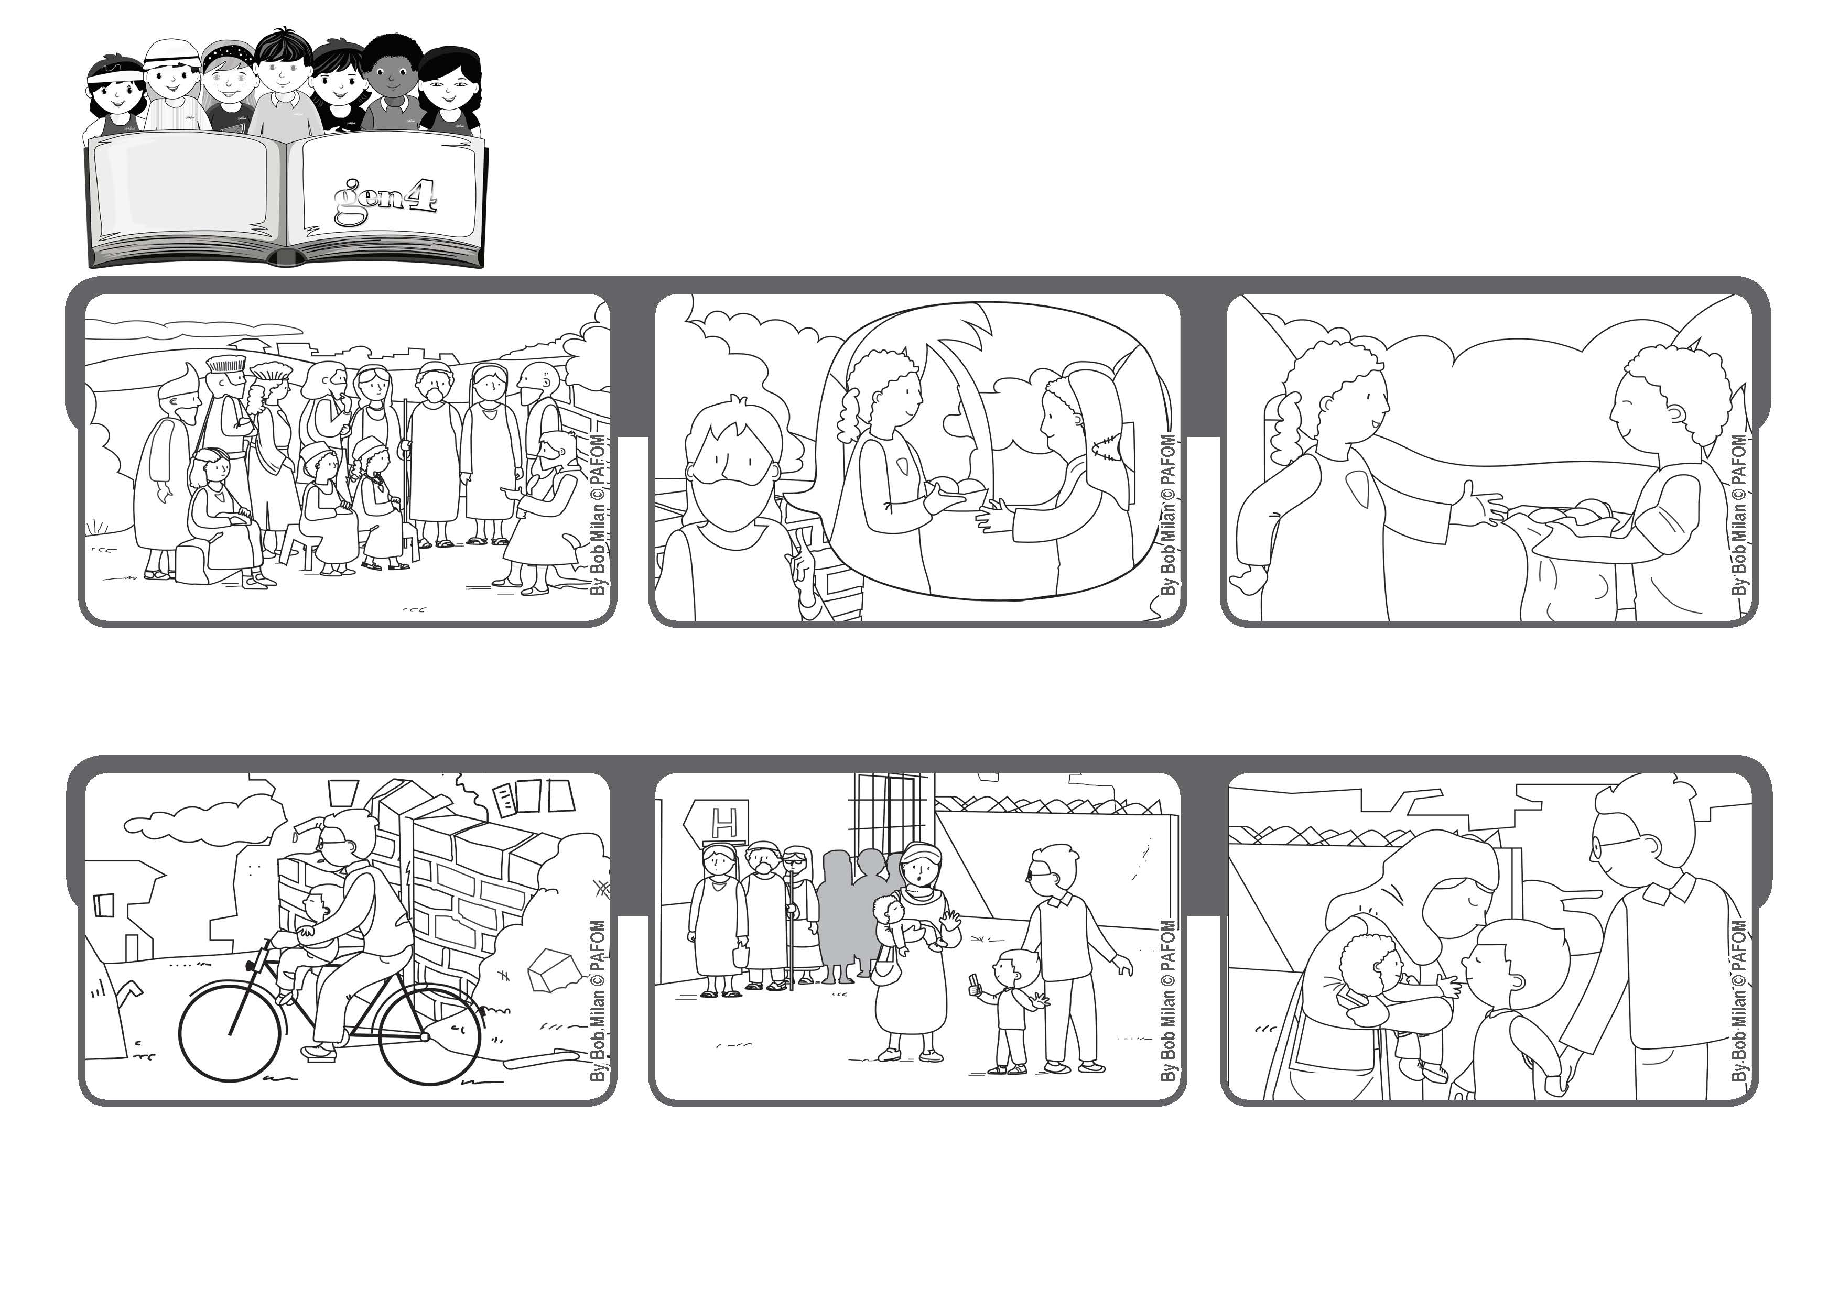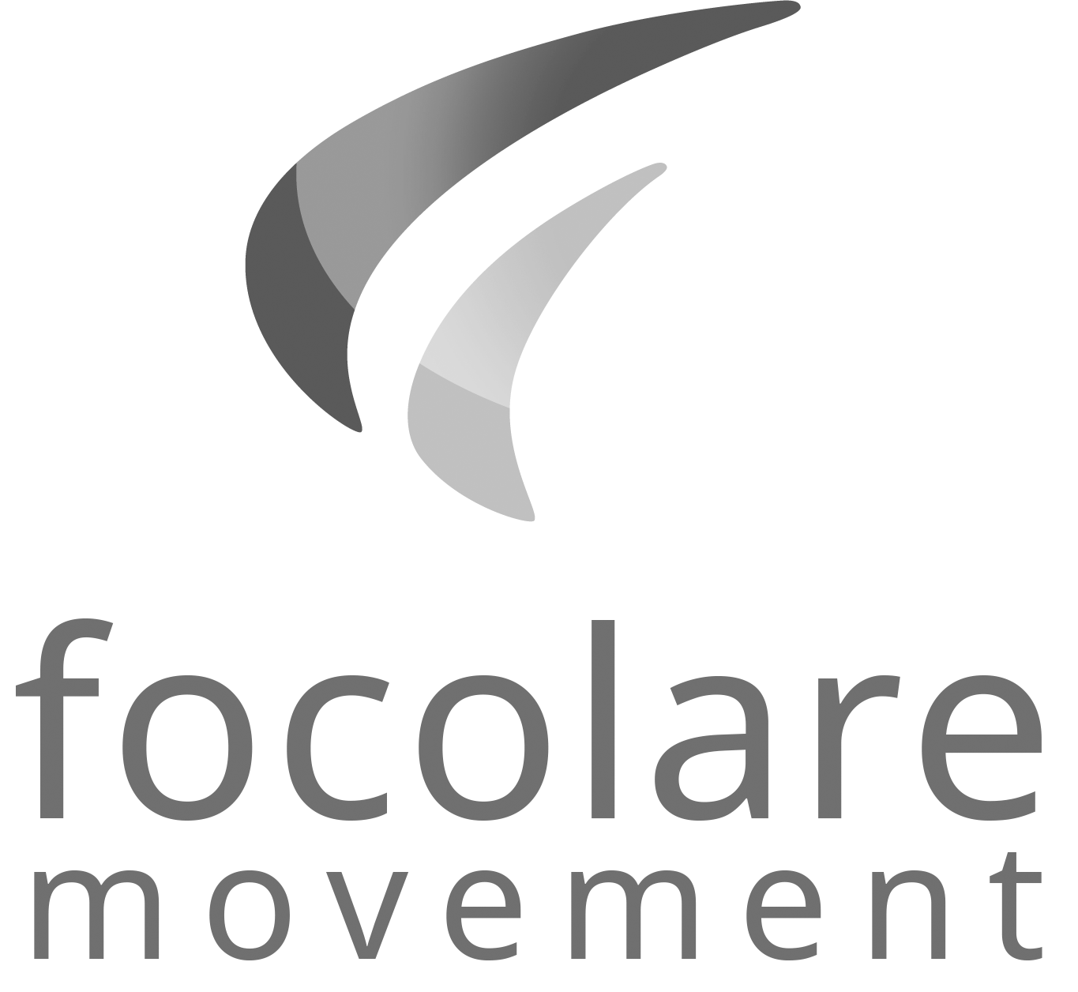

**“Give, and it will be given to you. A good measure, pressed down, shaken together, running over, will be put into your lap” (Lk 6:38).**

**Let’s give with joy**

**Many people were waiting in line and Fadi realized that one mother couldn’t get the medicine her child needed. It was the same medicine as was given to Fadi, so he decided with his dad to let the women have his medicine.**

**Jesus invited them all to give everything to others, not only material goods but also forgiveness and hospitality.**

**People from many different cities and of different backgrounds came to listen to Jesus.**

**Then he added that God our Father will give us back in abundance for all that we have given. He will give us heaven and often a reward here on earth, too.**

**In Fadi’s country the war destroyed had all the water pipes in the city. By drinking contaminated water, he too got sick. His father took him to the hospital.**

**The woman kissed Fadi to show him how grateful she was. A few days later, Fadi got well, even without the medicine.**

**© PAFOM, Drawings and text provided by the Gen4 Center.**

**The Gen4 are the young children of the Focolare Movement, which was founded by Chiara Lubich.**