

**October 2020**

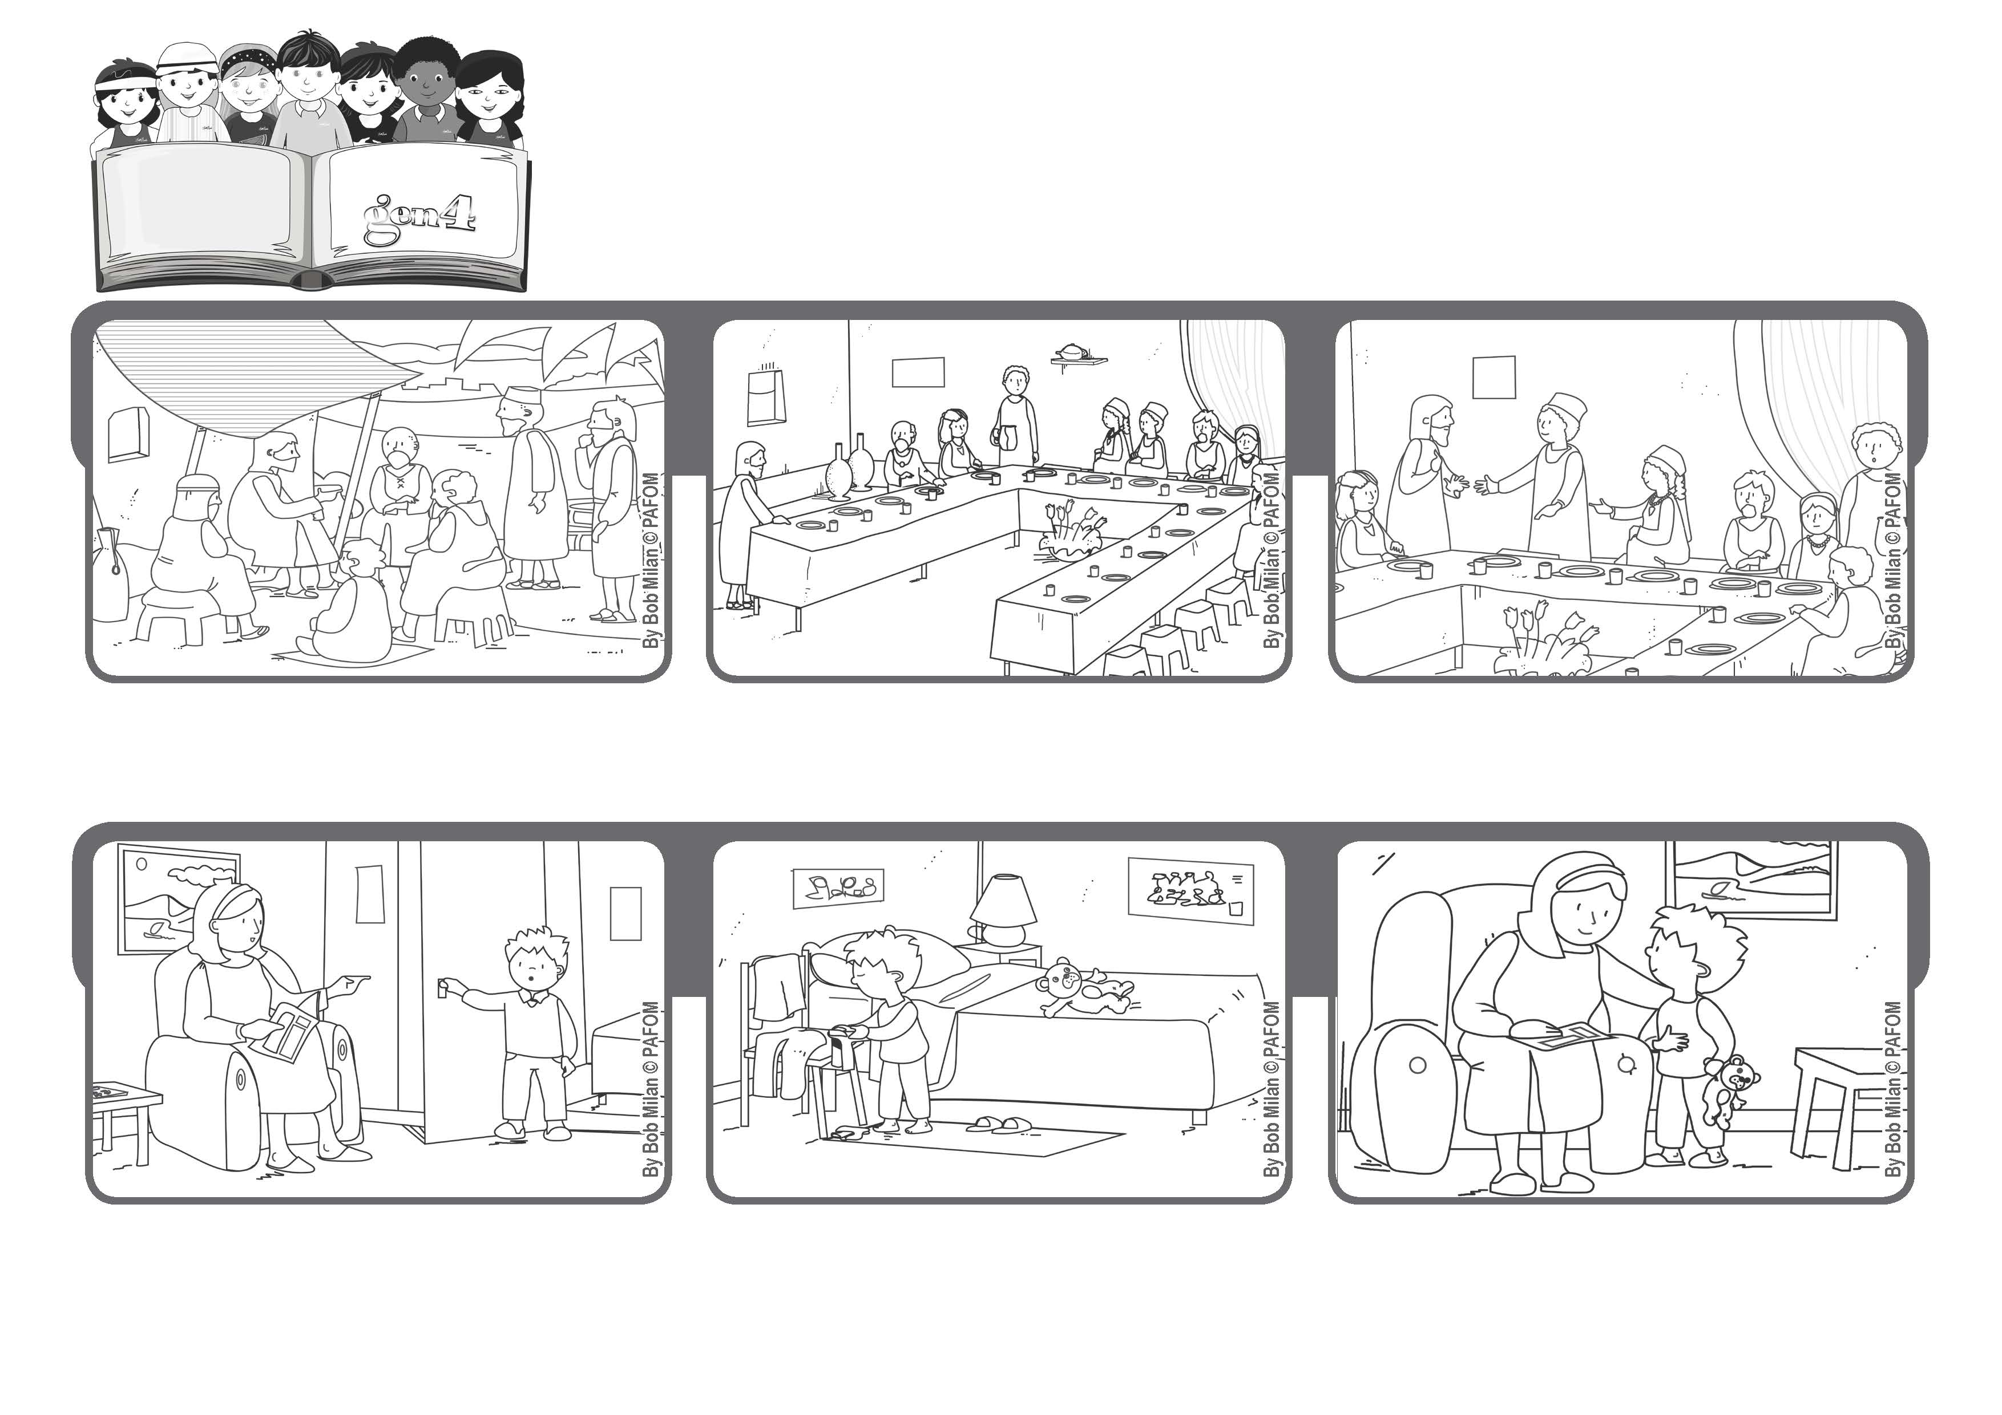

**“For all who exalt themselves will be humbled, and those who humble themselves will be exalted” (Lk 14:11).**

**Be like Jesus**

**Word of Life**

**Anthony accepted and went to get ready for bed by himself.**

**He said that if you are invited to a wedding feast, don’t take the best seat, but rather go to the back of the room.**

**Even though he was God, Jesus chose to be the servant of everyone. He asks his followers to be humble and he gives them an example.**

**When the person who invited you arrives and sees you sitting in back, he will say, “My friend, come up here in front” and you will be very happy.**

**(read Luke 14:8-10)**

**The experience of Antonio from Italy: One evening Antonio asked his mother to help him put on his pygamas, but his mom was tired and told him to do it by himself.**

**Then he went back to give his mom a kiss and told her: “Mommy, offer your tiredness to Jesus. I didn’t want to do my homework either, but then I thought about it and decided to do it.”**

**© PAFOM, Drawings and text provided by the Gen4 Center.**

**The Gen4 are the young children of the Focolare Movement, which was founded by Chiara Lubich.**