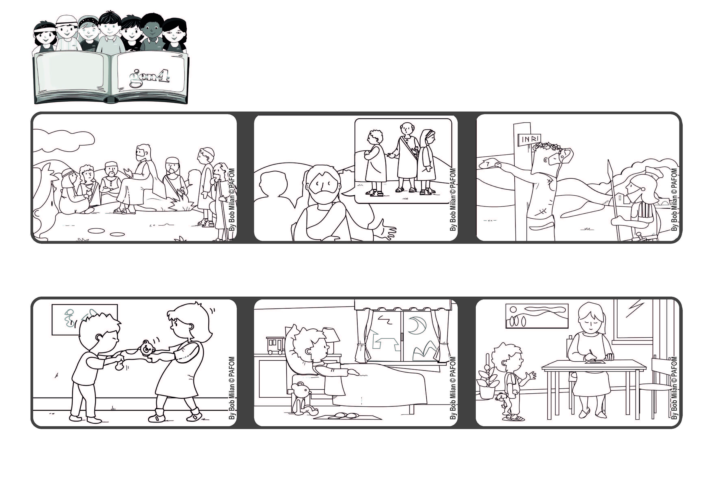



**November 2021**

**Word of Life**

**“Blessed are the peacemakers,**

**for they will be called children of God.” (Mt 5:9)**

**Let’s bring peace everywhere**

**That night in bed I thought about our fight and I couldn’t fall asleep. I wanted to tell her I was sorry, but I don’t know how to write yet. So I got an idea.**

**Experience of Paolo from Argentina: One day I had a fight with my older sister.**

**He also talked about those who bring peace. They are people who use their mind, heart and strength to overcome the selfishness that keeps people apart.**

**Jesus didn’t only talk about it, but he even gave his life so that people on earth would live as brothers and sister. If we bring peace everywhere, we will be like him.**

**Jesus went up on a mountain and sat down. He told the people about the “beatitudes,” listing all those who are truly “blessed” and full of joy.**

**The next morning I asked my mom to write it for me. I told her to write: “Please forgive me and I forgive you too. I love you!”**

**© PAFOM, Drawings and text provided by the Gen4 Center.**

**The Gen4 are the young children of the Focolare Movement, which was founded by Chiara Lubich.**