
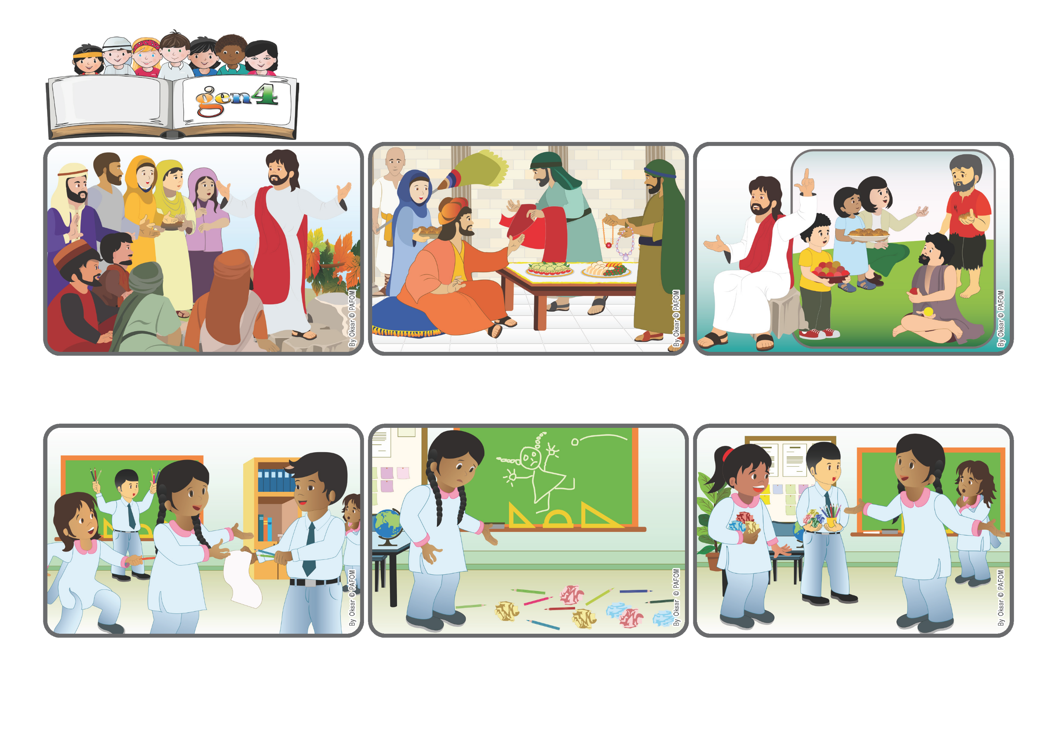
Let’s work for peace
«Blessed are the peacemakers, for they will be called children of God » (Mt 5:9).
Word
of Life
(From the liturgy of Saturday, November 1, All Saints Day)
Samina from Pakistan told us this experience: One day at school we had a drawing lesson towards the end of the morning. We were all a bit tired and some of the children started to play with the paper and pencils and even throw them around the room.

The classroom was a mess! The floor was full of paper and pencils and this made me very sad. Our teacher had gone out for a moment but she would be back soon. I tried to tell my classmates to stop...

Instead everyone started arguing with me! I felt really bad about that, but I still tried to love each one of them. Little by little, peace returned among us and they said they were sorry. We were all happy again! It was so nice to go back to being friend!

That’s what he was telling them! He said that those who are really happy are the ones who are meek, with pure hearts, who want to do what is right, who help others when they have problems and always try to bring peace. These are the ones who will be called “children of God!”
There was a big crowd following Jesus and so he had to go up on a hill so that they could hear him better. He wanted to tell them some things that were very important, but difficult to understand because exactly the opposite of what most people think.
Even back then, many people thought that to be happy you had to have many things, think only of yourself, boss others around, and so on. Rich people usually didn’t help poor people. Instead, according to Jesus, who are the happiest people?
© PAFOM, Drawings and text provided by the Gen4 Center.
The Gen4 are the young children of the Focolare Movement, which was founded by Chiara Lubich.

