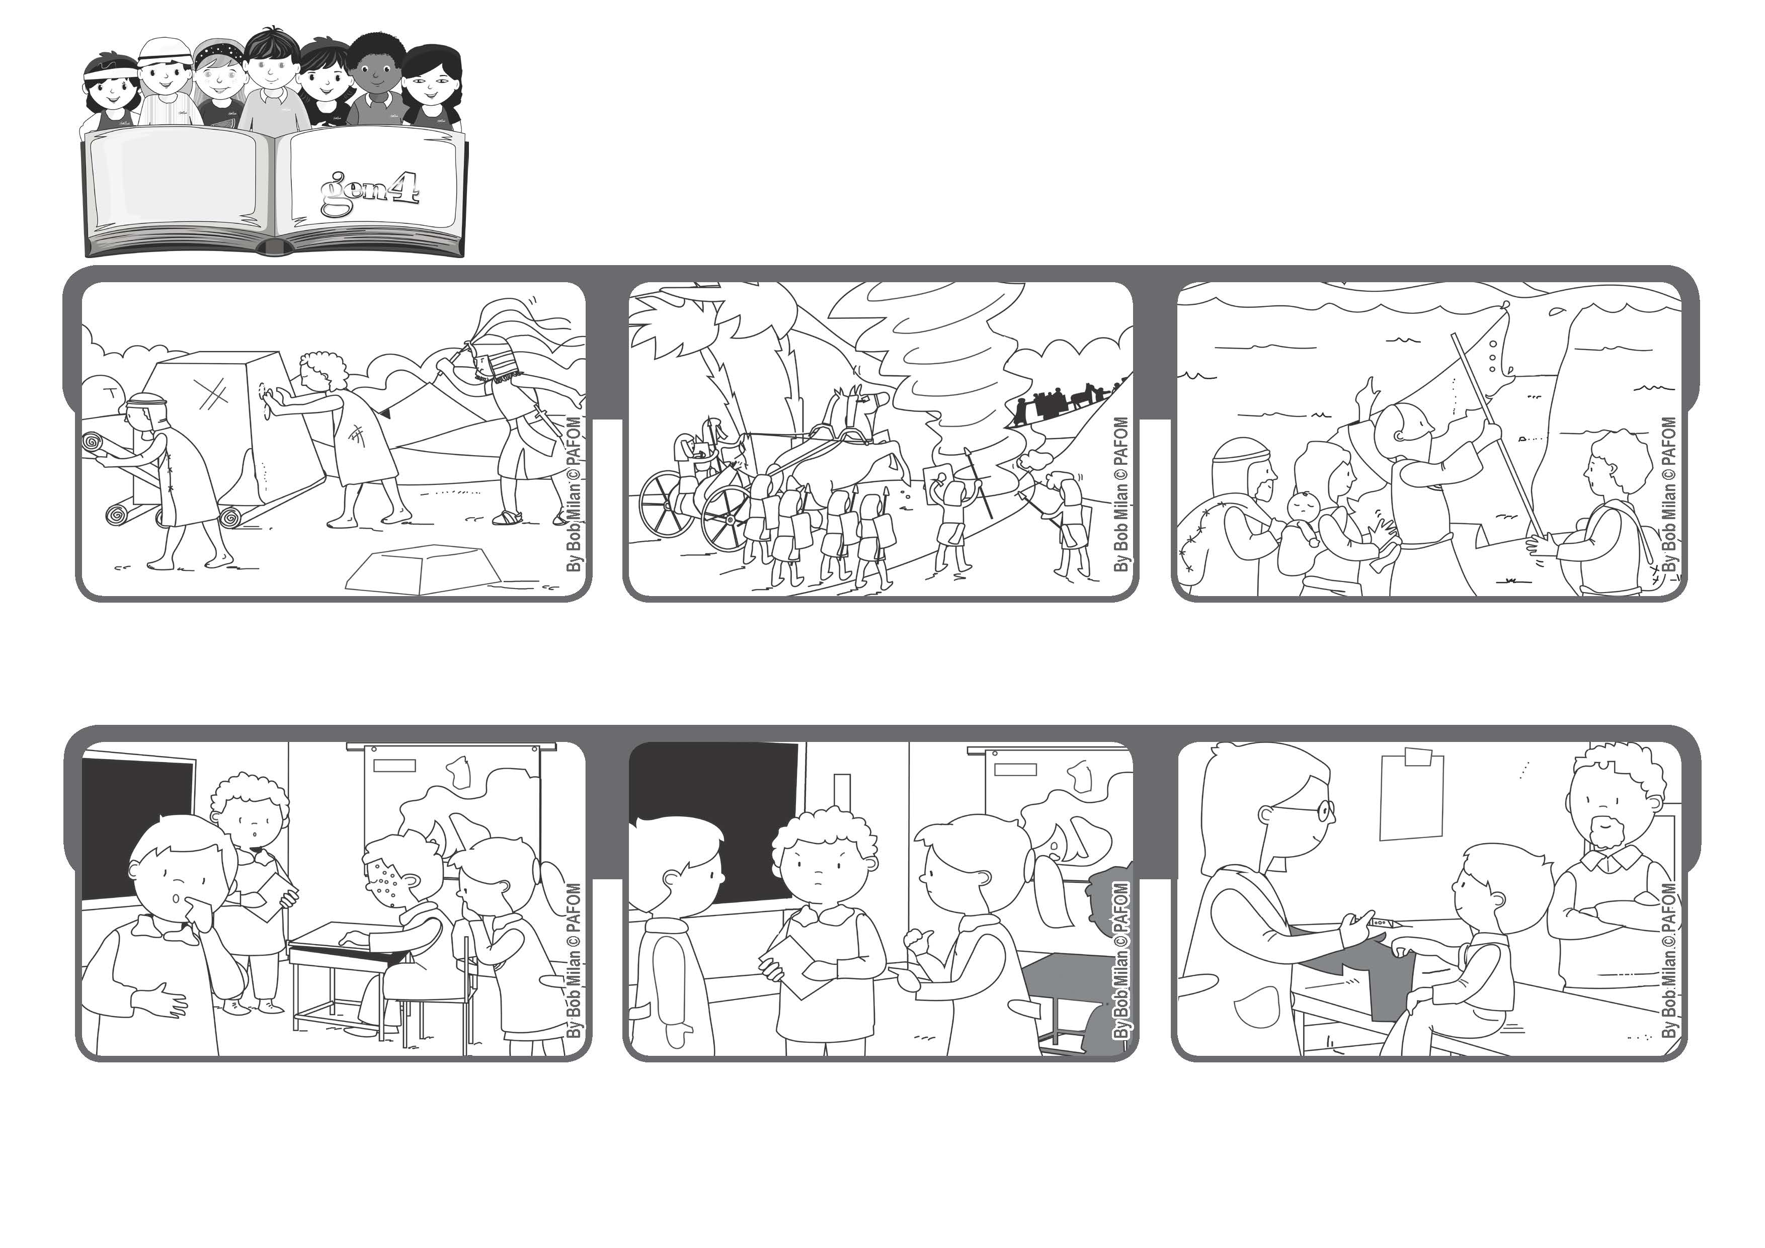

**December 2020**

**“The Lord is my light and my salvation; whom shall I fear?” (Ps 27:1)**

**Trust in me!**

**Word of Life**

**A lot of the children were angry with my friend because the shot was painful, but I remembered Jesus. He certainly didn’t get angry at those who nailed him to the cross where he suffered a lot.**

**During those years that were so sad and full of hardships, they felt that God never left them alone.**

**The Hebrews lived through many difficult moments, like when they had to leave their country and live in a foreign land far away.**

**He helped them know what to do, he protected them and he always brought them to freedom. We trust God, too. His love for us is like the sun that never sets.**

**One of my friends had an infectious disease and so all the children in my class had to go to the doctor to get a shot so that we wouldn’t get sick.**

**So I didn’t get angry with my friend either. I went to get the shot without being afraid of the pain.**

**Bernard’s experience**

**© PAFOM, Drawings and text provided by the Gen4 Center.**

**The Gen4 are the young children of the Focolare Movement, which was founded by Chiara Lubich.**