**“Whoever does the will of my Father in heaven is my brother and sister and mother.” (Mt 12:50)**

**Be the brother or sister or mother of Jesus**

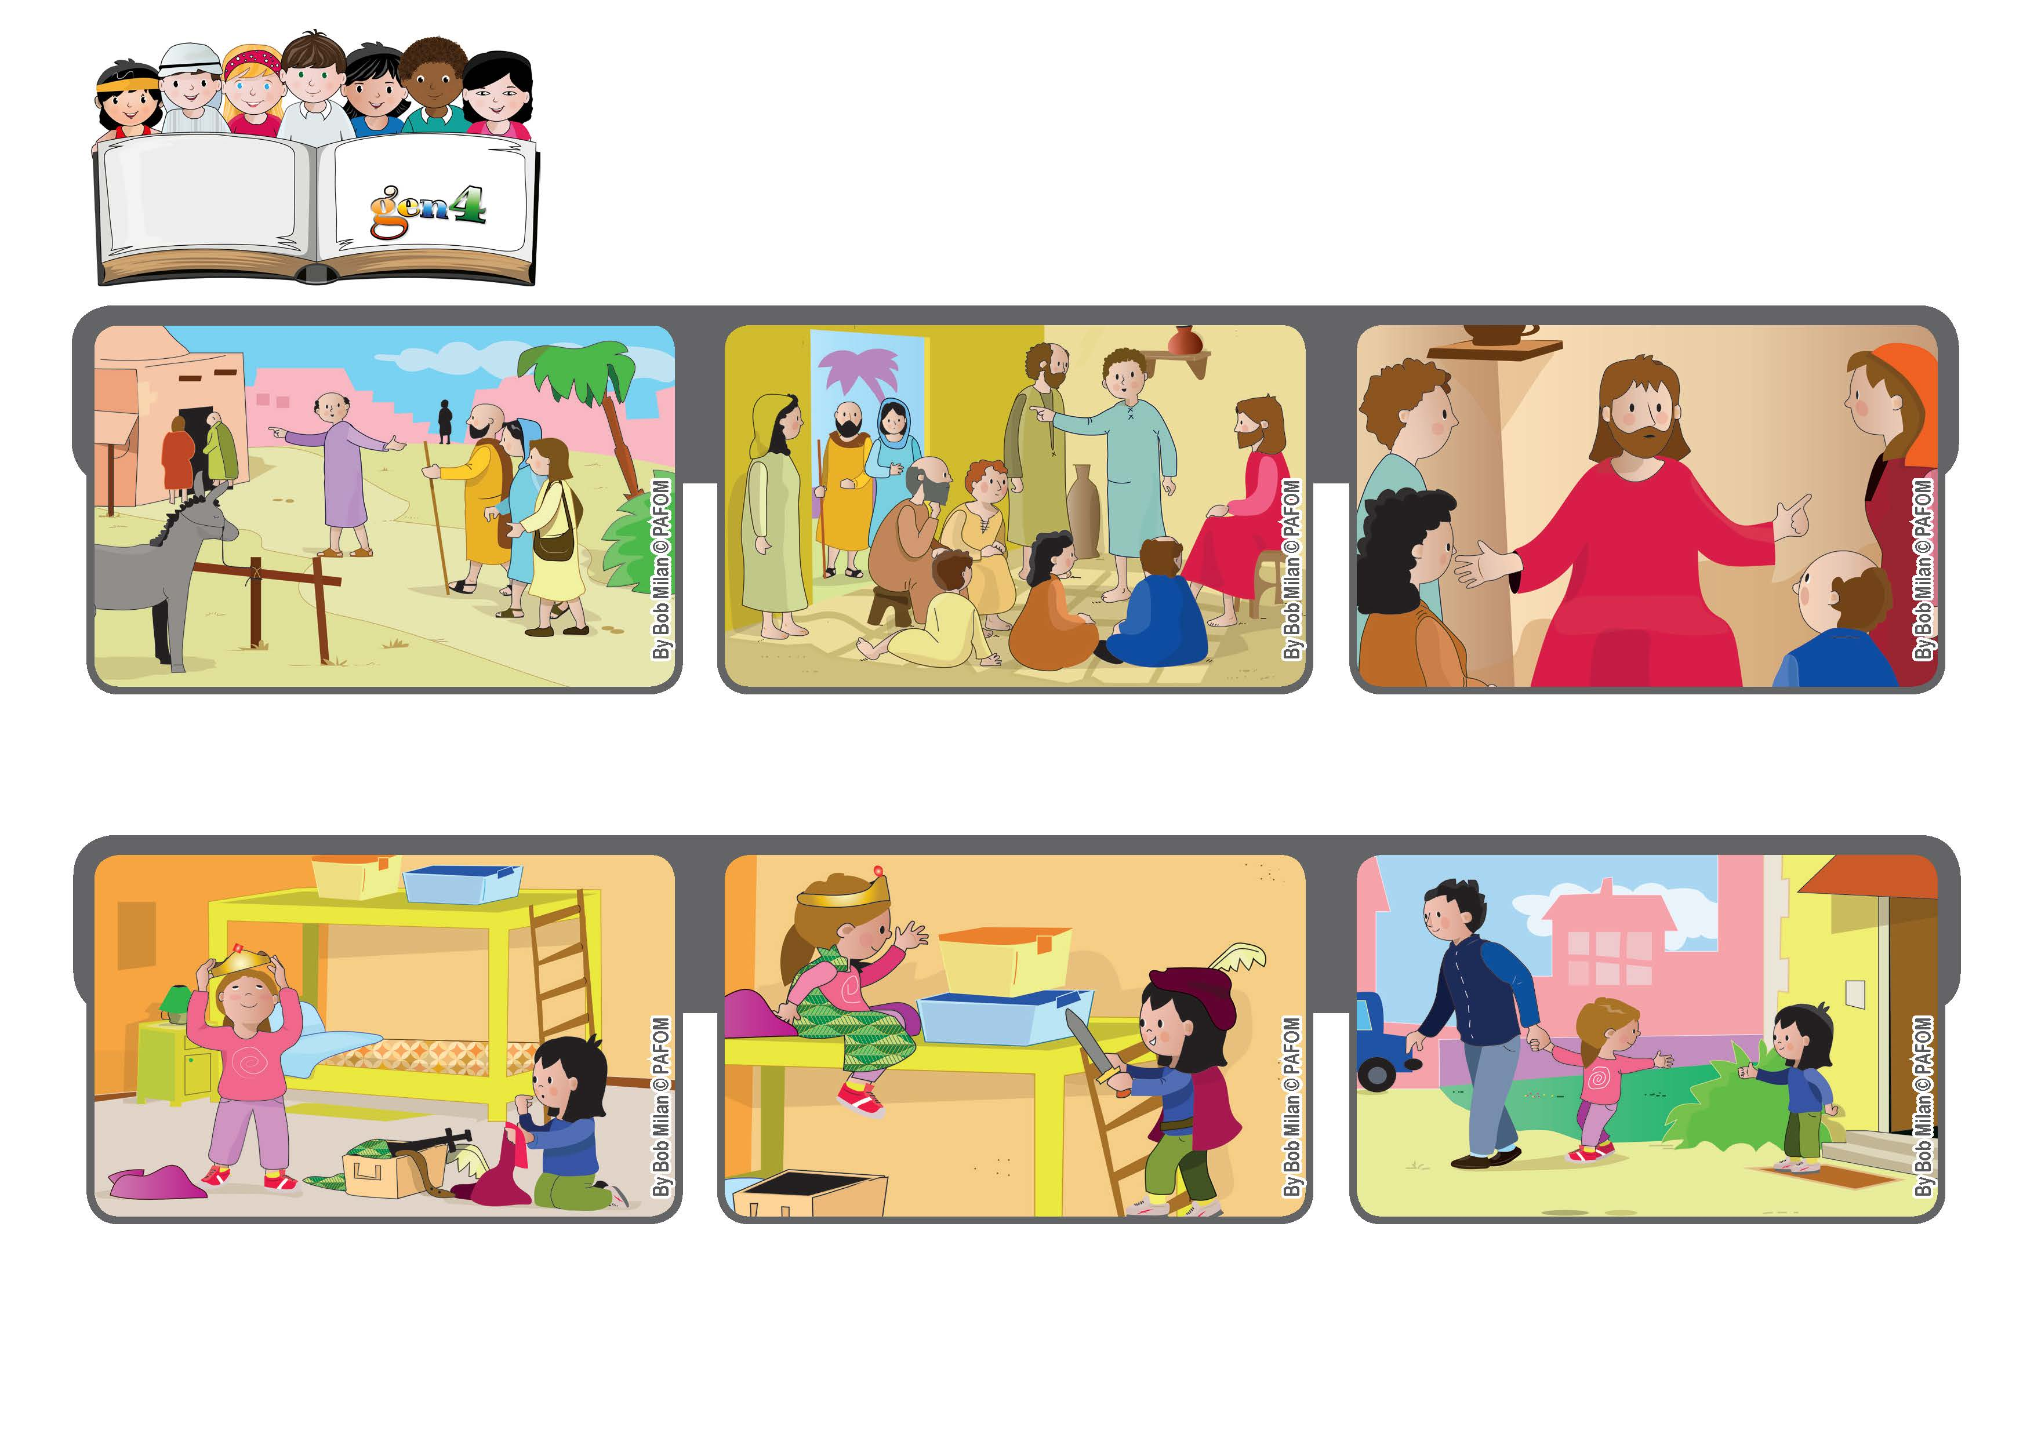

**July 2020**

**Word of Life**

**The apostles told Jesus, “Your mother and your relatives are outside and want to talk to you.”**

**The mother of Jesus and some of his relatives were looking for him because they wanted to talk to him.**

**Jesus pointed to those around him and said, “Whoever does the will of my Father in heaven is my brother and sister and mother.”**

**Paola went to visit her friend Noemi and they started to play a game of being a prince and a princess. Paola said, “I want to be the princess!”**

**Noemi wanted to be a princess too, but out of love for Paola, she accepted being the prince.**

**They had a good time playing and when it was time for Paola to go home, she thanked Noemi for her act of love. Experience of Noemi from Italy**

**© PAFOM, Drawings and text provided by the Gen4 Center.**

**The Gen4 are the young children of the Focolare Movement, which was founded by Chiara Lubich.**