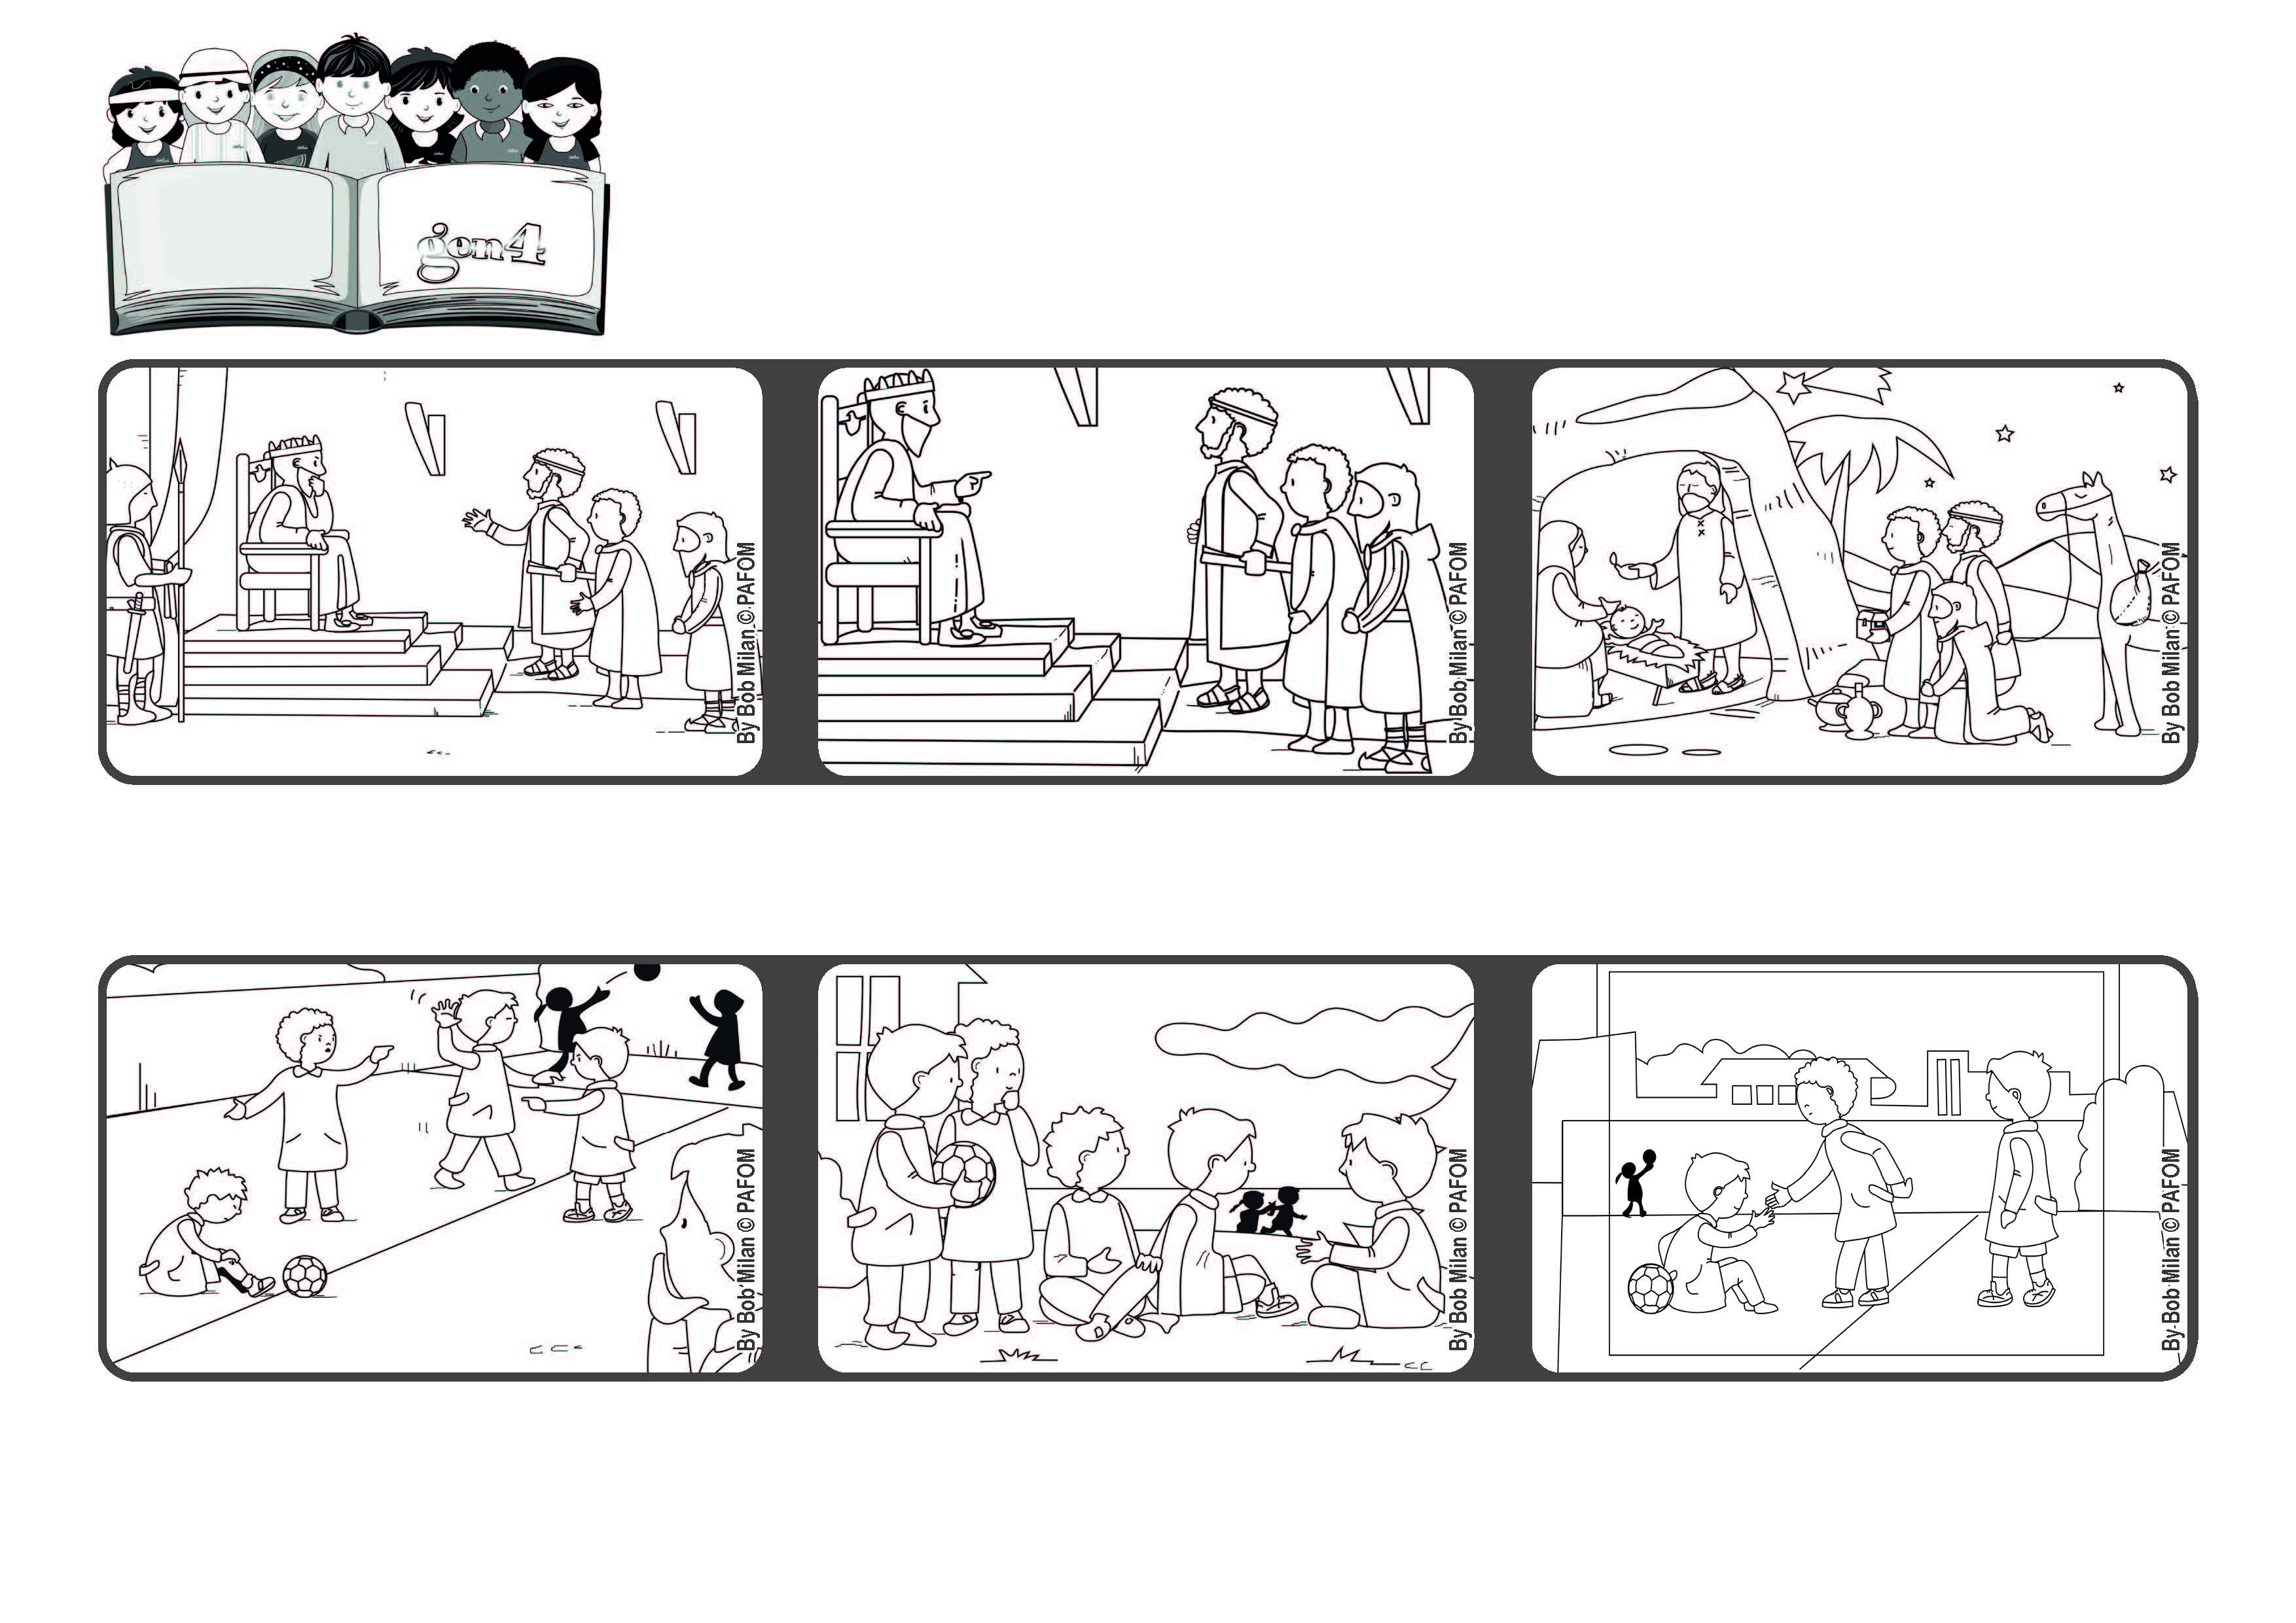

January 2022
Word of Life
“We saw his star in the east, and have come to worship him” (Mt 2:2).
Let’s go together to see Jesus
The three wise men found the stable and adored Baby Jesus. They were warned in a dream not to go back to see Herod and so they went home by another road.
Herod was worried about this new “king” and so he told them that when they found him, to come back and tell him. It was a trick so that he could kill Jesus.
Three wise men arrived in Jerusalem and went to see King Herod to ask him: “Where is the king of Israel? We saw his star and we came to adore him.”
Now when they play, if someone is hurt, they remember that Jesus suffered a lot, and so they keep on playing without starting a fight.
I started telling them the stories about Jesus and the three wise men and the star of Bethlehem and other things.
Experience of Paolo from Brazil: When my friends play at school, they end up hurting one another and then they fight.
© PAFOM, Drawings and text provided by the Gen4 Center.
The Gen4 are the young children of the Focolare Movement, which was founded by Chiara Lubich.

