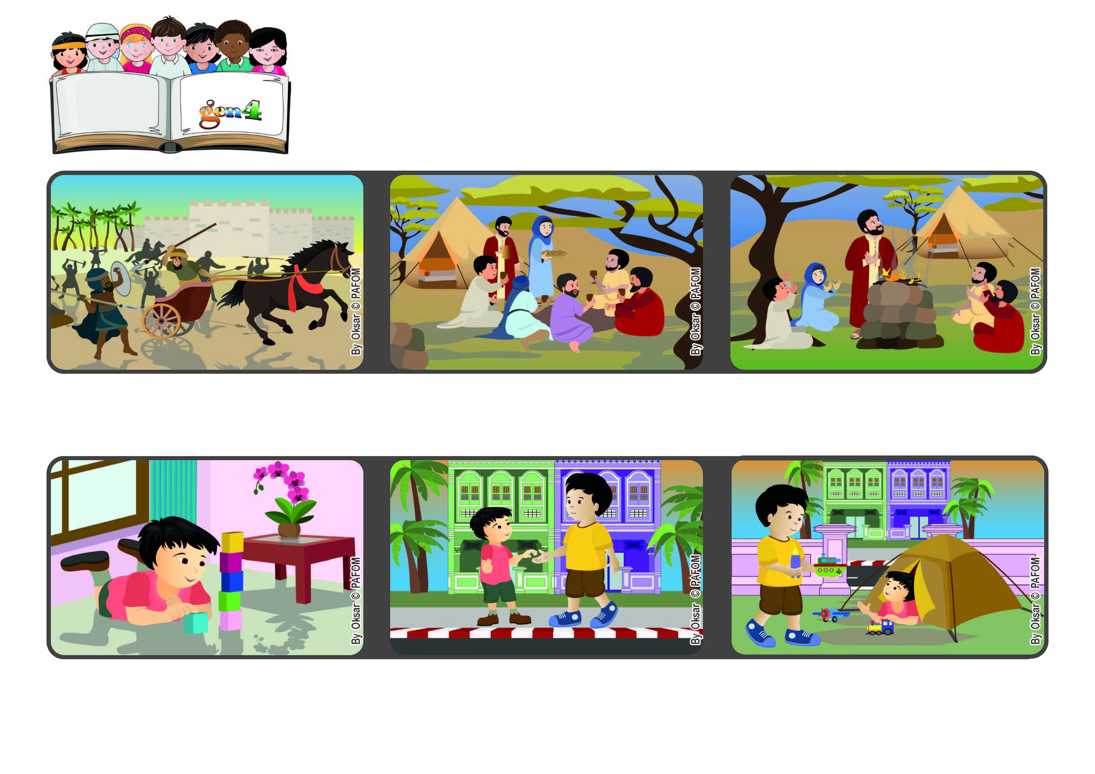

**Word of Life**

**January 2023**

**“Learn to do good; seek justice.” (Is 1:17)**

**Let’s do many acts of love!**

**I am really very happy that I can take care of Heng. It’s beautiful to be able to help others, giving a hand to those who are younger than us!”**

**© PAFOM, Drawings and text provided by the Gen4 Center.**

**The Gen4 are the young children of the Focolare Movement, which was founded by Chiara Lubich.**

**We can ask God anything because he always listens to us. When we love those around us, our prayers are even more powerful and we feel all his love.**

**In the Bible, the prophet Isaiah reminded the people that God invites all of us to take care of one another, especially those who are in great need.**

**Kai from Singapore shared this experience. “Heng is three years old and lives across the street from me. He likes to come over to my house to play with me, but it’s dangerous for him to cross the street by himself.**

**When he wants to play, he calls out to me, so I go over and get him, and help him cross the street. Then I spend a lot of time playing with him, sharing my toys and games.**

**There are many people in the world who are suffering because of wars, famine, unemployment and also natural disasters**