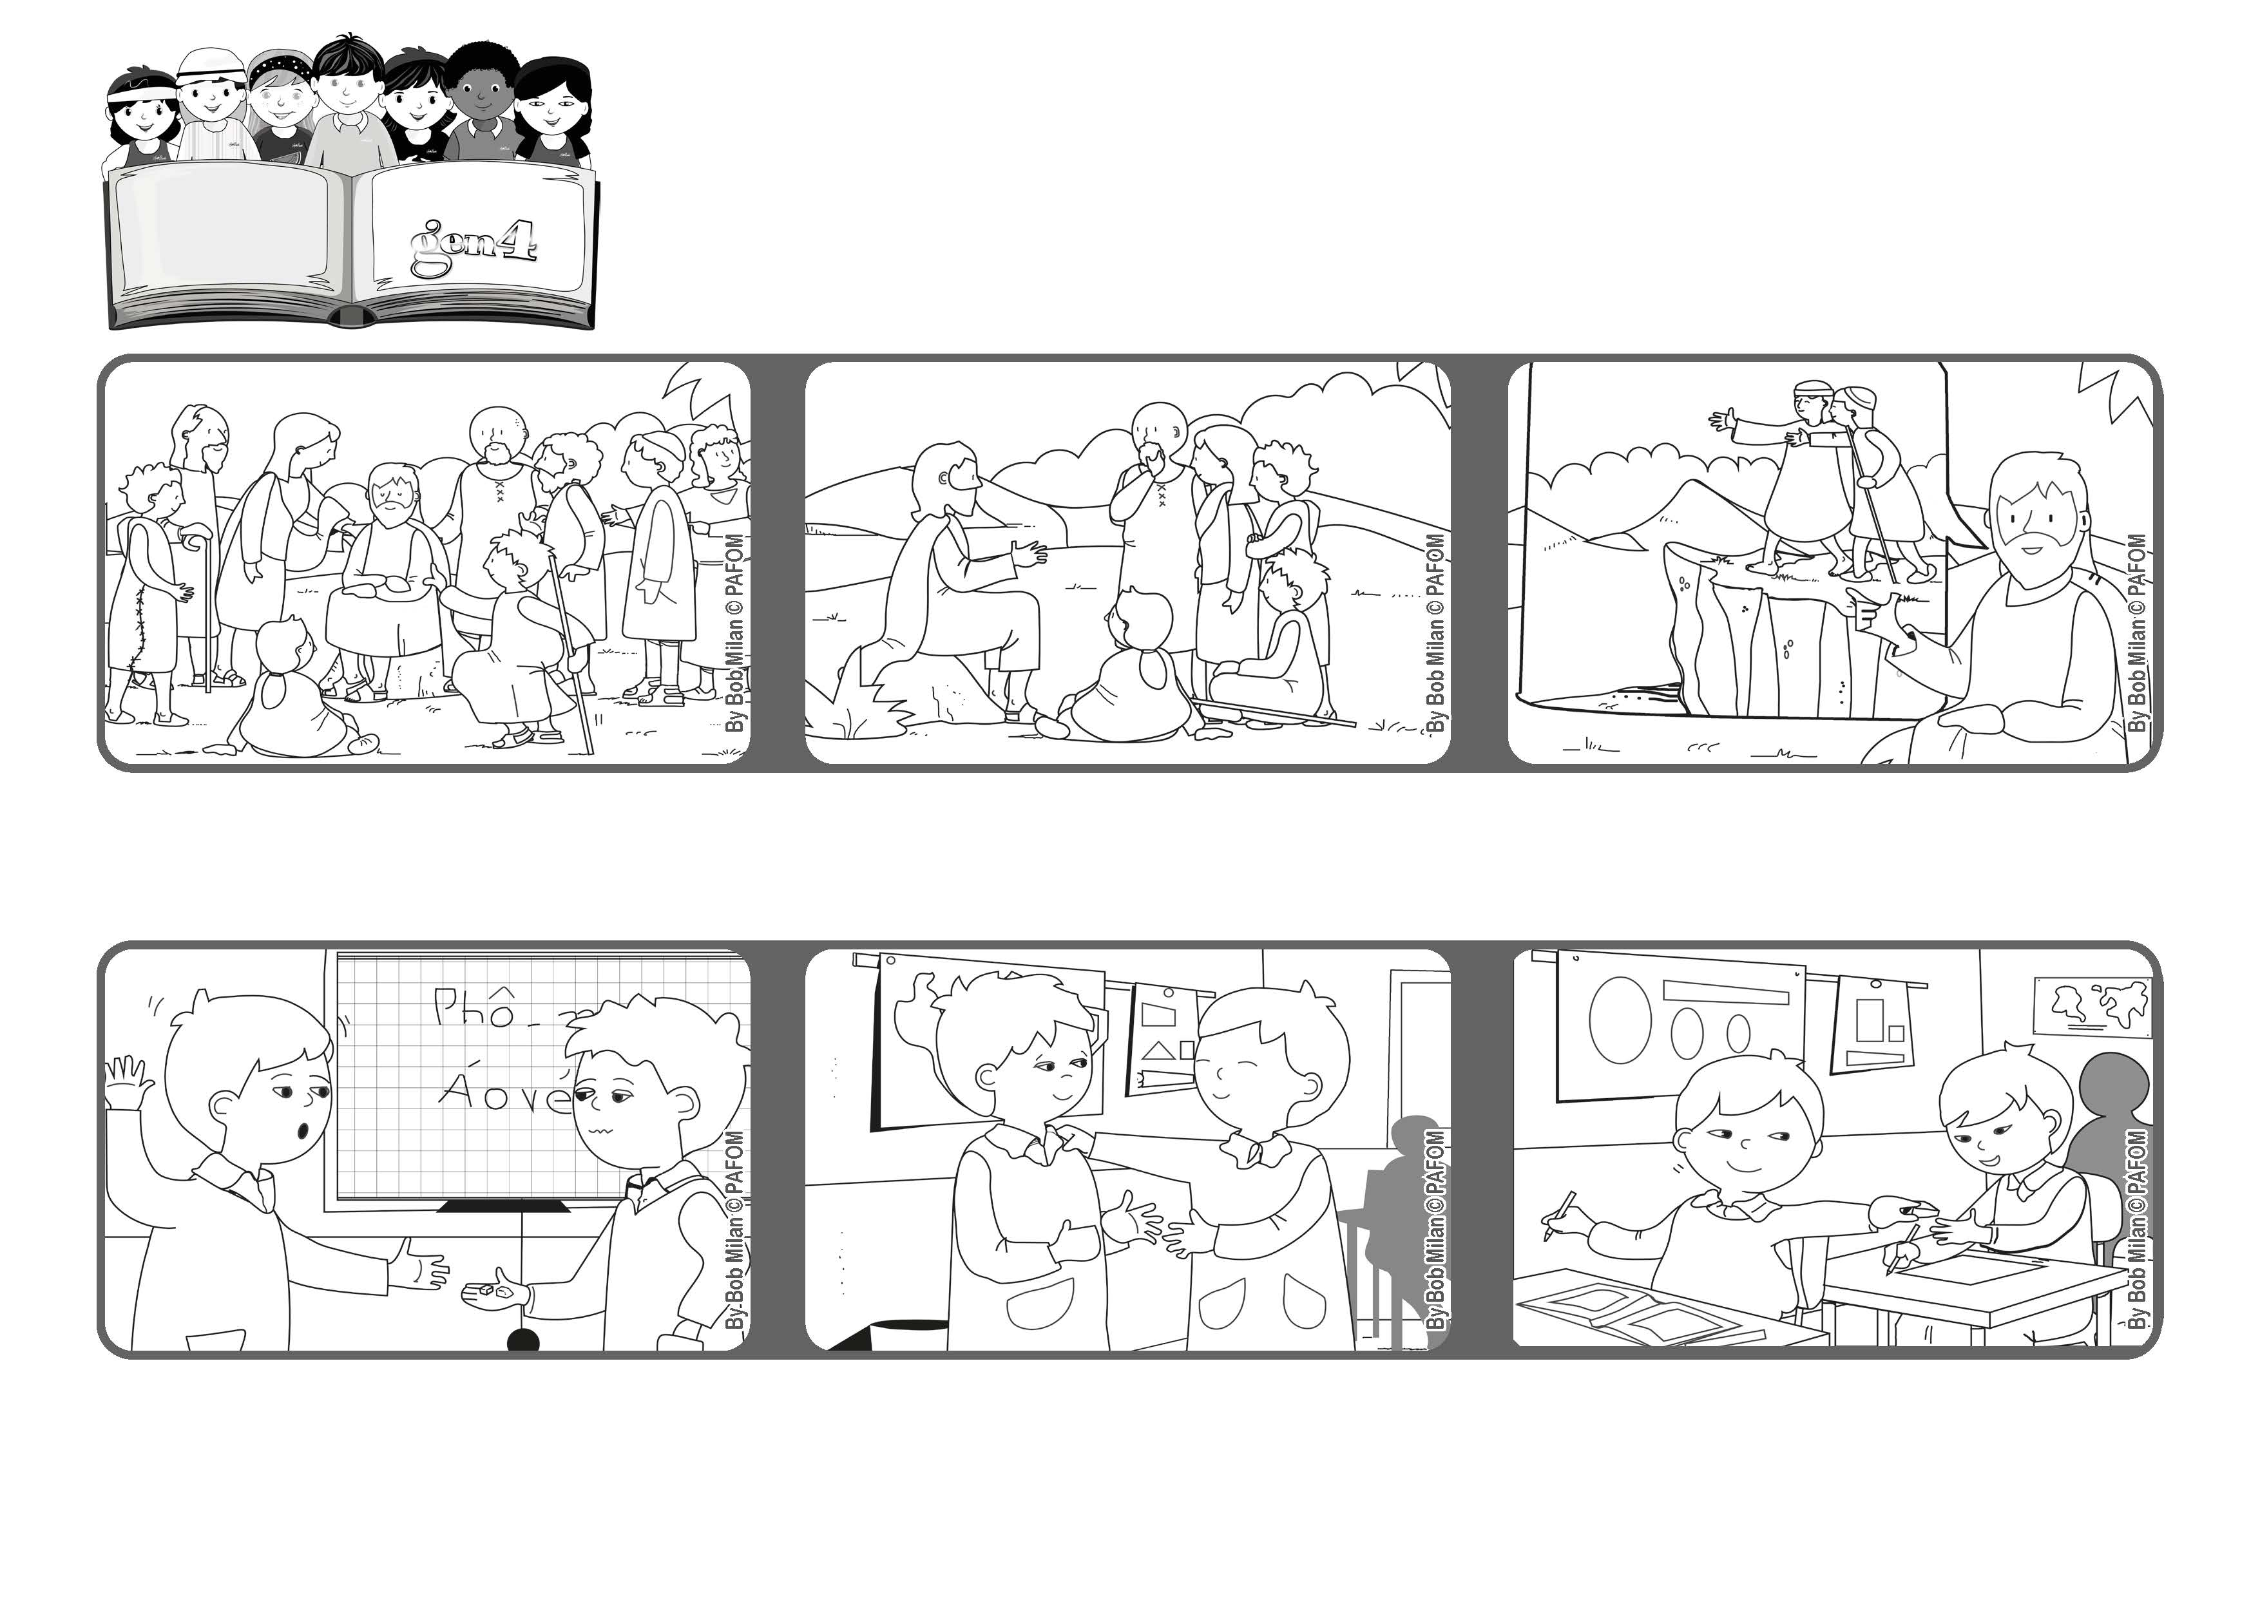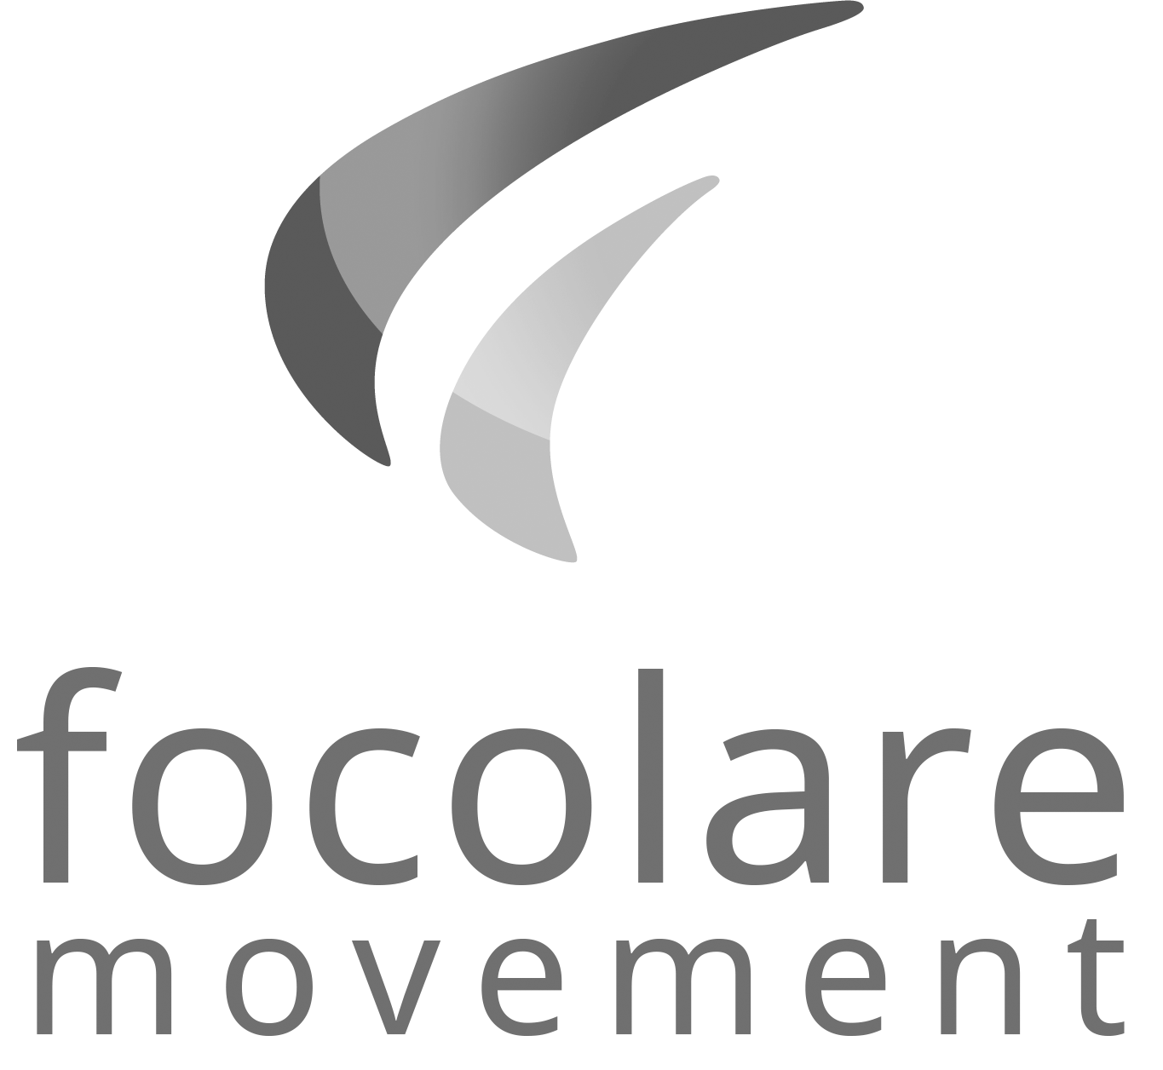

**February 2021**

**“Be merciful, just as your Father is merciful.” (Lk 6:36)**

**Forgive**

**Word of Life**

**Experience of Paolo from Vietnam: Paolo lent his eraser to Kim who gave it back to him broken in half.**

**He helped them and then told them to forgive others just as our heavenly Father forgives us.**

**Many people ran to hear Jesus and to be cured.**

**Kim said he was sorry, but Paolo was sad. Then he decided he could forgive him.**

**He added that if we don’t do that we are like a blind person leading another blind person and they both fall into a hole! (see Lk 6:36-39)**

**The next day Paolo gave a piece of the eraser to another boy who had lost his!**

**© PAFOM, Drawings and text provided by the Gen4 Center.**

**The Gen4 are the young children of the Focolare Movement, which was founded by Chiara Lubich.**